Supplementary Table S.1. Search strategy for the umbrella review

Database | String | Results
Pubmed | Search1: (egg) or (("Egg Proteins, Dietary"[Mesh] OR "Egg Yolk"[Mesh] OR "Egg White"[Mesh]) NOT ("Ovum"[Mesh] or "Zygote"[Mesh] OR "Fertility Preservation"[Mesh] OR "fertilization") Filters: Systematic Review, Humans  Search2: ("egg consumption" or "egg intake") and (health* or chronic disease* or diabete* or cancer or cholesterol* or dyslipid*) | 180  33
Web of Science | TS=(("egg" OR "Egg Proteins, Dietary" OR "Egg Yolk" OR "Egg White") NOT ("Ovum" or "Zygote" OR "Fertility Preservation" OR "fertilization")) | 3,882
Scopus | TITLE-ABS-KEY ( ( ( "egg" ) AND NOT ( "Ovum" OR "Zygote" OR "Fertility Preservation" OR "fertilization" ) ) ) AND ( LIMIT-TO ( LANGUAGE , "English" ) OR LIMIT-TO ( LANGUAGE , "Spanish" ) OR LIMIT-TO ( LANGUAGE , "Portuguese" ) OR LIMIT-TO ( LANGUAGE , "Italian" ) ) AND ( LIMIT-TO ( EXACTKEYWORD , "Human" ) OR LIMIT-TO ( EXACTKEYWORD , "Humans" ) OR LIMIT-TO ( EXACTKEYWORD , "Diet" ) ) AND ( LIMIT-TO ( SRCTYPE , "j" ) ) AND ( LIMIT-TO ( DOCTYPE , "re" ) ) | 3,367
Lilacs | ( ( ( "egg" ) AND NOT ( "Ovum" OR "Zygote" OR "Fertility Preservation" OR "fertilization" ) ) ) | 5
 |  | 7,467

Supplementary Table S.2. Detailed characteristics of included studies
Author, year, country | Participants (characteristics, total number) | Description of interventions/phenomena of interest | Sources searched | Included studies up to | Types of articles included | Quality / Risk of Bias Assessment | Outcome assessed | Significance/direction | Heterogeneity
Drouin-Chartier et al., 2020, Canada and USA | 16 studies for meta-analysis of 589,559 participants and 41,248 incident cases of T2D | Dietary information was collected through a semiquantitative FFQ. Participants were  asked how often on average they consumed whole eggs with yolk in the past year. Responses could range from <1 time/mo to ≥6 times/d with 1 whole egg as the standard serving size. | PubMed, Embase, and Web of Science | April, 2020 | Observational (prospective, ≥1-y follow-up duration) | NOS: 10 at low risk of bias, 6 high risk of bias. | Primary: T2D;  Primary confounders: age, sex, BMI, smoking status, physical activity, alcohol intake, and energy intake.  Secondary confounders: Hypertension, dyslipidemia, and intakes of foods associated with eggs (red and processed meat, refined grains, potatoes, coffee, fruit juice, soft drinks, and milk). | 14% higher risk of T2D.  US studies: for  each egg per day, T2D risk was higher by 18%,  European and Asian studies: no association | Substantial
Drouin-Chartier et al, 2020, USA | 28 studies, 1 720 108 participants, and 139 195 events | Categories of egg consumption.  50 g as the standard weight for one egg. | PubMed, Embase, and Web of Science | August, 2019 | Observational (prospective, with risk estimates for three or more levels of egg consumption or a dose-response estimate) | NOS: 12 low risk of bias.  No evidence of publication bias. | Incidence of cardiovascular disease (total cardiovascular disease; total, fatal, and non-fatal coronary heart disease; and total, ischemic, hemorrhagic, fatal and non-fatal stroke)  Primary confounders: Age, sex, body mass index, smoking status, physical activity, alcohol intake, and energy intake.  Secondary confounders: Hypertension, dyslipidemia, and red meat intake. | No association between egg consumption and risk of cardiovascular disease in three large US cohorts | Substantial
Emrani AS et al., 2023, Iran | 32 studies, 12 studies with 13 effect sizes and 570 participants | Amount of whole egg consumption and comparison food used | Scopus, PubMed, and Web of Science. | April, 2023 | Experimental (controlled clinical trials) | Rob2: 6 with some concern, 23 high risk, and 1 low risk of bias.  ROBINS-I: critical risk of bias.  No evidence of publication bias | body weight, body mass index (BMI), waist circumference (WC), fat mass, and fat-free  mass (FFM), | Whole egg consumption might significantly increase body weight  and BMI in studies longer than 12 weeks and in unhealthy  subjects. | High
Darooghegi M. et al., 2022, Malasya | 55 studies, 2,772,486 adults | categories of egg and dietary cholesterol intake, dietary  intakes were assessed using food frequency questionnaires in 43 publications, 6 applied to food recall or record, and 3 used dietary history | PubMed, Scopus, IWeb of Knowledge, and Google Scholar | April, 2021 | Observational (prospective cohort studies) | ROBINS-E: 24 serious risk of bias and 27 moderate risk of bias | all causes mortality, CVD mortality, and cancer mortality | A high intake of eggs and dietary cholesterol is associated with an increased risk of  mortality from all causes and cancer. Egg consumption was not associated with cardiovascular disease risk. Each additional egg per day was associated with a 5% higher risk of all-cause  and a 13% higher risk of cancer mortality. Each 100 mg/day increment in dietary cholesterol intake was associated with a 6% higher risk of all-cause mortality and a 6% higher risk of  cancer mortality. | Moderate-to-high
Godos J., et al., 2021, Italy, Poland, Spain, Denmark, Netherlands, Switzerland, USA | 39 studies, 38 cohorts: CHD (1,831,038 individuals and 85,053 cases), stroke (761,962 individuals and 25,103 cases), heart failure (254,588 individuals and 7536 cases), and CVD (1,117,033 individuals and 147,124 cases) outcomes | moderate consumption (four eggs per week) and a habitual consumption (one egg per day) | MEDLINE, Embase, and Web of Science | April, 2020 | Observational (prospective studies) | ROBINS-I, GRADE: low for all outcomes but stroke, for which was moderate.  No publication bias. | Total CVD, CHD, and stroke (including sub-types hemorrhagic and  ischemic stroke) incidence and mortality. Risk of heart failure incidence | no strong association with either increased or decreased risk of  cardiovascular outcomes following the habitual consumption  of eggs (1 egg per day compared to no intake), with exception of risk of heart failure, which resulted higher especially in men from US cohorts | High for CVD and CHD, low for Heart failure.
Kolahdouz-Mohammadi R., et al., 2020, Iran, USA | 15 articles, 748 adults participants (23.3 to 67.1 years old) | changes from baseline for SBP and DBP in experimental and control groups. | PubMed, Ovid Medline, Scopus, and the Cochrane | February, 2019 | Experimental (randomized clinical trials) | Cochrane Collaboration’s tool: 1 high quality, 7 fair, and 7 poor quality.  NutriGrade meta-evidence: moderate confidence | changes in SBP and DBP values  Subgroup analysis based on sex (male, female, or both), population health status (healthy, type 2 diabetic and metabolic syndrome, patients with coronary artery disease (CAD) and hyperlipidemia), hypertension and obesity status (nonobese or overweight/obese), duration (less than 12 weeks or ≥ 12 weeks) and design (parallel or crossover) of study, diet adherence (usual diet or specific/restricted diet), and amount of egg consumption in intervention group (one egg/day or greater than one egg/day). | No significant effect of egg consumption on blood pressure. Subgroup analyses showed that the pooled effects of egg consumption on SBP and DBP were not influenced by study design, sex, population health status, obesity and HTN status, diet adherence, study duration, and  number of eggs consumed. | No heterogeneity
Krittanawong, et al., 2020, USA | 23 prospective studies (follow-up of 12.28 years), 1,415,839 adults with a total of 123,660 cases and 157,324 CVD | egg consumption categories: (more than 1 egg/day) consulted dietitians and nutritionists for servings or nutritional units. | MEDLINE, Embase, Cochrane, Scopus, and Web of Science | January, 2020 | Observational (prospective or cross-sectional studies) | NOS: After excluding studies with a moderate risk of bias, no associations between egg consumption and the risk of cardiovascular disease. | CVD events, coronary artery disease, acute myocardial infarct,  acute coronary syndrome, stroke or heart failure | No significant association between egg consumption and risk of cardiovascular disease events, but egg consumption (>1 egg per day) is associated  with a reduction in coronary artery disease risk. | Substantial
Larson et al., 2024, Denmark, USA | 7 articles and 9 interventions with 3,575 children (6 months - 18 years) | Primary intervention: provision of eggs alone, or eggs together with another food or supplement,  Only if there was no secondary: behavioral intervention (e.g., a sanitation intervention, or dietary counseling) in conjunction with the primary | PubMed and Healthline | November, 2021 | Interventional (clinical trials randomized or not) | Rob2: 5 high risk of bias, 3 unclear,  GRADE: high certainty of the evidence | Change in height/length from baseline and the change in weight from baseline. | Improved growth in terms of both weight and height was observed in the treatment groups when compared to the control groups. The overall benefit was an additional 0.43 cm in height and an additional 0.07 kg in weight. Furthermore, these beneficial changes were more pronounced in children younger than 2 years of age as opposed to those older than 2 years. | High
Li MY et al., 2020, Taiwan | 24 references from 17 RCTs, 11 crossover studies | consumption of eggs without accompanying buttermilk drinks, (consumption of buttermilk and skimmed milk influences the effects of egg yolks on lipoprotein) | PubMed and Embase | May, 2020 | Experimental (randomized clinical trials) | Evaluation of selection bias, study design, confounders, blinding, data collection methods, withdrawals, and dropouts: strong evidence. | LDL-c/HDL-c ratio | Egg consumption significantly increases the LDL-c/HDL-c ratio and LDL-c levels, especially with a longer intervention duration. Egg consumption did not effectively increase the HDL-c level. Our pooled results revealed some significant  findings among subgroups of egg consumption levels, but the results did not show a clear trend of  increment with the egg consumption level. | Low
Ma W. Et al., 2022, China | 24 studies (48 reports) and 1 case-cohort study with adults (aged ≥18 y);  25 prospective cohort studies (22 articles) with 1,301,189 participants for the association of egg consumption with all-cause mortality. | categories of egg intake: highest egg consumption group with the lowest  categories of egg intake.  For the dose–response analysis per 1-egg/d increase, if studies reported egg intake as grams per week or day, we assumed that each egg was equivalent to 50 g. | PubMed, Embase, and Web of Science | November, 2021 | Observational | NUQUEST: 33.33% good and 66.67% neutral | all-cause mortality or CVD mortality [including cardiovascular-related mortality like coronary heart disease mortality, ischemic heart disease (IHD) mortality,  cerebrovascular disease (ischemic stroke and hemorrhagic stroke)  mortality, coronary artery disease mortality, myocardial infarction  mortality. | High consumption of eggs was not significantly associated with an increased risk of all-cause, CVD, IHD, and stroke mortality, but a 1-egg/d increment in egg consumption was significantly associated with a 5.6% higher risk of all-cause mortality, and this association was significant in women, Americans, and in studies with adjustment for hyperlipidemia. Egg consumption was not significantly associated with CVD, IHD, and stroke mortality. | Evidence of heterogeneity
Mousavi SM et al., 2022, Iran | 33 cohort studies (32 publications), 2,216,720 participants | a quantitative measure of egg consumption (i.e., servings/day or week, numbers/day or week, grams/day or week) for 2 or more categories with the  corresponding adjusted RRs and 95% CI, category-specific, or the total numbers of cases and noncases or person years. | PubMed/Medline, Scopus, Web of Science, and Embase | March, 2021 | Observational (prospective cohort studies) | ROBINS-I: not serious  GRADE: low-quality, certainty moderate | a quantitative measure of egg consumption (i.e., servings/day or week, numbers/day or week, grams/day or week) | No evidence of an association  between egg consumption and the risk of mortality from all  causes, CVD, stroke, CHD, and respiratory disease. There was a significant positive association  between egg consumption and the risk of cancer mortality. In the linear dose-response meta-analysis, 4% and 2% greater risks of mortality from cancer and all causes,  respectively, and a 4% lower risk of mortality from stroke by  an additional 1 egg intake per week. | Considerable heterogeneity and publication bias
Sikaroudi MK., et al., 2020, USA Iran | 66 clinical trials, 3,185 adult participants | maximum amount of egg | PubMed, Scopus, Web of Science and Cochrane | April, 2019 | Interventional (randomized clinical trials, parallel or cross-over design) | Cochrane Handbook for Systematic Reviews of Interventions: 13 good quality, 26 fair, and 27 trials as poor;  GRADE: moderate quality for TC,  LDL-C, HDL-C, TG, TC/HDL-C, apoA1, and apoB100;  low quality for VLDL-C and LDL-C/HDLC | TC, LDL-C, HDL-C, TG, VLDL-C, TC/HDL-C, LDL-C/HDL-C, apoA1, and apoB100. | Egg consumption can significantly increase the serum levels of TC, LDL-C, HDL-C, TC/HDL-C ratio, apoA1, and apoB100 but does not significantly influence TG, VLDL, and LDL-C/HDL-C ratio. There was a positive linear effect of egg consumption on TC, HDL-C, TG, ApoA1, ApoB100, VLDL-C, and LDL-C/HDL-C but not for LDLC, and TC/HDL-C. | High
Yang P et al., 2022, China | 19 studies, 1 737 893 participants | categories of egg consumption | PubMed and Embase | November, 2020 | Observational (prospective cohort, case-cohort studies) | ROBINS-I: Serious risk of bias  GRADE: very low quality | risks of mortality from all causes, cardiovascular disease,  cancer, stroke, and/or coronary heart disease in the general population | A high amount of egg consumption was associated with  an increased risk of death from all causes, cardiovascular  disease, and cancer in a nonlinear, dose-response  manner. | High
Zhao et al., 2022, China, USA, Finland | 41 studies, 49 risk estimates, 3,601,401 participants. | categories of egg consumption | Web of Science, PubMed, and Embase. | August, 2021 | Observational (cohort studies, Alpha-Tocopherol, Beta-Carotene Cancer Prevention (ATBC) Study) | NOS: low risk of bias | age at baseline (< 57, or ≥ 57 years), number of cigarettes smoked per day  (<16, 16 to <20, or ≥20), BMI (<30, or ≥30 kg/m2  ), history of cardiovascular disease (no, or  yes), intervention group (alpha-tocopherol/no alpha-tocopherol, beta-carotene/no betacarotene), high quality diet (no [quartiles of 1 to 3], or yes [quartiles of 4]; based on the  Alternate Mediterranean Diet Score, Table I in the Supplemental Data), total energy intake  (<2,589, or ≥2,589 kcal; median split), saturated fatty acid intake (low or medium [quartiles  1-3], or high [quartiles 4]), serum cholesterol (<205, or ≥205 mg/dL; median split) (for  dietary cholesterol or egg consumption as the primary exposure variable), dietary cholesterol  (<538, or ≥538 mg; median split), serum alpha-tocopherol (<11.5, or ≥11.5 mg/L; median  split), serum beta-carotene (<172, or ≥172 µg/L; median split), serum retinol (<577, or ≥577  µg/L; median split), follow-up period (0 to <13, 13 to ≤23, ≥23 years) | Greater consumption of dietary cholesterol and egg experienced modest but significant increases in risk of overall, CVD and heart disease mortality independent of other risk factors including serum total cholesterol | Substantial

Supplementary Table S.3. Quality assessment of studies for RCTs using the NutriGrade scoring system
 | Emrani, 2023 | Kolahdouz-Mohammadi, 2020 | Larson, 2024 | Li, 2020 | Sikaroudi, 2020
Risk of bias, study quality and study limitations | 0 | 0 | 1,5 | 0 | 1,5
Precision | 0 | 1 | 1 | 0,5 | 0,15
Heterogeneity | 0,3 | 0,4 | 0,3 | 0,4 | 0,4
Directness | 0 | 0 | 1 | 1 | 1
Publication bias | 1 | 0 | 0 | 1 | 0
Funding bias | 1 | 0 | 1 | 1 | 0
Study design (only RCTs) | 2 | 2 | 1 | 2 | 2
Total | 4,3  (low) | 3,4  (very low) | 5,8  (low) | 5,9  (low) | 5,3  (low)

Supplementary Table S.4. Quality assessment of studies for cohort studies using the NutriGrade scoring system
 | Drouin-Chartier, 2020 | Drouin-Chartier, 2020(2) | Darooghegi Mofrad, 2022 | Godos, 2021 | Krittanawong, 2020 | Ma, 2022 | Mousavi, 2022 | Yang, 2022 | Zhao,2022
Risk of bias, study quality and study limitations | 1,5 | 1 | 1,5 | 1,5 | 0 | 0,5 | 1 | 0 | 1
Precision | 0 | 0 | 0,3 | 0,25 | 0 | 0 | 0 | 1 | 1
Heterogeneity | 0,2 | 0,3 | 0,3 | 0,2 | 0,2 | 0,4 | 0,3 | 0,4 | 0,3
Directness | 1 | 1 | 1 | 1 | 1 | 1 | 0 | 0 | 1
Publication bias | 0 | 1 | 0 | 1 | 0 | 0 | 0 | 1 | 1
Funding bias | 1 | 1 | 1 | 1 | 0 | 0,5 | 0 | 1 | 1
Effect size | 0 | 0 | 0,3 | 0 | 1 | 0 | 0 | 0 | 0
Dose-response | 0 | 0 | 1 | 1 | 0 | 1 | 1 | 1 | 0
Total | 3,7  (very low) | 4,3  (low) | 5,1  (low) | 5,95  (low) | 2,2  (very Low) | 3,4  (very Low) | 2,3  (very Low) | 4,4  (low) | 5,3  (low)

Supplementary Figure S.1. Corrected covered area of the meta-analyses which investigated all-cause mortality
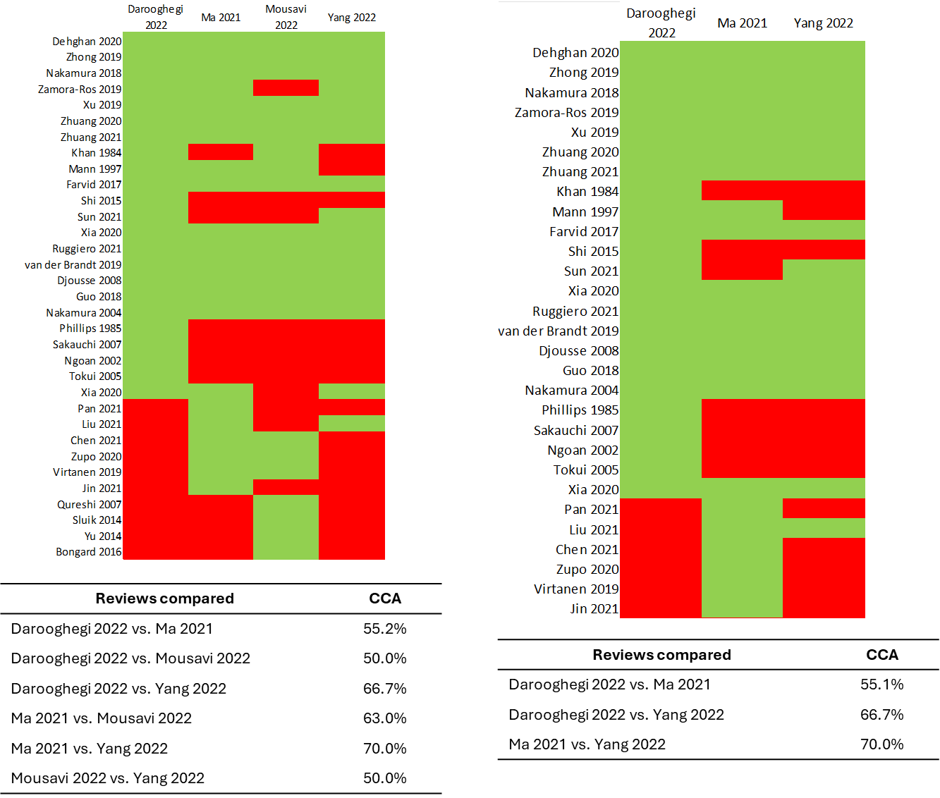
Green color indicates that a study is included in the single meta-analysis, whereas a red color indicates that a study is not included.

Supplementary Figure S.2. Corrected covered area of the meta-analyses which investigated cardiovascular disease mortality
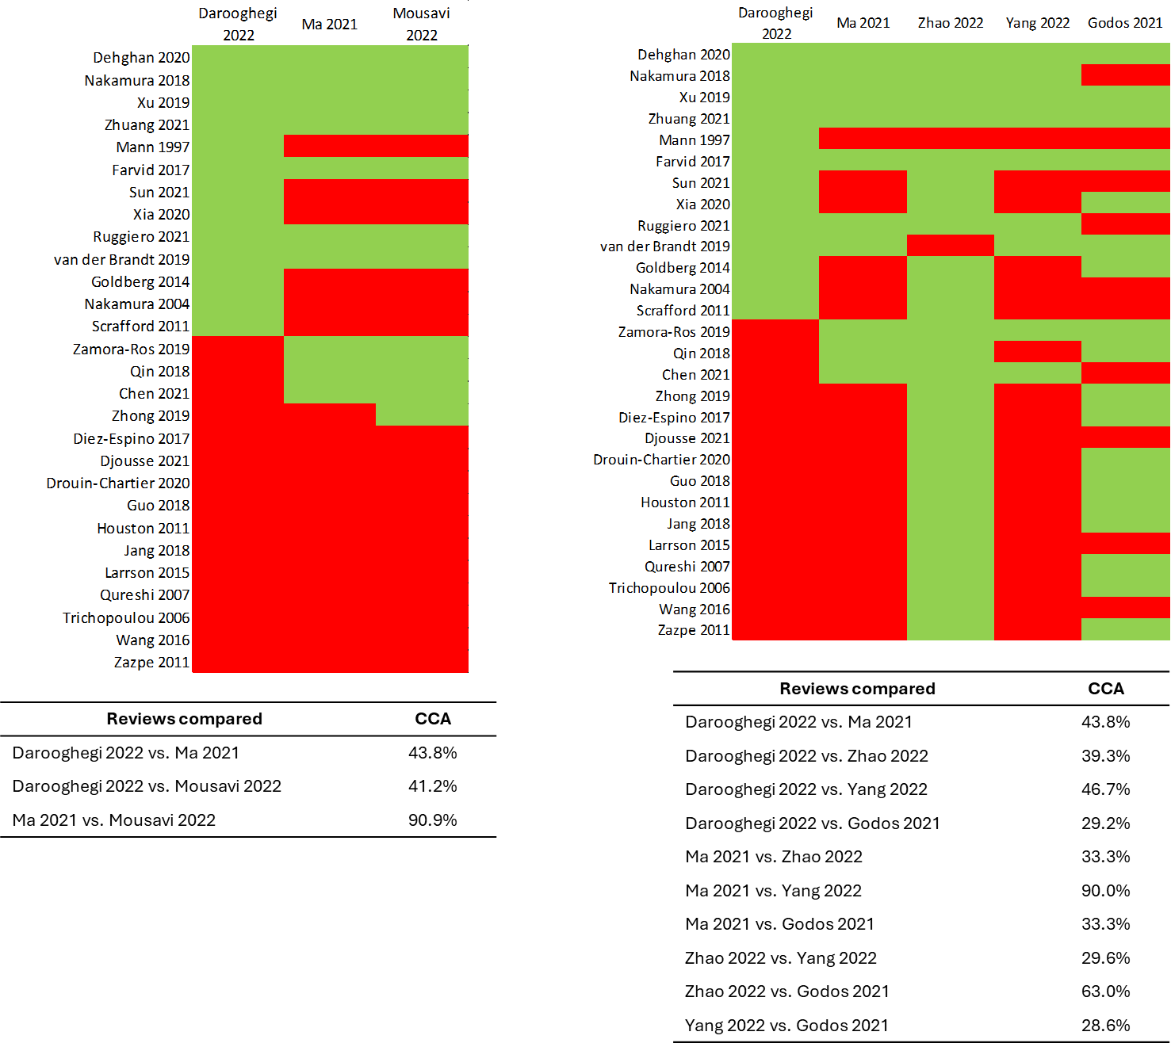

Green color indicates that a study is included in the single meta-analysis, whereas a red color indicates that a study is not included.

Supplementary Figure S.3. Corrected covered area of the meta-analyses which investigated cardiovascular disease incidence
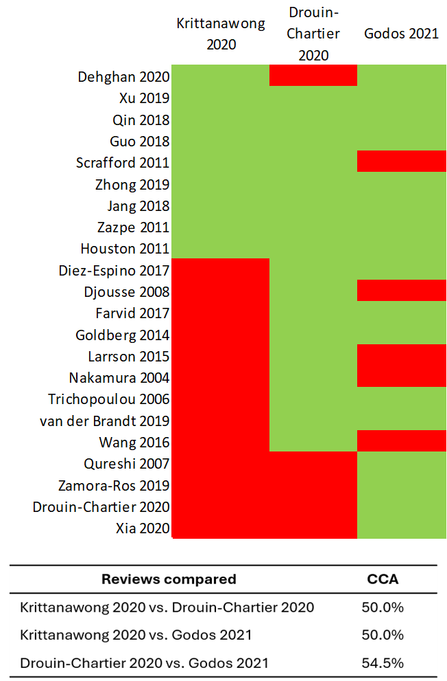
Green color indicates that a study is included in the single meta-analysis, whereas a red color indicates that a study is not included.

Supplementary Figure S.4. Corrected covered area of the meta-analyses which investigated coronary heart disease mortality
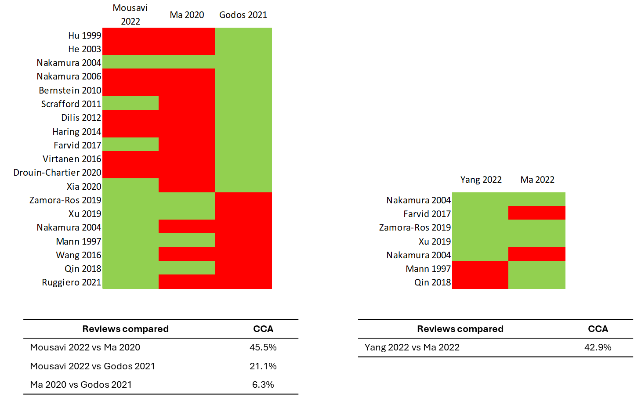Green color indicates that a study is included in the single meta-analysis, whereas a red color indicates that a study is not included.

Supplementary Figure S.5. Corrected covered area of the meta-analyses which investigated coronary heart disease incidence
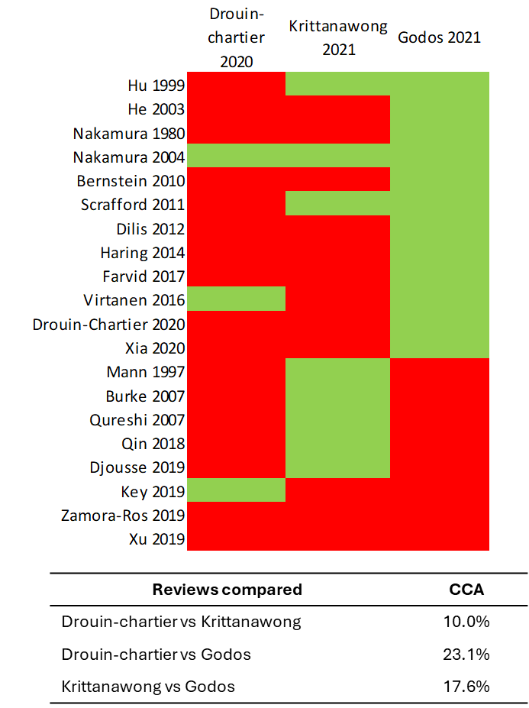
Green color indicates that a study is included in the single meta-analysis, whereas a red color indicates that a study is not included.

Supplementary Figure S.6. Corrected covered area of the meta-analyses which investigated stroke mortality
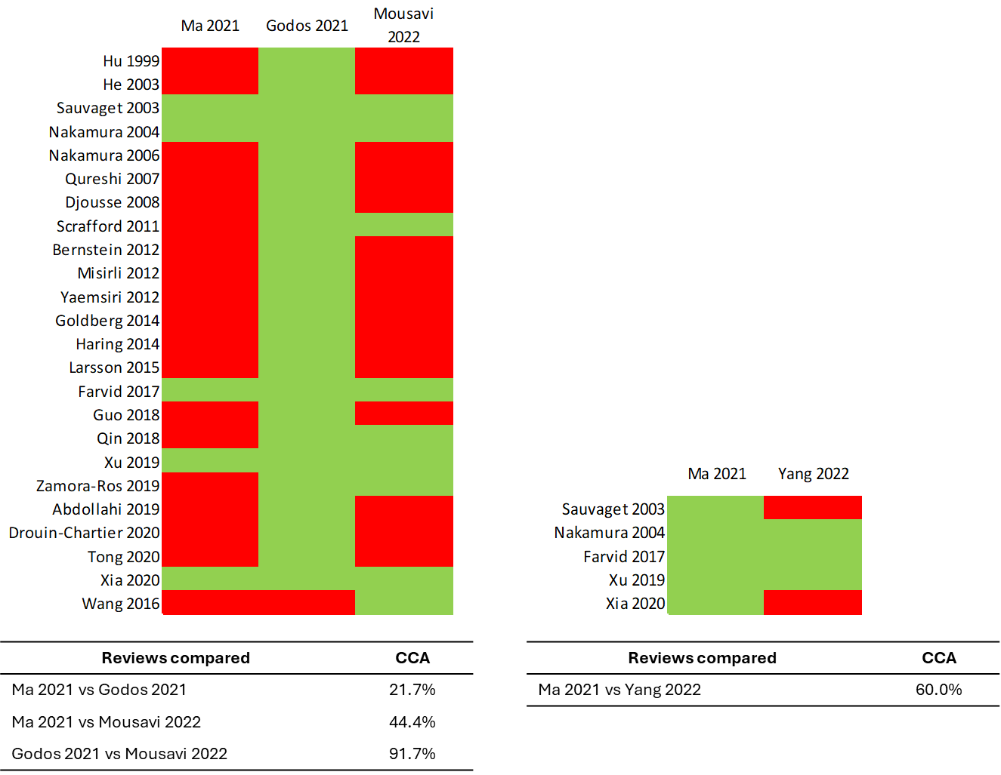Green color indicates that a study is included in the single meta-analysis, whereas a red color indicates that a study is not included.

Supplementary Figure S.7. Corrected covered area of the meta-analyses which investigated stroke incidence
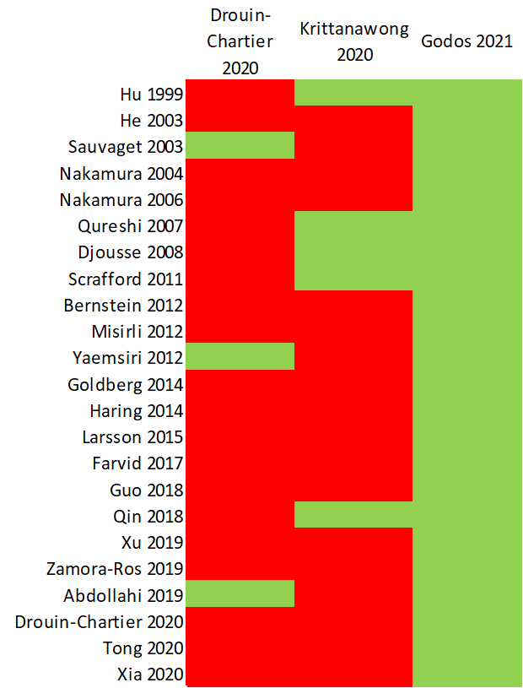
Green color indicates that a study is included in the single meta-analysis, whereas a red color indicates that a study is not included.

Supplementary Figure S.8. Corrected covered area of the meta-analyses which investigated cancer risk
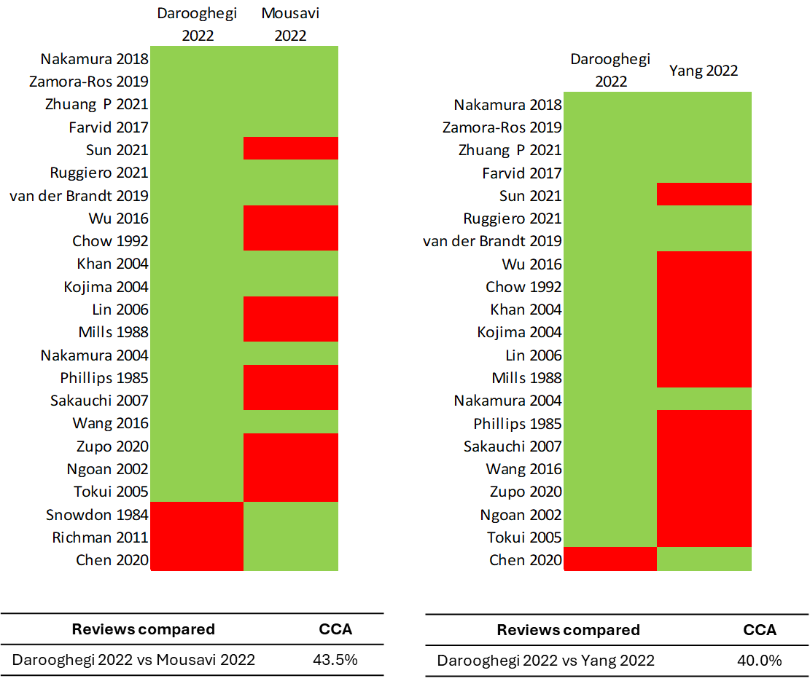
Green color indicates that a study is included in the single meta-analysis, whereas a red color indicates that a study is not included.

Supplementary Figure S.9. Corrected covered area of the meta-analyses which investigated HDL-C blood levels
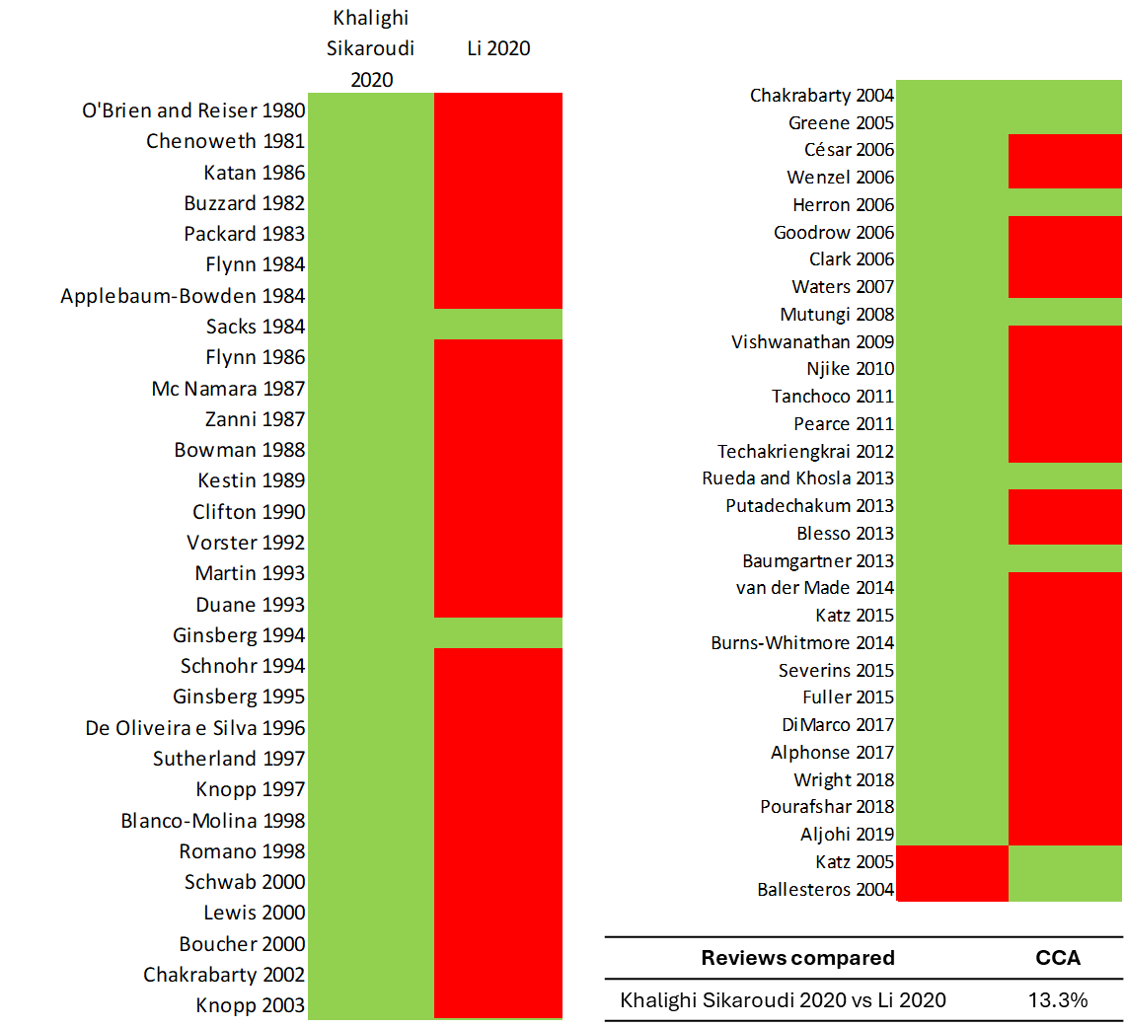
Green color indicates that a study is included in the single meta-analysis, whereas a red color indicates that a study is not included.

Supplementary Figure S.10. Corrected covered area of the meta-analyses which investigated LDL-C blood levels
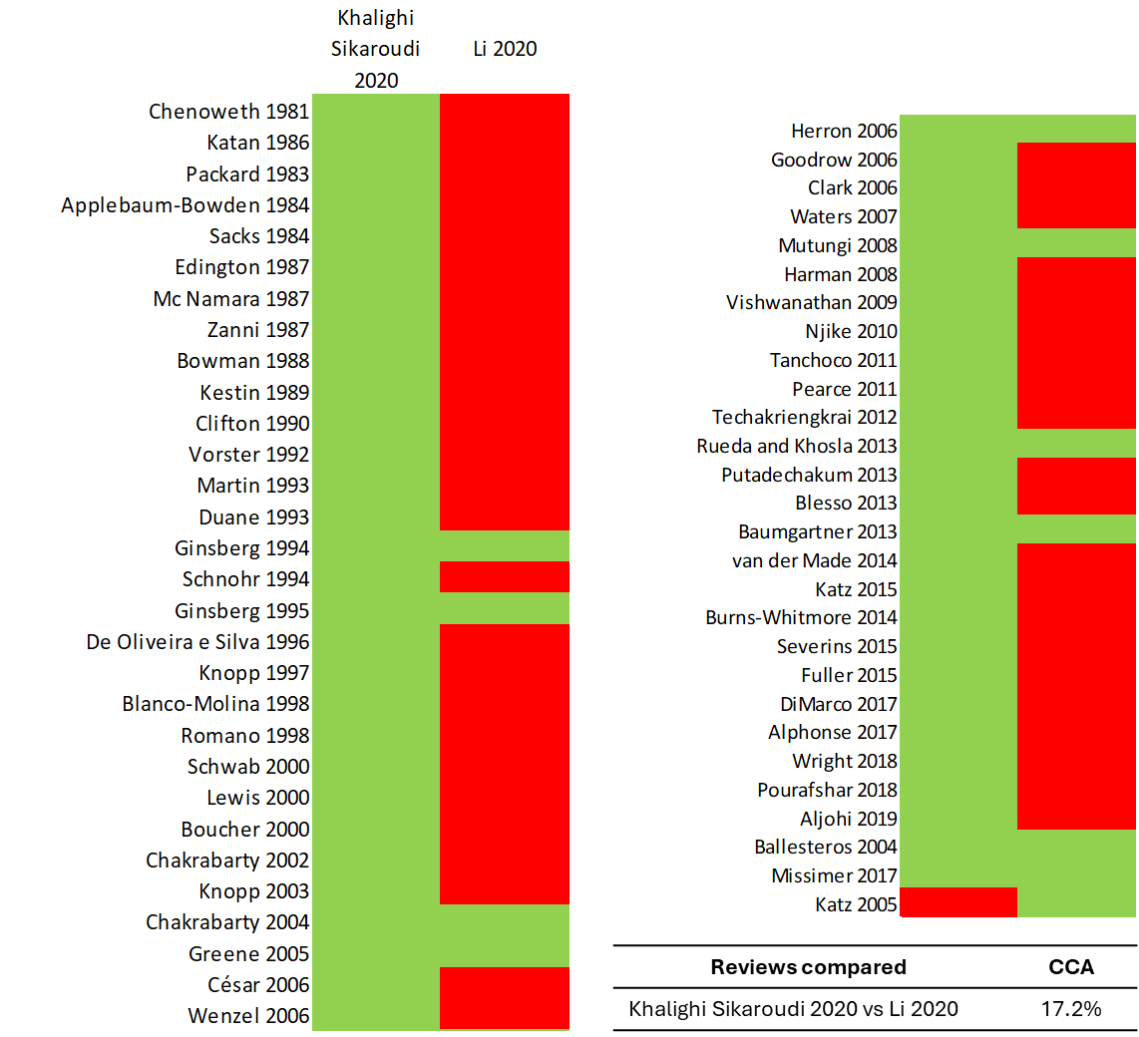
Green color indicates that a study is included in the single meta-analysis, whereas a red color indicates that a study is not included.

