Invasiveness modulation of glioma cells by copper complex-loaded nanoarchitectures

Agata Zamborlin,^{1,2,§} Francesca Pagliari,³ Maria Laura Ermini,¹ Valentina Frusca,^{1,4} Daniel García-Calderón,^{3,7} Luca Tirinato,^{3,5} Stefania Volante,⁶ Giulio Bresciani,⁶ Fabio Marchetti,⁶ Joao Seco,^{3,7,*} and Valerio Voliani^{1,8,*}

¹ Center for Nanotechnology Innovation@ NEST, Istituto Italiano di Tecnologia, Piazza San Silvestro, 12 – 56127, Pisa, Italy
² NEST-Scuola Normale Superiore, Piazza San Silvestro, 12 – 56127, Pisa, Italy
³ Division of BioMedical Physics in Radiation Oncology, German Cancer Research Center, 69120 Heidelberg, Germany
⁴ Scuola Superiore Sant’Anna, Piazza Martiri della Libertà, 33 – 56127, Pisa, Italy
⁵ Department of Medical and Surgical Science, University Magna Graecia, 88100 Catanzaro, Italy
⁶ Department of Chemistry and Industrial Chemistry, University of Pisa, Via Moruzzi 13, 56124 Pisa, Italy.
⁷ Department of Physics and Astronomy, Heidelberg University, Im Neuenheimer Feld 227, 69120 Heidelberg, Germany
⁸ Department of Pharmacy, School of Medical and Pharmaceutical Sciences, University of Genoa, Viale Cembrano, 4 – 16148, Genoa, Italy
§ Current affiliation: Ghent Research Group on Nanomedicines, Laboratory of General Biochemistry and Physical Pharmacy, Faculty of Pharmaceutical Sciences, Department of Pharmaceutics, Ghent University, Ottergemsesteenweg 460, 9000 Ghent, Belgium
*Corresponding author: j.seco@dkfz-heidelberg.de, valerio.voliani@unige.it

SUPPORTING INFORMATION

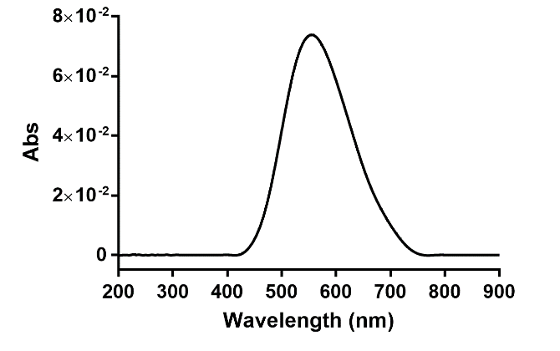
Figure S1. Background-subtracted absorption spectrum of CuLNAs. After dispersion in PBS 1X pH 7.4, CuLNAs showed the same absorption spectrum of AuNAs, supporting the versatility of the nanoplatform.
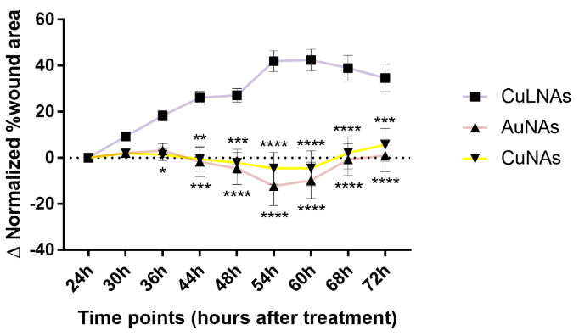
Figure S2. Difference of the normalized wound areas compared to the control. CuLNAs had a significantly better antimigration effect than AuNAs and CuNAs. Data are reported as mean ± standard error of the mean from three independent experiments performed in quadruplicate. Statistical analysis was performed against CuLNAs using Two-way ANOVA with Dunnett’s multiple comparison test, *p<0.05 **p<0.01 ***p<0.001 ****p<0.0001.
Figure S3. Cell counting assay on H4 cells after NAs application. Cell proliferation was not affected by 24h-NAs application, supporting the antimigratory effect previously recorded. A specific Macro was designed within ImageJ to count the stained nuclei, and the cell number was normalized over the control. Data are presented as mean ± standard error of the mean derived from two independent experiments performed in triplicate, then presented as number of cells normalized over the non-treated control. Statistical analysis was performed with Two-way ANOVA with Dunnett’s multiple comparison test, *p<0.05 **p<0.01 ***p<0.001 ****p<0.0001.

