Supporting Information

In vivo Combined Photoacoustic Imaging and Photothermal Treatment of HPV-negative Head and Neck Carcinoma with NIR-responsive Non-Persistent Plasmon Nano-Architectures
Valentina Frusca,^{1,2,£} Chiara Cavallini,^{3,£} Agata Zamborlin,^{1,4,#} Giuliana Drava,⁵ Virginia Barone,⁶ Lisa Gherardini,⁷ Mario Chiariello,⁷ Paolo Armanetti,^{3,§} Maria Laura Ermini,^{1,§} Luca Menichetti,^{3,§,*} Valerio Voliani,^{1,5,§,*}
¹ Center for Nanotechnology Innovation@NEST, Istituto Italiano di Tecnologia, Piazza San Silvestro 12, 56127 Pisa, Italy
² Scuola Superiore Sant’Anna, Piazza Martiri della Libertà 33, 56127 Pisa, Italy
³ Institute of Clinical Physiology, Italian National Research Council, via Giuseppe Moruzzi 1, 56124, Pisa, Italy
⁴ NEST-Scuola Normale Superiore, Piazza San Silvestro 12, 56127 Pisa, Italy
⁵ Department of Pharmacy, School of Medical and Pharmaceutical Sciences, University of Genoa, Viale Cembrano 4, 16148 Genoa, Italy
⁶ Department of Molecular and Developmental Medicine, University of Siena, Via Aldo Moro 2, 53100 Siena, Italy.
⁷ Institute of Clinical Physiology, Italian National Research Council and Core Research Laboratory (CRL), Istituto per lo Studio, la Prevenzione e la Rete Oncologica (ISPRO), Via Fiorentina 1, 53100 Siena, Italy
# Current address: Ghent Research Group on Nanomedicines, Department of Pharmaceutics, Ghent University, Ottergemsesteenweg 460, B-9000 Ghent, Belgium.
£ Contributed equally
§ Shared senior Authorship
* Corresponding Authors: luca.menichetti@ifc.cnr.it, valerio.voliani@unige.it

The section of Supporting Information incorporates Figure SI.1-8 and Table SI.1.-2, which are referenced in the manuscript and provide detailed information regarding the experimental setup and study implementation.

Figure SI.1
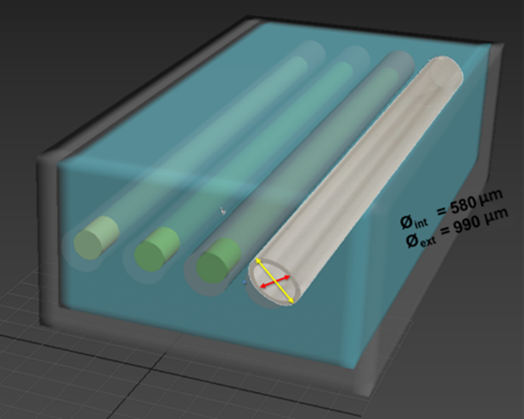
Figure SI.1: Setup used to characterize NAs-IRDye and tNAs-IRDye. The experimental setup comprised a planar array of medical-grade low-density polyethylene (LDPE) tubes immersed in a water-filled polypropylene container.

Table SI.1
 | Concentration (mg/mL) | Avg PAS  (a.u.) | Std Dev PAS  (a.u.) | CNR | SNR | %CV
NAs-IRDye | 0.2 | 0.648 | 0.021 | 29 | 31 | 3.2
tNAs-IRDye | 0.2 | 2.057 | 0.071 | 28 | 29 | 3.4

Table SI.1: NAs-IRDye and tNAs-IRDye PA characterisation in LDPE medical tubes. The table reports the average values for PA photostability (Avg PAS) measured at 800 nm and its standard deviation (Std Dev PAS), contrast-to-noise ratio (CNR), signal-to-noise ratio (SNR), and the percentage coefficient of variation (%CV).

Table SI.2
 | Concentration (mg/mL) | Avg PAS  (a.u.) | Std Dev PAS  (a.u.) | CNR | SNR | %CV
NAs-IRDye | 0.2 | 0.427 | 0.013 | 18 | 32 | 3.1
tNAs-IRDye | 0.2 | 0.4786 | 0.005 | 22 | 102 | 1.0

Table SI.2: NAs-IRDye and tNAs-IRDye PA characterisation in ex-vivo samples. The table reports the average values of PA photostability (Avg PAS) measured at 800 nm and its standard deviation (Std Dev PAS) obtained from regions injected with NAs-IRDye and tNAs-IRDye. Image quality parameters, including contrast-to-noise ratio (CNR), signal-to-noise ratio (SNR) and the coefficient of variation compared to the non-injected region of the samples, are also included.

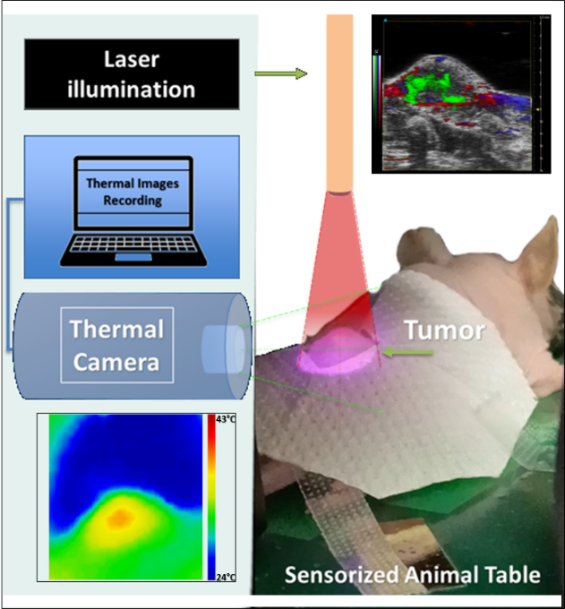
Figure SI.2

Figure SI.2: Schematization of the hyperthermic treatment setup on a reference mouse. The panel illustrates the tumor under 808 nm CW laser illumination and the geometrical placement of the laser light output and thermal camera. At the bottom left, a thermal image of the tumor heating acquired during the laser illumination (rainbow scalebar from 24°C to 43°C); at the top right, the PAUS spectral unmixed image showing the nanoparticle distribution in the tumor (grayscale for the US signal, red scale for the PA signal of oxygenated hemoglobin, blue scale for the PA signal of deoxygenated hemoglobin, green scale for the PA signal of nanoparticles).

Figure SI.3
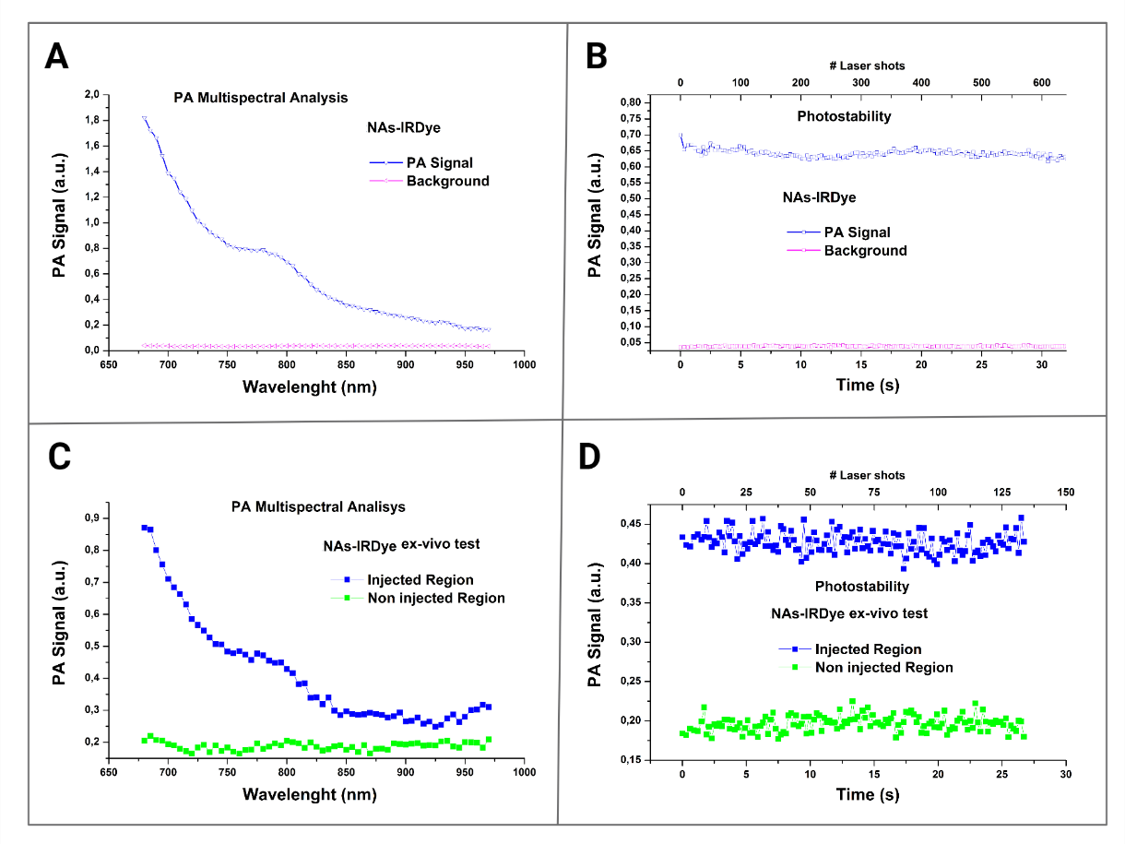
Figure SI.3. (A) PA multispectral trend and (B) photostability under prolonged 800 nm- laser illumination of a solution of NAs-IRDye at a concentration of 0.2 mg/mL in gold. (C) PA multispectral trend and (D) photostability of a 0.2 mg/mL bolus of NAs-IRDye in an ex vivo sample of chicken breast (blue dots: NAs-IRDye, green dots: non-injected region).

Figure SI.4
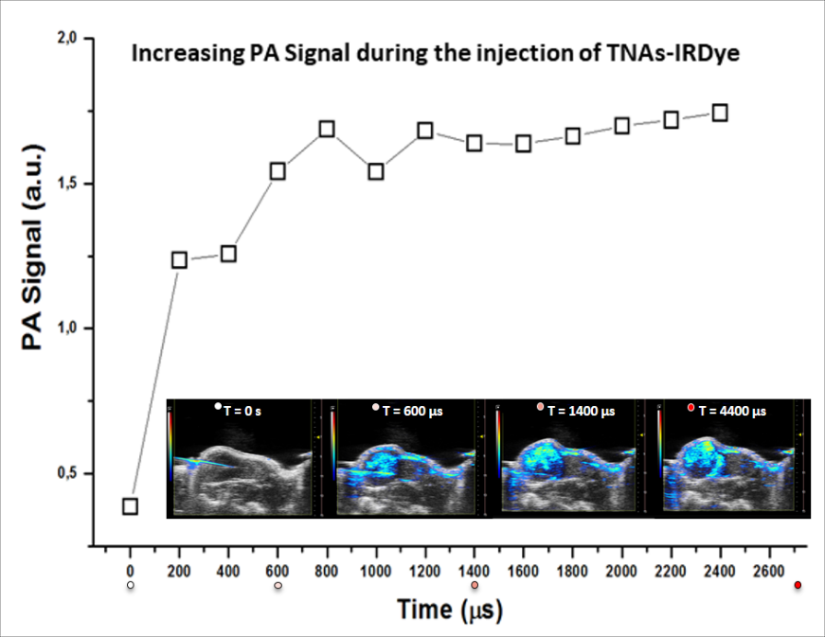
Figure SI.4: Photoacoustic signal as a function of time during the injection of tNAs-IRDye.
Inset pictures are PA images acquired at four different time points during the injection.
See also the SI Movie file 1 (PA acquisition during the injection) and the SI Movie file 2 (3D Spectral unmixing reconstruction of tNAs-IRDye distribution in the injected tumor). Greyscale and rainbow scale for US and PA signals, respectively.

SI Movie File 1
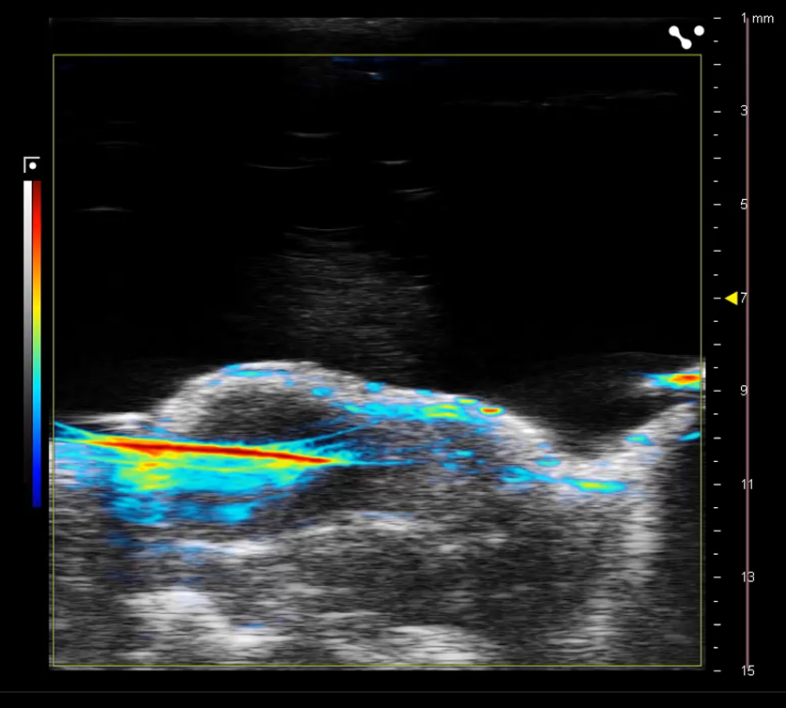
SI Movie File 1. tNAs-IRDye PA signal increase during intratumoral injection, acquired at 800 nm wavelength laser stimulation. Greyscale and rainbow scale for US and PA signals, respectively.

SI Movie File 2
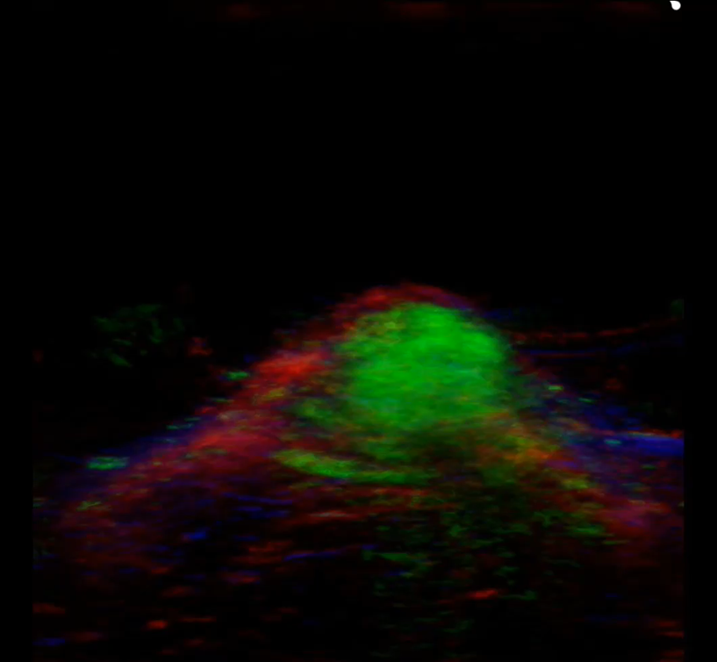
SI Movie File 2. 3D Spectral Unmixing Volume Reconstruction of tNAs-IRDye distribution in a reference tumor.
The processed 3D PA volume shows the internal distribution and recognition of the endogenous molecules of oxygenated (red) and deoxygenated (blue) hemoglobin and the tNAs-IRDye nanoparticles (green).

Figure SI.5
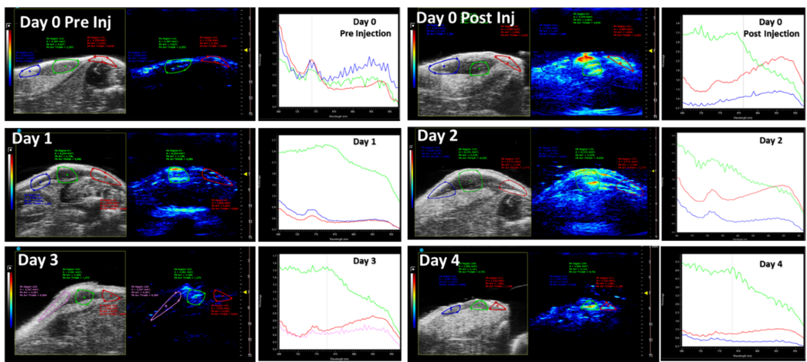
Figure SI.5: PA and US images (PAUS) in a reference tumor for the evaluation of the permanence and distribution of tNAs-IRDye in a reference tumor. The PAUS images report the central slice of the tumor monitored in the first four days after treatment, along with the PA spectral trend acquired from three different regions of interest. The first row reports the PA images pre- and post-injection of the tNAs-IRDye, while the following rows display the PA images and plots of the same section of the sample during the next four days after the laser treatment. The time sequence of the PA images indicates the presence and permanence of tNAs-IRDye at the injection site differentiating from the PA signal of oxy- and deoxy-hemoglobin.

Figure SI.6
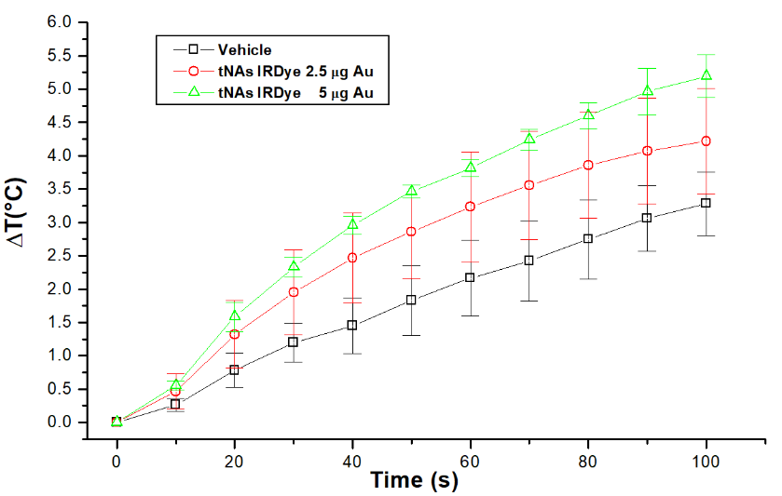
Figure SI.6: Heating curves for the tumors injected with the vehicle (black) and tumors treated with tNAs-IRDye (red: 2.5 μg in gold, green: 5 μg in gold).

