In Silico Exploration of 4(α-l-rhamnosyloxy)-benzyl isothiocyanate: A Promising Phytochemical-based Drug Discovery Approach for Combating Multi-drug Resistant Staphylococcus aureus
Soham Bhattacharya^{1#}, Adrish Dutta^{2#}, Pijush Kanti Khanra³, Neha Gupta², Ritesh Dutta⁴, Nikolay T. Tzvetkov⁵, Luigi Milella^{6*}, Maria Ponticelli^{5,6}
¹Department of Agroecology and Crop Production, Faculty of Agrobiology, Food and Natural Resources, Czech University of Life Sciences Prague, Kamýcká 129, Prague 6 – Suchdol, 165 00, Czech Republic.
²Department of Crop Sciences and Agroforestry, Faculty of Tropical AgriSciences, Czech University of Life Sciences Prague, Kamýcká 129, Suchdol, 165 00 Prague 6, Czech Republic.
³Department of Biosciences and Bioengineering, Indian Institute of Technology Guwahati, Guwahati, 39, Assam, India
⁴Environmental Biotechnology & Genomics Division, CSIR-National Environmental Engineering Research Institute (CSIR-NEERI), Nehru Marg, Nagpur 440020, India
⁵ Department of Biochemical Pharmacology & Drug Design, Institute of Molecular Biology “Roumen Tsanev”, Bulgarian Academy of Sciences (BAS), Acad. G. Bonchev Str., bl. 21, 1113 Sofia, Bulgaria
⁶Department of Science, University of Basilicata, V.le Ateneo Lucano 10, 85100 Potenza, Italy
# Authors sharing the first authorship
*Corresponding author: Luigi Milella, luigi.milella@unibas.it, Phone/fax +390971205525

Table of content

Figure S1. 3D protein-ligand interactions | 2
Table S1. Top hit interactions of GMG-ITC with proteins | 3
Table S2. Estimated K_{i HYDE} lower boundaries and LLE values for GMG-ITC with 8 targeted proteins. | 4

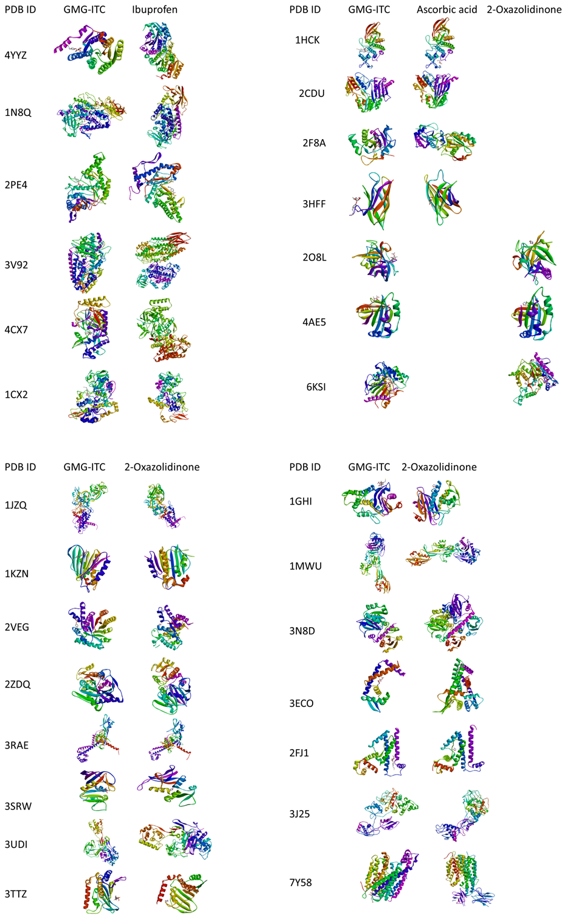
Fig. S1: 3D protein-ligand interactions of all tested compounds (GMG-ITC, and reference drugs- ibuprofen, ascorbic acid, and 2-oxazolidinone) with all targeted proteins.

Table S1. Top hit interactions of GMG-ITC with proteins.
Proteins | No. of H-bonds | H-bonds and interacting residues | No. of other total number of interactions | Other interactions and numbers | Other interaction and interacting residues
1CX2 | 2 | Asn382(2) | 6 | Attractive charge (1), Carbon hydrogen bond (2), Unfavourable Donor-Donor (1), Pi-alkyl (2) | Glu290 (1), His214 (1), His386 (1), Thr212 (2), Val291 (1)
1MWU | 3 | Arg241 (1), His293 (1), Thr165 (1) | 7 | Attractive charge (2), Carbon hydrogen bond (1), Pi-Pi T-shaped (1), Alkyl and Pi-alkyl (3) | Asp275 (2), Asp295 (1), His293 (1), Val256 (1), Val277 (2)
2CDU | 2 | Lys134 (1), Ser41 (1) | 4 | Unfavorable Donor-Donor (1), Pi-Sigma (1), Pi-Sulfur (1), Alkyl (1) | Ala300 (1), Ile160 (1), Gly158 (1), Lys134 (1)
3ECO | 0 |  | 5 | Carbon hydrogen bond (1), Unfavorable Donor-Donor (1), Pi-Pi T-shaped (1), Alkyl and Pi-alkyl (2) | Ala20 (1), Asn31 (1), His35 (1), Phe108 (2)
3J25 | 3 | Asn5 (2), Ile96 (1) | 5 | Carbon hydrogen bond (1), Unfavorable Donor-Donor (1), Pi-Sigma (1), Alkyl and Pi-alkyl (2) | Gly7 (2), Ile96 (1), Thr235 (1), Val70 (1)
3N8D | 3 | Glu16 (1), Thr23 (1), Val19 (1) | 4 | Carbon hydrogen bond (1), Pi-Sigma (1), Amide-Pi stacked (1), Pi-alkyl (1) | Met310 (2), Leu94 (2)
3SRW | 1 | Asp28 (1) | 5 | Attractive charge (1), Carbon hydrogen bond (1), Unfavourable Donor-Donor (1), Pi-Sulfur (1), Pi-alkyl (1) | Asp28 (1), His31 (1), Ile15 (1), Ser50 (1), Thr47 (1)
6KSI | 1 | Leu18 (1) | 5 | Carbon hydrogen bond (1), Pi-Pi T-shaped (2), Alkyl and Pi-alkyl (2) | His115 (1), His349 (1), Phe17 (1), Val309 (1), Val350 (1)

Table S3. Estimated K_{i HYDE} lower boundaries and LLE values for GMG-ITC with 8 targeted proteins. The K_{i HYDE} values were obtained using the best-scored docking pose of GMG-ITC within the respective biological target. The highest estimated binding affinities are highlighted in bold.
PDB ID Entry | K_{i HYDE} lower boundary (µM) | LLE ¹⁾
3SRW | 0.639 | 5.68
1CX2 | 0.635 | 5.69
1MWU | 2.769 | 5.05
2CDU | 1.089 | 5.45
3ECO | 69.83 | 3.65
3J25 | 0.852 | 5.59
3N8D | 0.293 | 6.02
6KSI | 0.458 | 5.82
¹⁾ LLE = Ligand lipophilic efficiency = pIC50 – clogP. Estimated using SeeSAR tool (www.biosolveit.de).

