In vitro electrophysiological drug testing on neuronal networks derived from human induced pluripotent stem cells

Giulia Parodi, Giorgia Zanini, Linda Collo, Roberta Impollonia, Chiara Cervetto, Monica Frega, Michela Chiappalone, and Sergio Martinoia

Supplementary Figures
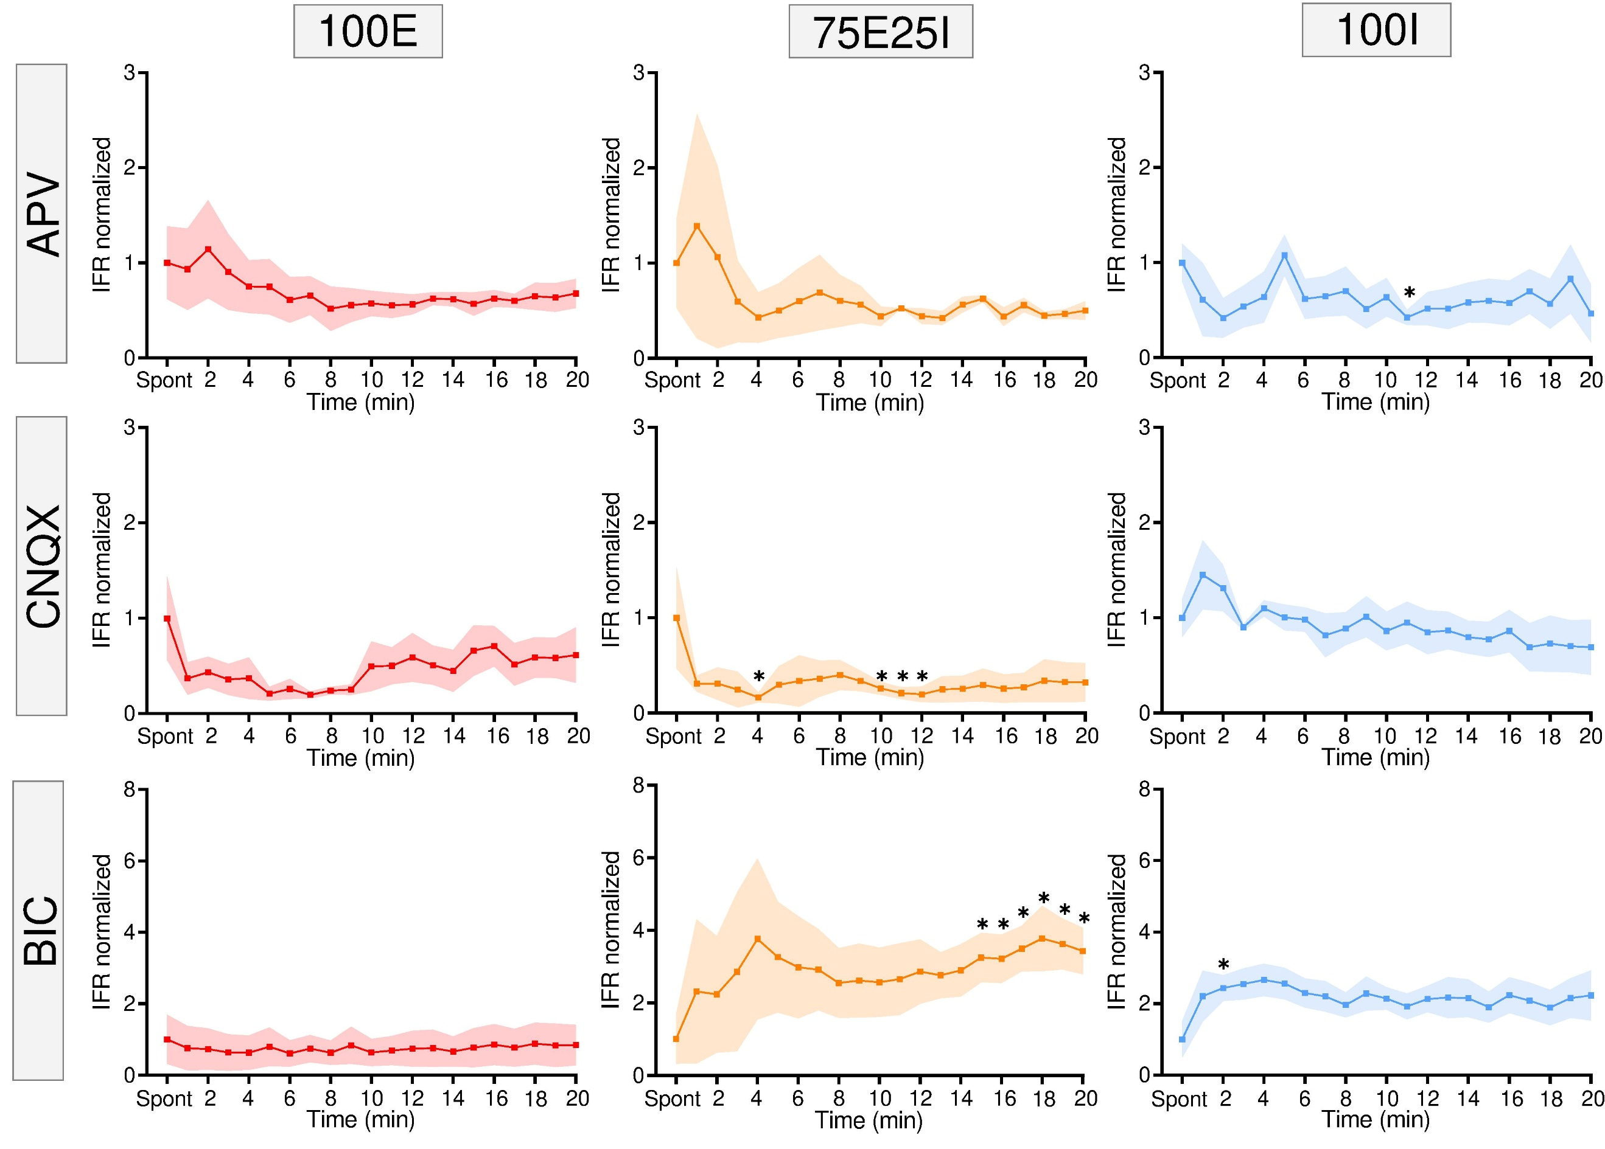
Fig. S1: Spiking activity characterization during the chemical modulation with bin size equal to 1 minute. Normalized Instantaneous Firing Rate (IFR) of 100E (red), 75E25I (orange), and 100I (blue) configurations when APV (first row), CNQX (second row), or BIC (third row) was added. The timepoint “Spont” represents the normalized firing rate computed over the 10-minutes recording of the spontaneous activity. Data are represented with the mean (dot) and the standard error of the mean (shadow) (∗ refers to p < 0.05).

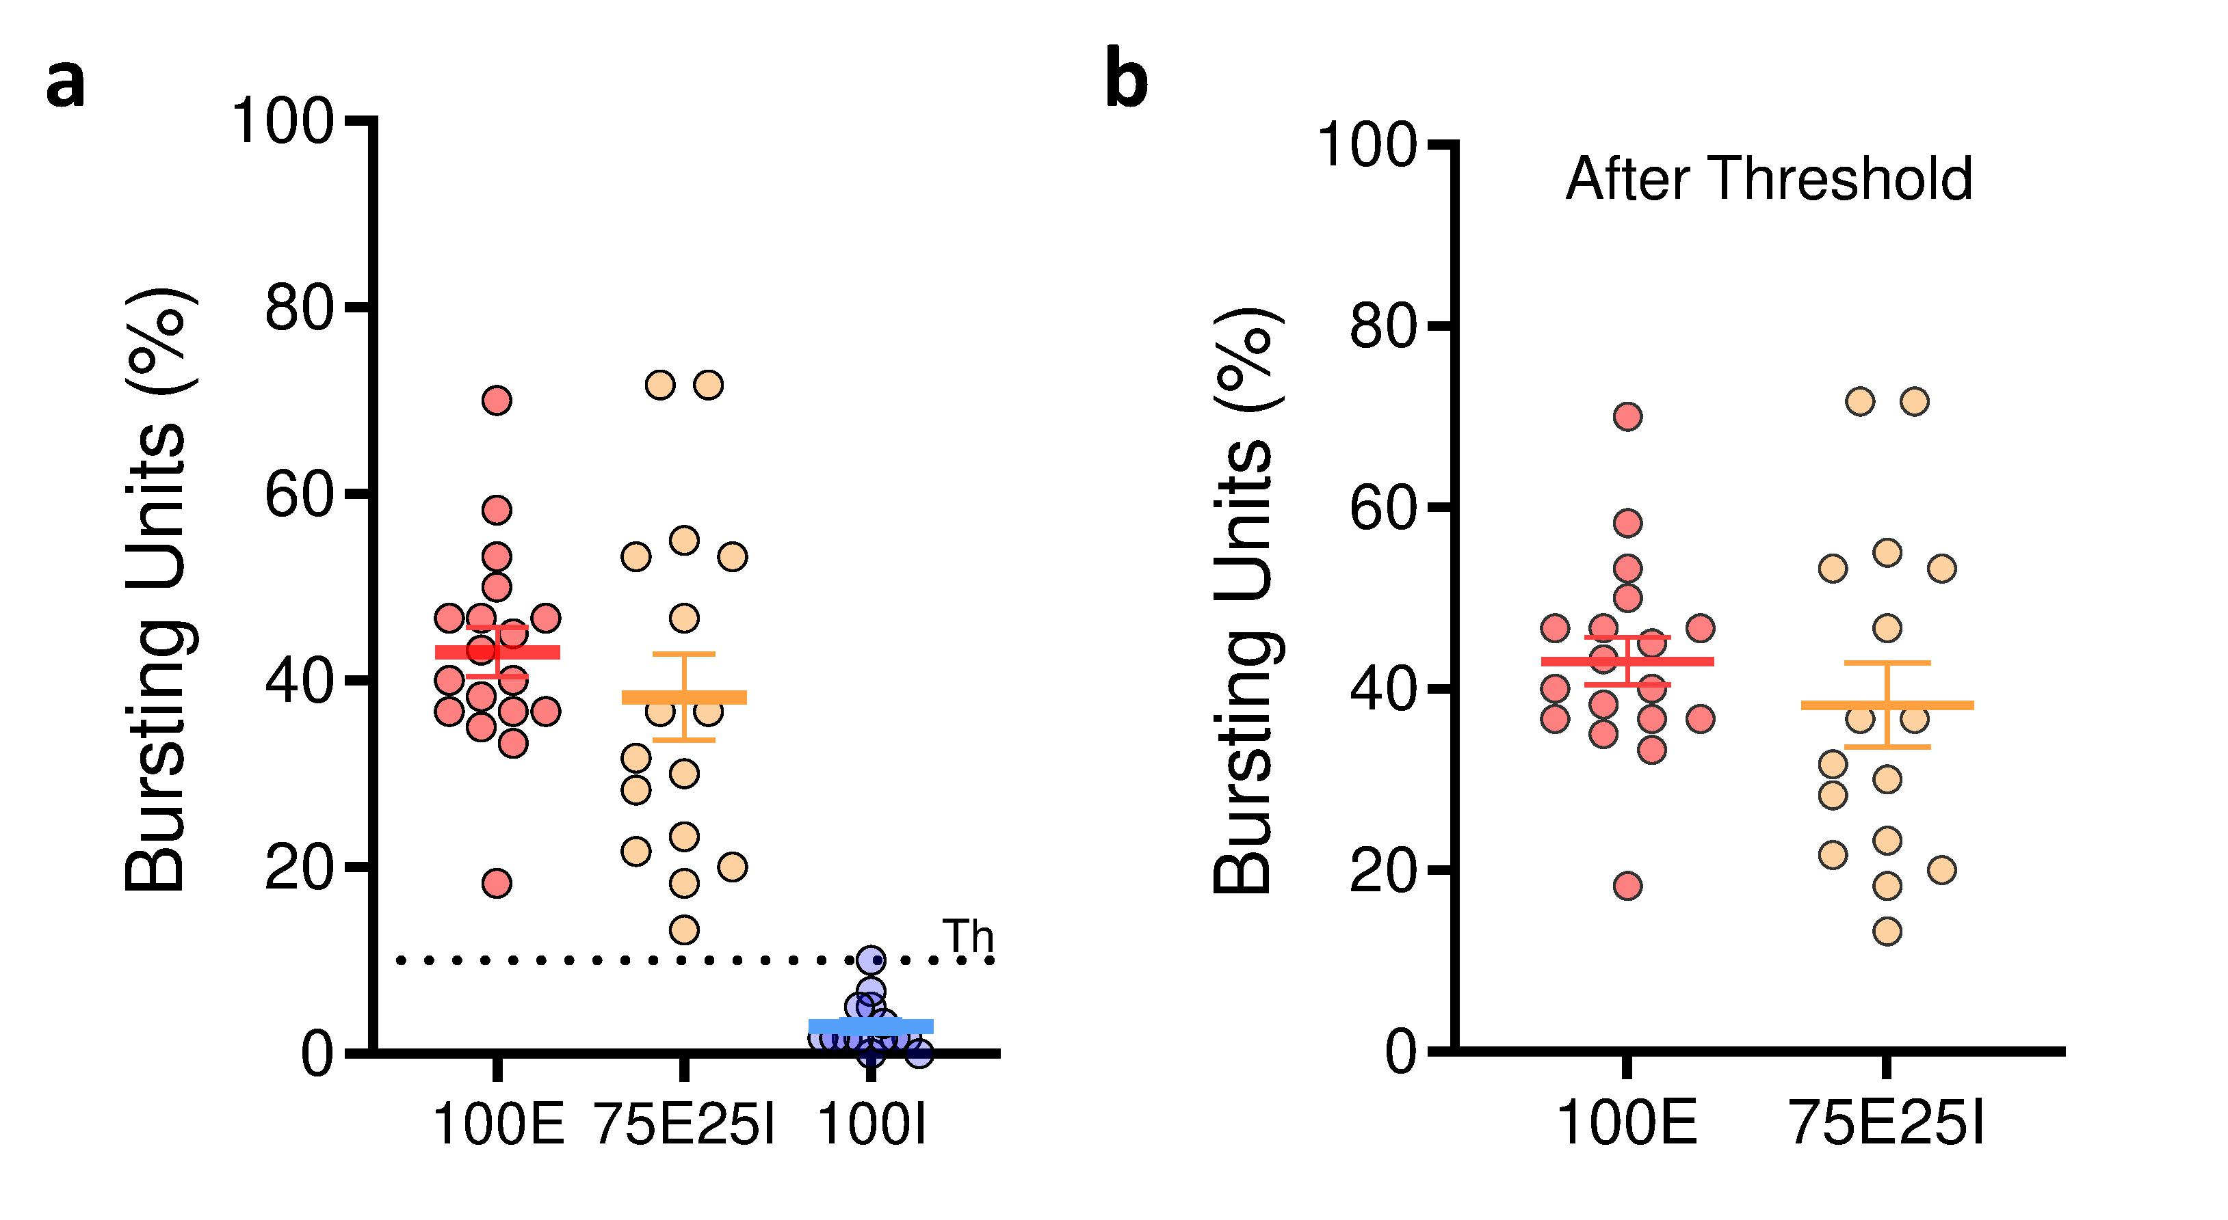
Fig. S2: Bursting units quantification. (a) Percentage of bursting units without applying any threshold. (b) Percentage of bursting units after applying a threshold equal to the 10% of active channels. Data are represented the mean (horizontal line) and the standard error of the mean (whiskers).

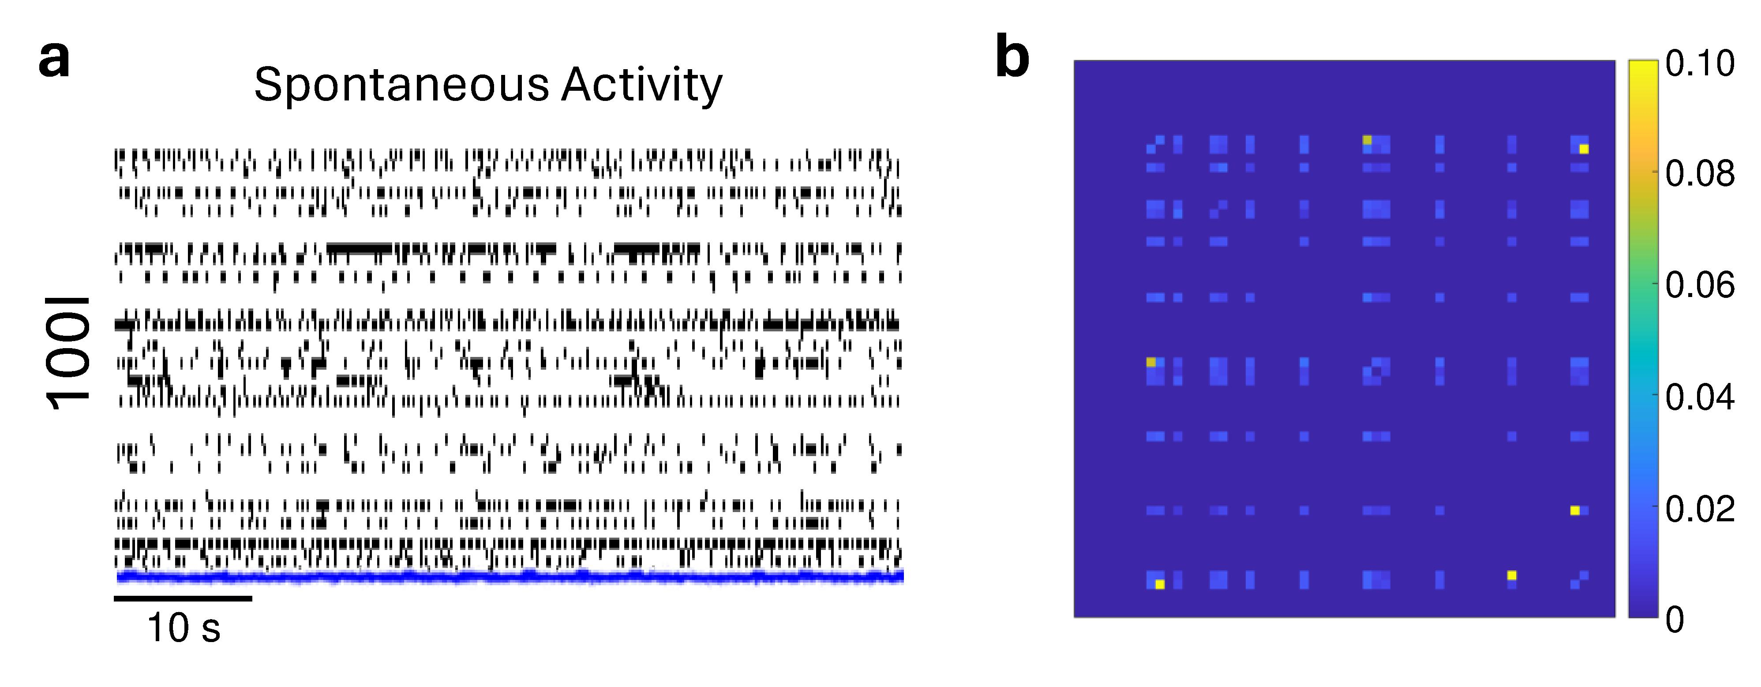
Fig. S3: Characterization of the fully inhibitory neuronal networks. (a) Raster plot and respective cumulative instantaneous firing rate profile (overlapped in blue, bin = 10 ms) of the spontaneous electrophysiological activity of a representative 100I neuronal culture. A black dot represents a detected spike. (b) Connectivity map of a representative 100I neuronal culture. In the connectivity map, the connection between two units is represented by a pixel which colour represents its strength.

Supplementary Tables
Table S2: Statistical analysis results obtained comparing the IFR of the spontaneous and the chemically evoked activity after the treatment with APV, CNQX and BIC. In the table, all the p-values are reported. Significative p-values are presented in bold.

Table S1: Normalized Instantaneous Firing Rate (IFR, mean values ± standard error of mean, bin size = 5 min) values of the neuronal networks treated with APV, CNQX and BIC for all configurations, i.e., 100E (red), 75E25I (orange), and 100I (blue).

Table S5: Normalized number of network bursting units (NB units, mean values ± standard error of mean) of the spontaneous and chemically evoked activity after 10-15 minutes from the treatment with APV, CNQX and BIC for 100E (red), and 75E25I (orange) configurations.

Table S6: Statistical analysis results obtained comparing the NB units in the spontaneous and in the chemically evoked activity after 10-15 minutes from the treatment with APV, CNQX and BIC. In the table, all the p-values are reported. Significative p-values are presented in bold.

Table S4: Statistical analysis results obtained comparing the NBR of the spontaneous and the chemically evoked activity after the treatment with APV, CNQX and BIC. In the table, all the p-values are reported. Significative p-values are presented in bold.

Table S3: Normalized Network Bursting Rate (NBR, mean values ± standard error of mean) values of the neuronal networks treated with APV, CNQX and BIC for 100E (red), and 75E25I (orange) configurations.

Table S7: On the left, Network Burst Duration (NBD, mean values ± standard error of mean) values of the spontaneous and chemically evoked activity after 10-15 minutes from the treatment with BIC for 100E (red), and 75E25I (orange) configurations. On the right, statistical analysis results obtained comparing the NBD of the spontaneous and the chemically evoked activity after 10-15 minutes from the treatment with BIC. In the table, all the p-values are reported. Significative p-values are presented in bold.

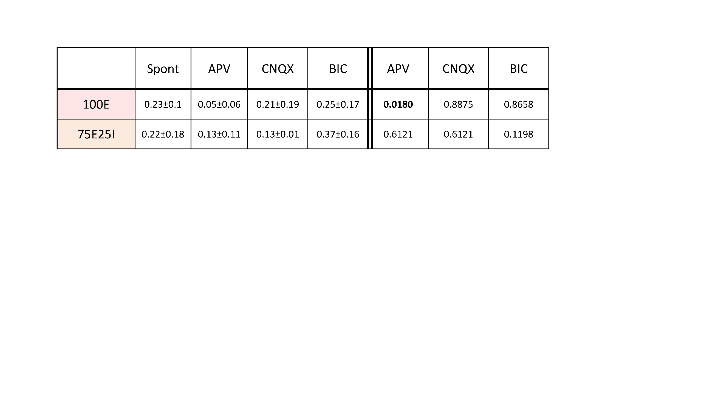
Table S8: On the left, Cpeak (mean values ± standard deviation) values of the spontaneous and chemically evoked activity after 10-15 minutes from the drug’ treatment for 100E (red), and 75E25I (orange) configurations. On the right, statistical analysis results obtained comparing the Cpeak of the spontaneous and the chemically evoked activity after 10-15 minutes after the drug' treatment. In the table, all the p-values are reported. Significative p-values are presented in bold.

Table S9: Normalized Instantaneous Firing Rate (IFR, mean values ± standard error of mean, bin size = 5 min) values of the neuronal networks treated with PTX and PTZ for all configurations, i.e., 100E (red), 75E25I (orange), and 100I (blue).

Table S13: Normalized number of network bursting units (NB units, mean values ± standard error of mean) values of the spontaneous and chemically evoked activity after 10-15 minutes from the treatment with PTX and PTZ for 100E (red), and 75E25I (orange) configurations.

Table S12: Statistical analysis results obtained comparing the NBR of the spontaneous and the chemically evoked activity after the PTX and PTZ treatment. In the table, all the p-values are reported. Significative p-values are presented in bold.

Table S11: Normalized Network Bursting Rate (NBR, mean values ± standard error of mean) values of the neuronal networks treated with PTX and PTZ for 100E (red), and 75E25I (orange) configurations.

Table S10: Statistical analysis results obtained comparing the firing rate of the spontaneous activity and the chemically evoked activity after the treatment with PTX and PTZ. In the table, all the p-values are reported. Significative p-values are presented in bold.

Table S16: Statistical analysis results obtained comparing the NBD of the spontaneous and chemically evoked activity after 10-15 minutes from PTX and PTZ treatment. In the table, all the p-values are reported. Significative p-values are presented in bold.

Table S15: Network Burst Duration (NBD, mean values ± standard error of mean) values of the spontaneous and chemically evoked activity after 10-15 minutes from the PTX and PTZ treatment for 100E (red), and 75E25I (orange) configurations.

Table S14: Statistical analysis results obtained comparing the NB units in the spontaneous and in the chemically evoked activity after 10-15 minutes from the treatment with PTX and PTZ. In the table, all the p-values are reported. Significative p-values are presented in bold.

