Intermodal nodes and external costs: re-thinking the current network organisation

Ambrosino Daniela - Department of Economics, University of Genoa (ambrosin@economia.unige.it)
Ferrari Claudio – Department of Economics, University of Genoa (ferrari@economia.unige.it)
Sciomachen Anna - Department of Economics, University of Genoa (asciomachen@gmail.com)
Tei Alessio - Department of Economics, University of Genoa (tei@economia.unige.it)

Abstract
Modern ports are part of intermodal and international networks and have great effects at regional level, influencing both the efficiency of the local markets and the external costs of the served industries. Several studies underline how modern ports need to be inserted in an efficient network system in order to exploit all their potential. Moreover, concerning the role of the ports within the whole supply chain, a key element is the location and the organization of intermediate facilities – such as logistic parks or inland ports – that heavily affect the effectiveness of the logistic corridors. The accuracy in designing a logistic system can have a great impact on the externalities created by transportation. New and adequate infrastructures can reduce congestions, pollution and accidents.
The proposed study evaluates different potential locations of inland ports that might serve a market through different transport alternatives, in terms of transport modes, costs and distances. Further, the present study has the additional goal of including the external costs in the decision process. For this scope, a mathematical programming model with both continuous and binary decision variables is given. The required parameters and the constraints of the problem are shown together with real data concerning the Italian north-western regions. Thanks to the proposed model, different intermodal freight logistic networks are compared; in particular, a sensitivity analysis on both the rail capacity and external costs is performed. Note that the outcomes can be used for improving current transport policies that might foster a more efficient and less impacting hinterland transport solution.

Keywords: Intermodal Transport; Cost Internalization; External Cost

- Introduction
International transports are based on complex networks of services that involve a plurality of actors and transport solutions in order to make possible an efficient connection between globalised origins and destinations (e.g. Meersman et al, 2009). For these reasons, all possible connections between a port and its own hinterland represent strategic links able to foster the port efficiency and its competitiveness (e.g. Tongzon, 2009). Several evidences show how well connected hinterlands might increase port competitiveness (e.g. Ferrari et al., 2011) and how the organisation of intermodal transport – that efficiently uses either logistic parks or inland ports – might enlarge port catchment areas (e.g. Notteboom and Rodrigue, 2008).
Moreover, the connections between a port and its hinterland are not just important for efficiency reasons but also for the overall costs due to different transport solutions (e.g. Arnold et al., 2004; Iannone, 2012), accounting not only for direct private costs but also for external ones. Starting from Pigou (1932), external costs of any economic activity gain importance due to the divergence between the perceived “private” costs of a specific economic behaviour and the real overall costs, that in many cases include external costs, such as the enrivonmental ones. In the maritime academic literature this issue has been seldomly studied until the ‘90s when it became one of the major concerns in the maritime science (e.g. Lakshmanan 2001; Meersman et al., 1998); in particular, many studies tried to evaluate the discrepancy between the private perceived costs of a specific transport solution and its actual cost for the society. Estimations varied over the time due to the difficulties in clearly evaluating external effects and their range of impact (e.g. Maibach et al., 2008). Despite this, external costs have recently been deeply studied, also under many EU projects, aiming, for instance, at assuring their internalization (e.g. eurovignette); however, only few studies try to link external costs to the optimization of intermodal transport solutions (e.g. Janic, 2007; Arnold et al., 2004).
In the recent literature, many studies focus on the effective flow distribution in a determined hinterland (e.g. Racunica et al. 2004; Notteboom and Rodrigue, 2008; Ambrosino and Sciomachen, 2012) together with the problem of internalizing the transport costs (e.g. Grosso, 2011) and the effects of recent EU transport policies on both the cost internalization and its effects of the transport patterns (e.g. Ferrari and Tei, 2012). Nevertheless, at the best of our knowledge only few studies analyse the most effective flow distribution in a given port hinterland (e.g. Iannone, 2012), taking into account not only the transportation costs but also the external ones. The present paper tries to fill this gap. A mathematical programming model has been developped for designing a distribution netwok, in which inland ports have to be located on a specific hinterland and the optimal distribution flow has to be defined; two competing transport modes are considered, namely rail, road that can be also combined generating an intermodal transport. The location and flow distribution decisions are taken with the aim of minimizing the overall distribution costs, which are given by tranportation and externality costs and those associated with the inland ports. A real case scenario, referring to the North Western Italian regions, has been analysed; the data used have been provided by the Italian National Customs for Ligurian ports (i.e. Genoa, La Spezia and Savona) at 2011 (the last full available year). Moreover, infrastructural data have been collected for being able to draw the network analysed by the proposed model; more precisely, the whole highway and railway networks of the Italian regions under study have been considered. Finally, threee candidate inland ports have been analysed to choose the best ones for defining the distribution network, as it will be described in the following sections. Concerning the definition of inland port, in this study we refer to a facility characterised by “a rail (or a barge) terminal that is linked to a maritime terminal with regular inland transport services” having an intermodal terminal within its boundaries, as defined by Rodrigue et al. (2013).
The paper is structured as follows. After this introduction, Section 2 focuses on the regional and port characteristics of the considered area, while Section 3 is dedicated to the model description. Section 4 presents the results applied to the porposed case study and discusses them also performing a sensitivity analisysis on the optimal solution. Finally, Section 5 addresses conclusions and provides insights for future research developments.

- Regional framework
Freight distribution in Italy is mainly based on an extensive use of the road transport and this mode is also dominant for the volume of cargo generated by the domestic seaports (e.g. Consulta Nazionale per l’Autotrasporto e la Logistica, 2011). The statistics produced by the European Environmental Agency (EEA, 2015; EEA, 2008) as well as several relevant literature (e.g. Iannone, 2012) together with the last National Logistics Plan (Consulta Nazionale per l’Autotrasporto e la Logistica, 2011) highligth how such an unbalanced modal split is deeply impacting on the environment due to the dominant role of the road transport (e.g. according to Pastori [2015] less than 10% of the cargo hanlded by the port of Genoa is shipped by rail). This issue has been deeply analyzed and several local and national projects are trying to deal with the externalities generated by trucks (e.g. De Martino et al., 2013). While modal shift policies are often based on incentives to make modal alternatives more convenient – as for the Ecobonus that in Italy characterises the Motorways of the Sea (e.g. Tei and Ferrari, 2012) – less attention has been paid on policies able to internalize external costs. This issue is mainly linked to the poor political consensus given by these latter policies and the fact that they are harder to apply. Nevertheless, the definition of the most efficient transport solution – considering the overall generated costs – is essential in order to minimize the overall transportation costs (i.e. private plus external ones).
Concerning the cost internalization, Maibach et al. (2008) underlined how the road transport would become much more expensive when the external costs are considered along with the private ones. Among the main external costs, the “Handbook on estimation of external costs in the transport sector” (Maibach et al., 2008) takes into consideration three main components: pollution (atmospheric and noise related one), risk (e.g. increasing probability to have an accident) and congestion. Other specific external costs have been also considered in the handbook but not all of them can be easily adapted to all different European contexts or transport solutions, as for the climate change effects.
It is important to underline that external costs not only relate to “environmental” aspects but also to some side effects that can have a great impact also on the network efficiency. Among these aspects, the main one is the congestion, that can heavily affect the efficiency of the transportation system. For this reason, many authors (e.g. Janic, 2007) underline how external costs internalization might positively impact on the rationalization of the flows, also incentivising the use of intermodality due to a better mix among the transport solutions.
2.1 The collected data
This study starts with the analysis of the freight distribution of three of the major Italian ports, that is Genoa, La Spezia and Savona. In fact, Ligurian ports accounted in 2014 for about 35% of the Italian container traffic – being the greatest gateway port region in Italy – and for more than 18% of the overall Italian port throughput (Assoporti, 2015). Port hinterlands are quite similar even if specific regions concentrate a great share of the three ports’ activity, as shown in Figure 1 in which NUTS-3 regions are used as basic geographical unit to map the distribution flow structure. In particular, Figure 1 shows the import distribution of the containerised cargo, as it is used in the proposed analysis. The import flow of containerised cargo is used in the present study for two main reasons: first, containerised cargo is the only one, in Italy, that is currently able to be competitive using both the rail and the road transport solutions (even if with different level of performance); second, it seems easier to aggregate the import flows for the rail transport given the aggregation point (i.e. the seaport) with respect to the export flows that might not be directly be consolidated in their origin (i.e. ports, as well as inland ports, can be used to aggregate flows coming from the same point and going to close destinations but different considerations should be added if this initial aggregation is not possible).

Figure 1: Containerised import distribution (port-NUTS3 flows)
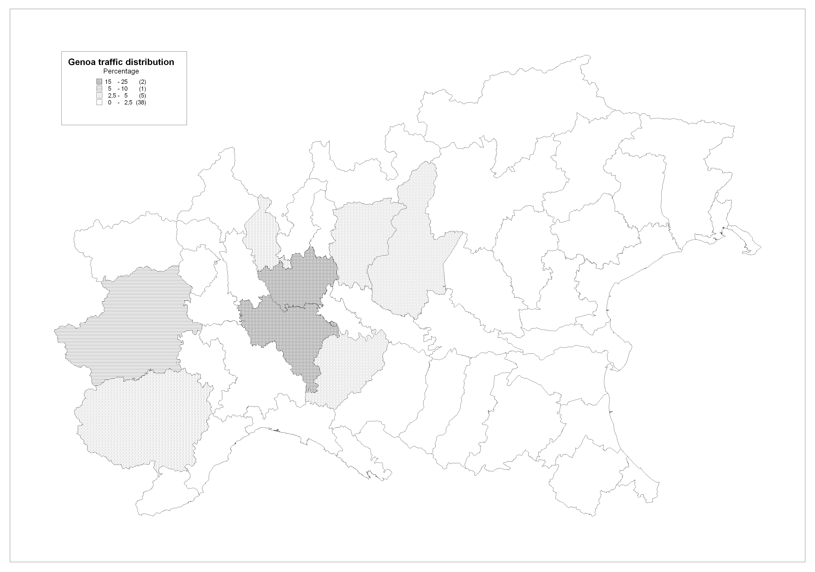
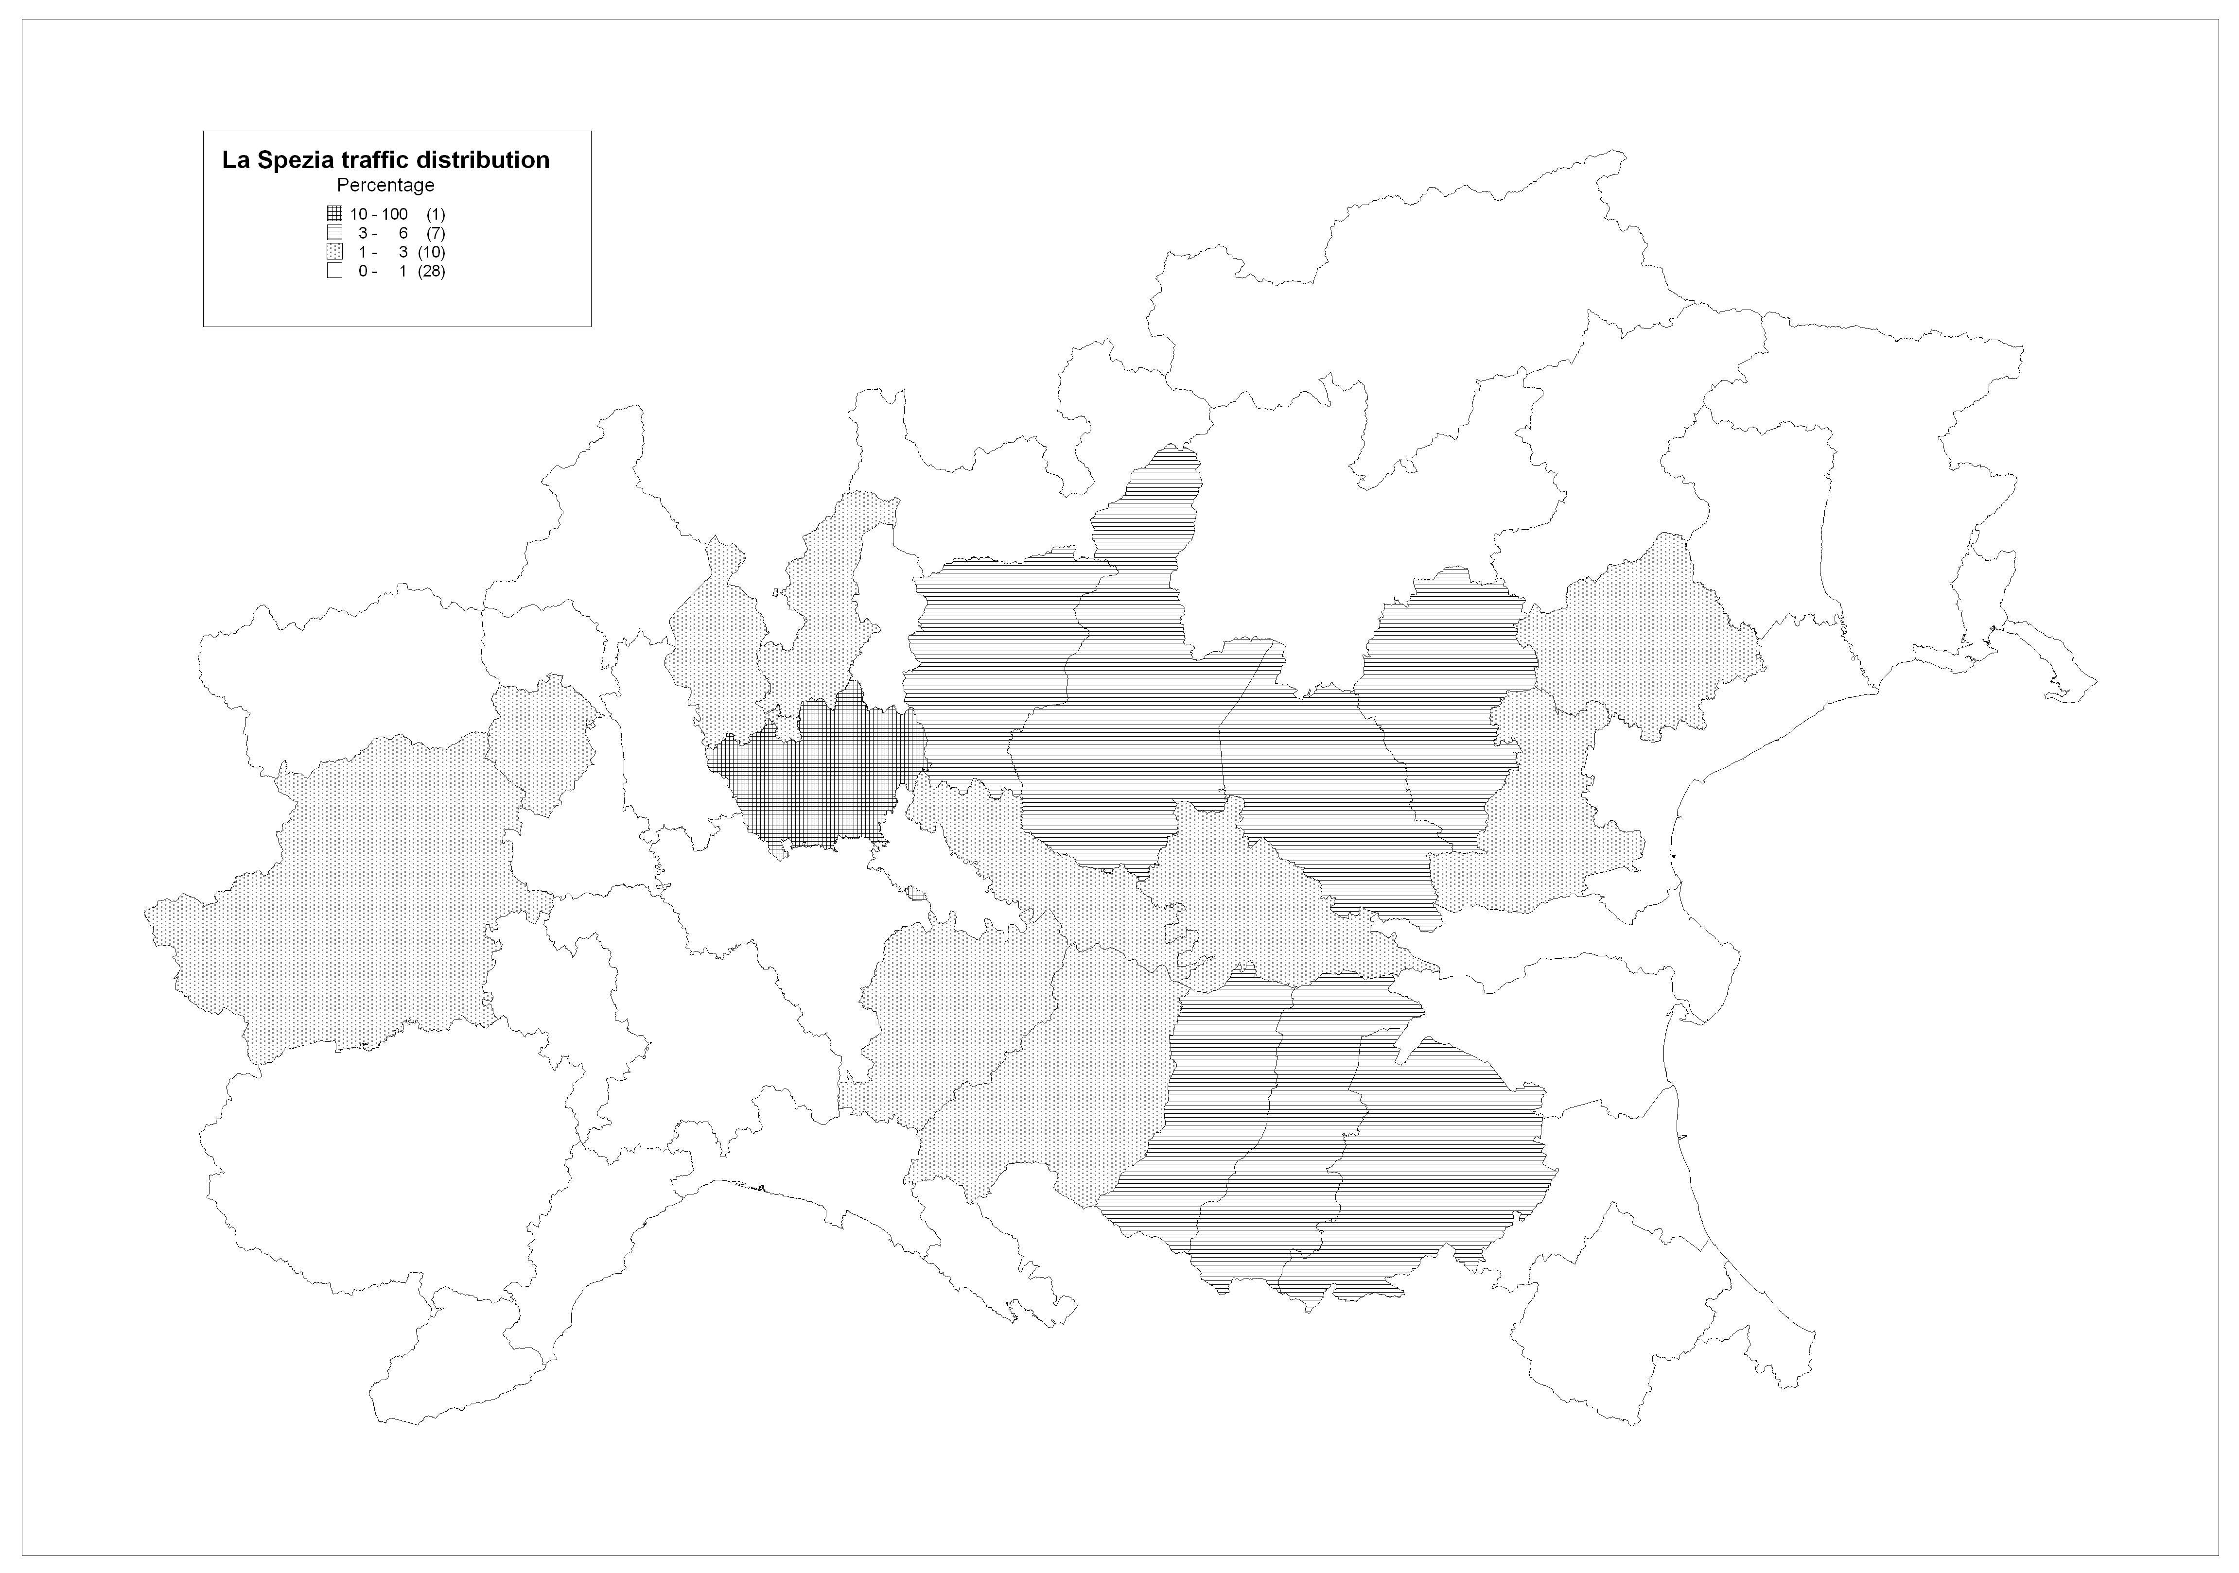
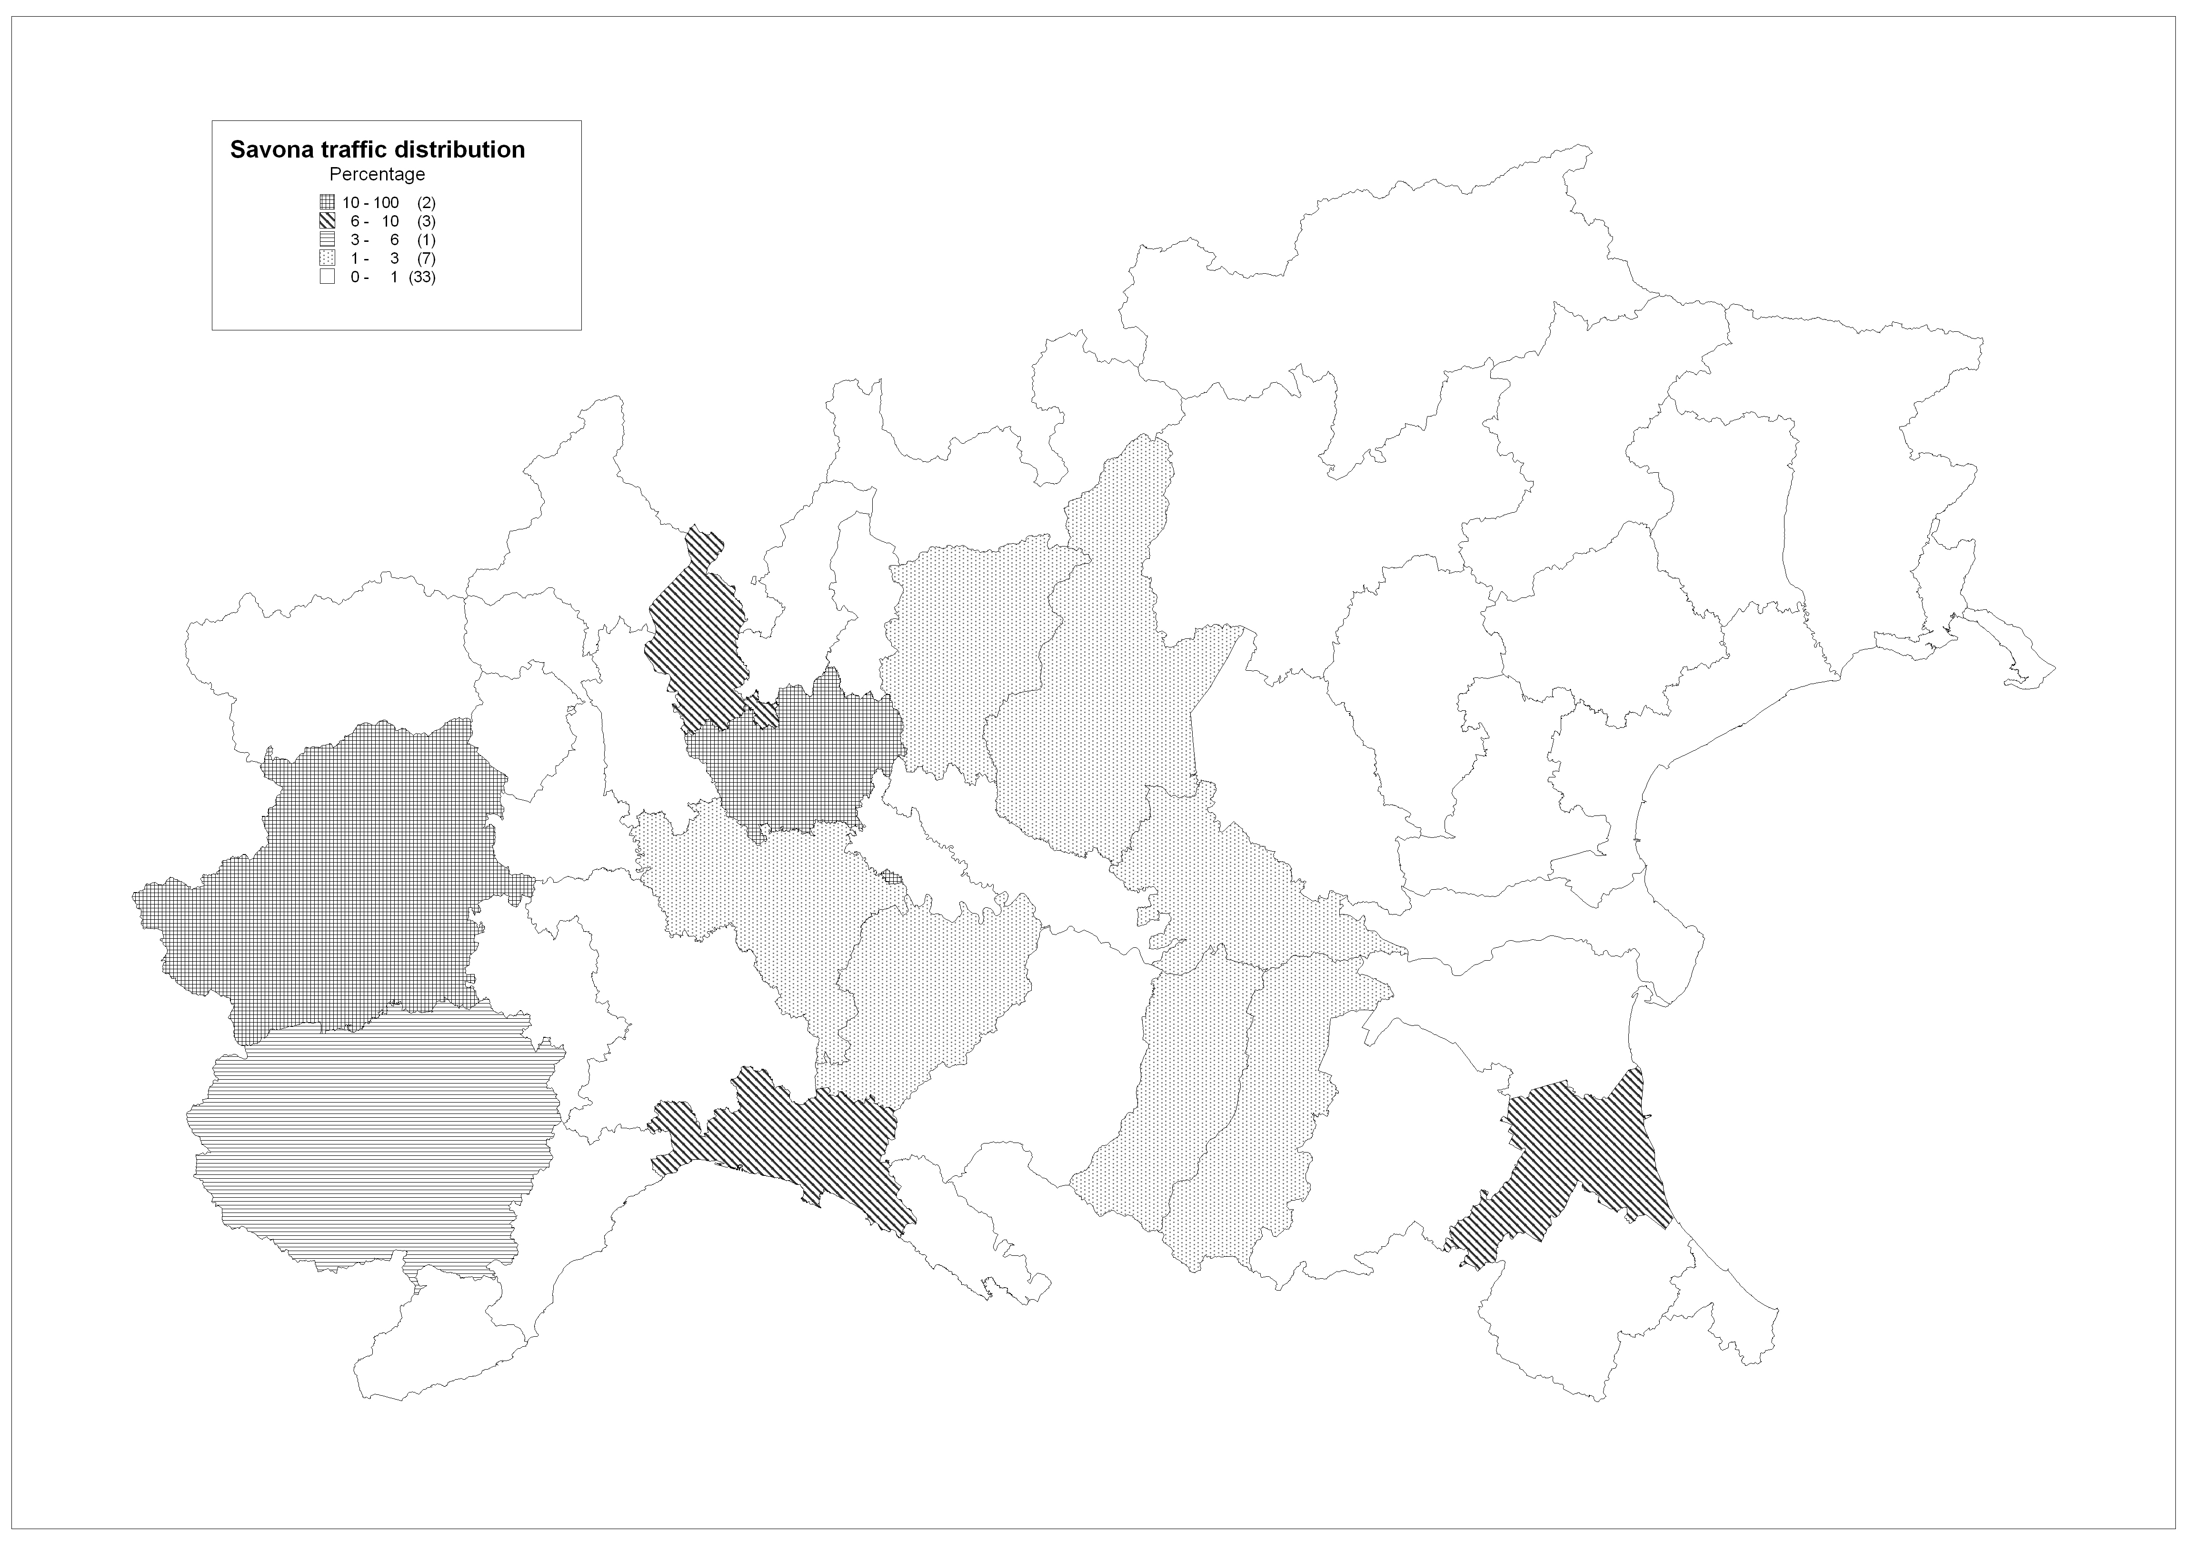
Source: Own elaboration form Customs Database, 2012.

Considering the 2011 spatial distribution of the import containerised cargoes handled by the three Ligurian ports, it is important to underline a substantial overlapping in the catchment areas between the ports of Savona and Genoa – basically corresponding to Piedmont (in particular Turin and Cuneo) and Lombardy (in particular Milan) regions, while La Spezia seems to be more focused on cargoes directed to the Emilia-Romagna region. Despite the geographical concentration of some of the traffic, another peculiarity of the considered ports is the wide range of the catchment area. For instance, the smallest studied container port (i.e. Savona) attracts cargos from the Venice region despite the presence of closer ports specialised in container activity, such as Venice and Trieste.
Moreover, all the studied ports have several plans to expand their container activities thanks to new terminals; therefore, it is crucial to study the possibility of using the rail network for the cargo distribution.
As said, the strict majority of the freight is currently delivered by road (according to Pastori [2015] and the related port authorities’ statistics, road solution account for more than 90% in Genoa and Savona, more than 80% in La Spezia) while only two inland ports are presently active; one inland port is located in the Alessandria Province and receives flows from the port of Genoa, while the second one is in Milan and is mainly used by La Spezia. Several plans can be found in the port websites discussing the possibility of using other inland ports in order to serve other markets or to enlarge the railway activity.
Considering the network data about infrastructural constraints and distances, official statistics have been used in order to collect all the needed information from official databases published by the Ligurian Region (i.e. Regional Logistics Plan) and by the infrastructure managers (i.e. Rete Ferroviaria Italiana for railways and Autostrade per l’Italia for the motorways). Thus, considering the collected data, the road and rail networks have been built: as underlined by the Regional Logistics Plan (Regione Liguria, 2010), the main hinterland connections are represented by three main inter-regional links (Genoa-Milan/Turin; Savona-Turin; La Spezia-Parma; La Spezia-Leghorn) and an intra-regional one (Ventimiglia-La Spezia) that allow to easily reach the main destinations using both motorways and railways. Motorway and railway networks use similar origin-destination trajectories, but the rail infrastructures are characterised by several technical constraints that are currently increasing the costs of moving freight by rail. In particular, the constraints are related to the slope of the rail tunnels, the presence of only one track in some of the mixed freight/pax rail trunks, and the gabarit of tunnels. These limitations affect the costs of the rail operations in three ways: reducing the length of the trains and thus their capacity; increasing the number of locomotives needed to overcome steepest rail trunk and diminishing the number of possible daily trains together with the time schedule. For instance, only concerning the Ligurian rail network, the maximum number of daily trains varies from a minimum of 60 to a maximum of 180 trains per track (considering also the passenger ones).
On the other hand, the motorways do not present similar constraints, even if bottlecknesses are quite frequent on the highways, with the number of lanes varying depending on the specific highway (and impacting on the overall capacity). Moreover, in all three ports some of the freight truck movements involve the city centre area, impacting on the urban congestion level.
As far as the costs are considered in order to evaluate possible distribution patterns, several studies have been used in order to find the main cost components. Table 1 resumes the main sources used for the present study. Note that the distibution patterns differ for: i) the network distribution with or without inland ports; ii) the import flows for the three transport modes (road, rail and intermodal).

Table 1: Sources used in the paper
Data | Collected Data | Source | Data used in the model
Traffic Flows | Official Data | Italian National Custom Agency | Node-to-node flows (TEU)
Road Network Characteristics | Official Data | Autostrade per l’Italia | Node-to-node distance (km)
Rail Network Characteristics | Official Data | Rete Ferroviaria Italiana | Node-to-node distance (km)
Road Transport Costs | Official Data | Italian Ministry of Transport | 1.6€ TEU/km
Rail Transport Costs | Estimation from the literature review, validated through rail operator interview | Baumgartner, 2001; Grosso, 2011 | 1,96€ TEU/km [avg.]
Inland Costs | Estimation from the an interview, validated through literature review | ? | Handling and Activation Costs
External Transport Costs | Estimation from the official EU report and related updates | Handbook on estimation of external costs in the transport sector (yy 2008-2014) | Noise (), Congestion () and Pollution ()

For the private cost component, official documentation has been used; for the road transport we referred to the official minimum tariffs set by the Italian Ministry of Transport. For the year 2011, tarrifs vary with respect to the distances and the kind of truck from about a minimum of 1.3 €/km to a maximum of 1.9€/km (Italian Ministry of Transport, 2011); consequently, an average value of about 1.6 € for TEU/km has been used in this study. Since there are not official data related to the rail transport costs, different values have been compared through a literature review (e.g. Baumgartner, 2001; Grosso, 2011) and validated by an interview with a rail company. The estimation led us to an average value of about 1.96 € TEU/km, but with high variations depending on constraints and distances (costs are actually estimated using an average cost value per train). Considering the infrastructure, in the present study also the cost associated with the inland ports are considered; in particular, activation costs and handling ones have been included. The handling costs represent the operative costs, which are also usefull in order to simulate the transhipment cost. These costs have been derived from a direct interview to a manager of an inland port operating in the North of Italy. Activation costs represent the cost to invest in a inland port and to open it. In order to
2.2 The external costs
As external costs to be included in the analysis, noise, pollution and congestion costs are considered. As suggested by the Handbooks on Estimation of External Costs in the Transport Sector (e.g. Maibach et al., 2008), the estimation of such kind of costs is not easy and it depends on the particular characteristics of the surrounding environment ( e.g. urban or rural areas), of the vehicle (e.g. EURO policy for road vehicles) and of the infrastructure (e.g. motorways or urban roads). Moreover, some of the related costs might depend on the average travelling speed and on other travel elements. The abovementioned characteristics affect the correct value that should be considered for any external costs evaluation. Given the characteristics of analysis – that focus on distribution paths within a macro-region – and the fact that the majority of the distribution trips is usually made by similar vehicles (Consulta Nazionale per l’Autotrasporto e la Logistica, 2011), in not urban areas and using motorways, average external costs have been used following the abovementioned trip characteristics. For this reason – and according to Maibach (2008) – an average value of 32 €/km is used for computing the congestion costs to be paid for the road flows leaving the ports. The average value used for the road pollution is 5 €/km, while for the rail, it is estimated about 42 €/km for train (2.3 €/km/teu) Finally, the average value used for the road noise is 1,5 €/km, while for the rail is 3.5 €/km. All these values have been applied to the actual transport flows generated by the ports in relation to the particular travel path. Since ports are the only urban areas that are taken into consideration, for the part of the path that uses the urban network (about an average of 1km), urban values has been considered.
- The proposed model
The evaluation of different distribution solutions, in which some inland ports can be activated and used in an existing multimodal network, is here performed thanks to a mathematical programming model that, as already said, has been implemented by the spreadsheet Excel. In this section the model is described. Note that the present model represents an extension of the one proposed in Ambrosino and Sciomachen (2014) for solving an intermodal hub location problem.
The here given model permits to define the optimal flow distribution that minimizes the overall costs described in the previous section while defining the optimal location of inland ports in the intermodaldistribution network. It differs from the location allocation models proposed in the recent leterature for…..
The main aim of the present analysis is to understand the effect of different distribution systems on both modal split and costs and, thanks to the spreadsheet Excel, to analyse the impact of variations in the external costs on both the flow modal split and the location decisions.
The multimodal distribution network under investigation is represented by a weight digraph G=(V,E). V is the set of nodes; it is split into 4 subsets, namely:
- the seaports (V_{O}), representing the origin nodes of the flows in G;
- the destination nodes (V_{D}), i.e. the demand nodes of G;
- the candidate nodes (V_{H}), representing the possible sites where to locate/activate an inland port in G;
- the transition nodes (V_{T} ), necessary for being able to represent all the possible paths of the flow in the network and, consequently, computing the externality costs as function of the flow in G.
E is the set of oriented arcs representing connections between nodes of V; in particular, E = , where set E_{m} represents the arcs traveled in G using the m-th transportation modality, m ∈ M.
M is the set of transport modalities. In this paper, |M| = 2 and set E is split into 2 subsets:
1) E_{T}, representing the road connections;
2) E_{W} , representing the railway connections.
Before presenting the mathematical formulation for the problem under consideration, let us introduce the required additional notation.
Constants
Nodes’ weight
Cf_{h} fixed cost for locating an inland port at node h,∀ h∈V_{H}
Cv_{h} unit handling cost at inland port h, ∀ h∈V_{H}
K_{h} maximum handling capacity of inland port h,∀ h∈V_{H}
Q^{m}_{h} in/out capacity of inland port h related to transport modality m,∀ h∈V_{H}, ∀ m ∈ M
Ce_{i} congestion cost paid for unit of road outflow from node i,∀ i∈V_{O}
d_{ij} flow demand from node i to node j, ∀ i∈V_{O} , ∀j∈V_{D}
Arcs’ weight
c^{m}_{ij} transportation cost of arc (i,j) for transport modality m, ∀(i,j)∈ E_{m}, ∀m∈M
cp^{m}_{ij} pollution cost of arc (i,j) for transport modality m, ∀(i,j)∈ E_{m}, ∀m∈M
cn^{m}_{ij} noise cost of arc (i,j) for transport modality m, ∀(i,j)∈ E_{m}, ∀m∈M
q^{m}_{ij} flow capacity of arc (i,j) for transport modality m, ∀(i,j)∈ E_{m}, ∀m∈M

Thus, having in mind the distribution network described above, in the definition of the best distribution solution it is possible to decide:
- the number of inland ports to locate/activate and their location, by choosing among the candidate nodes (V_{H}) (network design problem)
- the transportation modes and the paths to use for shipping the required volume of goods from the origin nodes (V_{O}) to the destination ones (V_{D}) (flow optimization problem).
The following variables are then defined:
flow variables:
x^{m}_{ij} ≥ 0 flow on arc (i,j) with transport modality m, ∀(i,j)∈ E_{m}, ∀m∈M
x_{h} ≥ 0 flow managed by node h, ∀ h∈ V_{H}
x^{T-}_{i} ≥ 0 road outflow from node i, ∀ i∈ V_{O}
inland port location variables:
y_{h} ∈{0,1}, ∀ h∈ V_{H}, indicate which inland ports are chosen; in particular, y_{h} =1 if node h is chosen, y_{h} = 0 otherwise.

The objective function of the proposed model is devoted to the minimization of different costs components:
- inland opening and operative costs
- transportation costs
- externalities costs
Note that, activation and handling costs are associated with each candidate node (V_{H}). This cost depends on both the size and the handling capacity of the candidate inland port. External costs are included in the analysis in order to make externalities part of the decision making process of transport users; pollution and noise costs are proportional to the flow on the arcs of the network, while congestion costs are proportional to the raod flow leaving ports.
The sets of constraints of the proposed model are the following and are useful for:
- Defining variables related to the in /out flows:
is computed as the sum of the flows entering and leaving the inland port h with any transport modality m

is computed as the sum of the road flows leaving node i.

- Satisfying o-d demands
The total flow leaving origin node i must be equal to the sum of the o-d demands having node i as origin node.

The total flow entering destination node j must be equal to the sum of the o-d demands having node j as destination node.

- Satisfying capacity constraints on arcs
The flow passing through arc (i,j) by transport modality m can not be greater than the flow capacity of the arc.

- Satisfying capacity constraints on nodes:
in/out flow capacity of inland ports for road and rail modality
The total in and out flow by transport modality m must be lower than the given capacity of the inland port.

The total flow entering and leaving inland port h must be not greater than the handling capacity of the inland port (no flow can enter/leave the node if the inland port is closed, i.e. y_{h} = 0).

- Flow conservation constraints:
At transition nodes
The flow entering a transition node i by modality m must also leave that node by the same modality.
At inland ports
The total flow entering an inland port must also leave it (but the modality may be changed)

In the next section the results obtained by solving the proposed model by spreadsheet Excal are discussed.

- The case study results
In the network under investigation there are 73 rail arcs and 85 road arcs; the number of nodes is 53, split into 3 ports, 3 candidate inland ports, 13 destinations and 34 transition nodes. The total import flow transferred to the 13 destination nodes is equal to 431,811 TEUs; such flow corresponds to the volume of containers moved by the three ports in 2011 and transferred to the studied hinterland.
Firstly, the model proposed in the previous section and implemented by the spreadsheet has been used for defining how to transfer goods from the three origin seaports to the destination nodes in order to minimize the total costs in different scenarios: a first scenario without inland ports, a second one with three operative inland ports, and, finally a last scenario in which the number of inland ports to activate is a decision to take. Referring to the first two scenario the model is used only to define the optimal flows in the existing network, while in the last case the model is used for defining the best distribution network (i.e. a network design problem is solved) (see sub-section 4.1).
Secondly, the spreadsheet has been used for performing a sensitive analysis with the aim of understanding the variation in the modal split and in the costs composition (i.e. transportation costs, external costs and inland costs) when varying the rail capacity of both the port outflows and the inland ports (see sub-section 4.2).
Finally, the spreadsheet has been used for evaluating the robustness of the model when varying external costs; the effects on both the location of inland ports and the modal split, and on the costs composition is analysed (see sub-section 4.3).

4.1 Analysis of the optimal solution and other scenarios
Since one of the main scope of the paper is to investigate the impact of the internalization of congestion, noise and pollution costs in the decision process, in Table 2 different solutions obtained by solving the model presented in section 3 are compared in terms of split flows among road and rail transport modes. Different external costs are included in the analysis: 6 cases are considered, they differ for the external cost internalized (i.e. cases 1 – 6 in Table 2 - costs included in the analysis: inland ports costs (IC), transportation costs (TC) and external costs (EC) with their components congestion (Ce), pollution and noise for road transport and, finally, pollution and noise for rail transport (cp, cn)).
Table 2 reports the optimal solutions of the three scenarios described above (e.g. no inland ports, 3 inland ports, optimal number (Y*) of inland ports). For each scenario in Table 2 are shown the cost composition (% IC - % TC - % EC) and the modal split of the flows of the network. In particular, the modal split is detailed for the out-flow from seaports (OUT-F-O), in-flow at inland ports (IN-F-I), the out-flow from inland ports (OUT-F-I), and the in-flow at destination nodes (IN-F-D).
Table 2: optimal solution of 3 scenarios solved by considering 6 different degrees of internalization of EC
When no inland ports are present in the network, the rail flow is conditioned by the rail capacity of seaports. The presence of external costs (even the presence of only one type of these costs, i.e. congestion costs) modifies the modal split of the out flow from seaports (OUT-F-O) in favour of rail transport until rail capacity is saturated (i.e. 20,28%). Note that from case 2 to case 6, the flows on the network are unchanged.
When the network is organized with 3 inland ports the out-flow from seaports is again conditioned by the rail capacity, but the presence of intermodal inland ports permits to obtain a modal split with higher percentage of rail in the in-flows at destination nodes (IN-F-D). In case of external costs paid only on the road modality this percentage becomes 33.69% (cases 3 and 4) with an intermodal flow on the network equal to 13.41% due to a flow entering the intermodal inland ports by road and leaving by rail (IN-F-I and OUT-F-I). In cases 5 and 6, in which the external costs are also paid on rail transport, the modal split is different. The change of modality at inland ports regards the 12.87% of the total flow of the network and the rail flow at the destination nodes is 33.15%; these values are lower than the percentages obtained in cases 3 and 4. Anyway, cases 5 and 6 seem to be the more adequate for solving this problem.
In the graphs a), b) and c) reported in Figure XYZ it is possible to note the behaviour of the modal split of the flows at the origin nodes, at the destination nodes and at inland ports when varying the types of external costs included in the decision process (from case 1 to 6). The considered scenario is that with 3 operative inland ports. Looking at graph c) it is possible to note that the presence of the only congestion costs in the decision process has no effect on the flows at inland ports, while pollution and noise seem to be the key factor for affecting the intermodal flows.
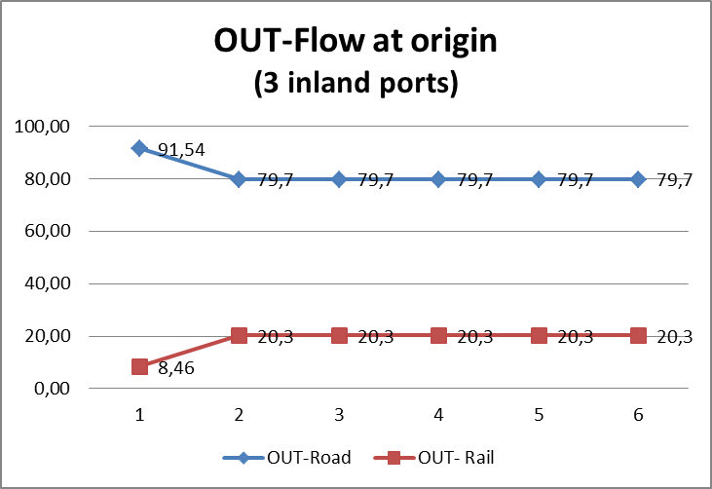 | 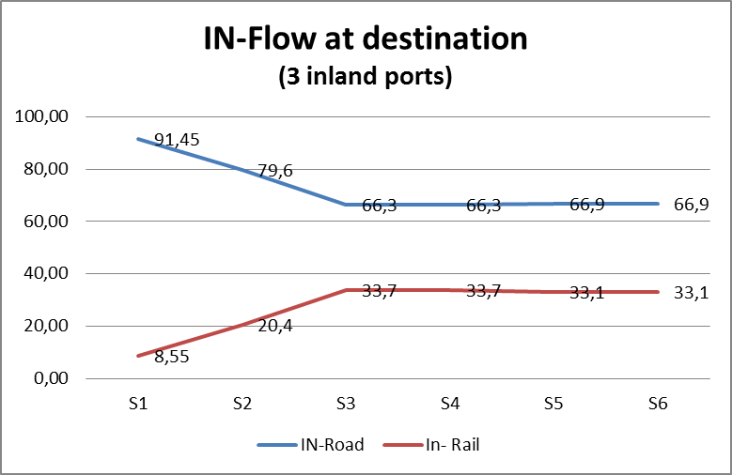
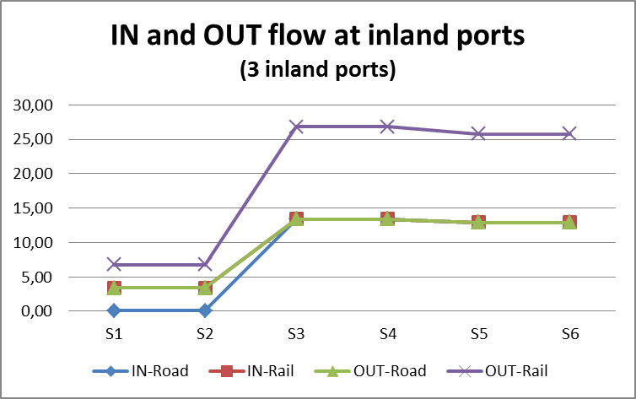
Figure XYZ:
The last rows of Table 2 refer to the optimal network obtained by solving the model in such a way to define the optimal number of inland port to activate (Y*). When the external costs are either not included or only related to congestion costs (cases 1 and 2) the optimal network is without inland ports (e.g. Y*=0). The situation is different when external costs refer only to road transport. In cases 3 and 4 the optimal network presents two inland ports (Y* =2) that are able to increase the rail flows and consequentially to reduce the EC of the system. Finally, in cases 5 and 6 the optimal solutions present only one inland port is activated (Y* =1). The graphs a) and b) in Figure YY show the different modal split in the six cases at the origin and at the destination nodes.
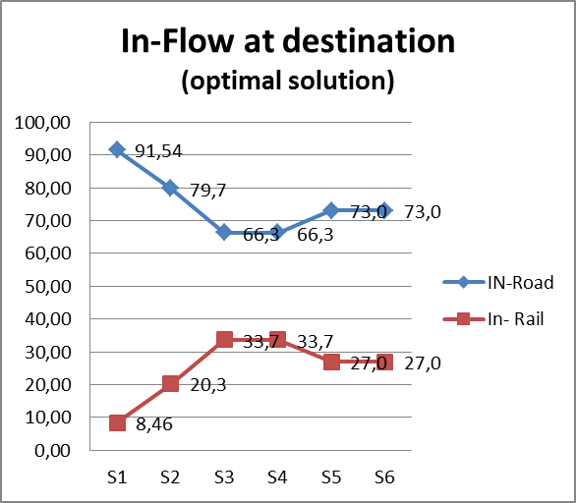 | 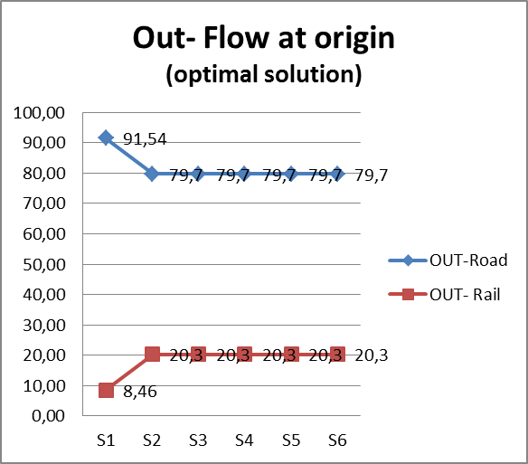
Figure YY
The behaviour of the modal split of the out-flows at the origin nodes obtained by solving the network design model (scenario 3) is equal to that observed in graph a of Figure XYZ. For what concerns the in-flow at destination nodes, by looking at graph a) of Figure YY it is clear the effect of a greater internalization of external costs on the modal split.
In the graph of Figure XY a comparison of the in-flow modal split at destination nodes in the three considered scenarios is reported. The analysis is done when all types of external costs are included in the decision process (case 6). The graph shows the road and the rail flow reaching the destination nodes of the network and the intermodal flow passing through the activated inland ports. Moreover, for scenarios 1 and 2, the percentage cost deviation with respect to the total cost of the optimal solution with only one inland port is also reported. The solution with 3 inland ports permits to obtain a greater split in favour of the rail transport but it is worse than the solution with one inland port only of 0.5% , that in absolute term represents about 3.5 million of euros.

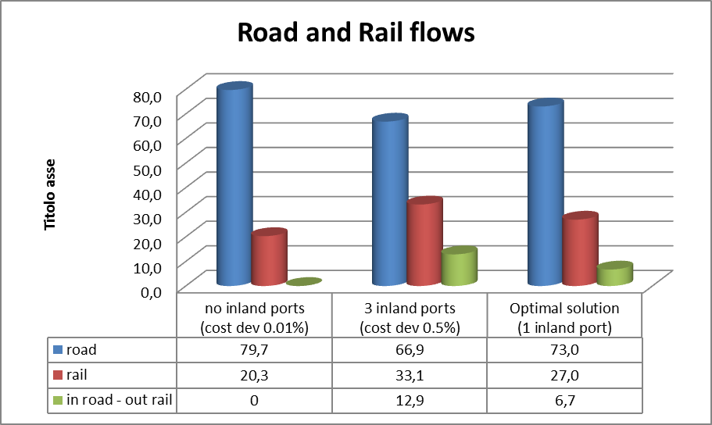
FIG XY

Case 6 is here analysed in more detail. In the optimal solution of the network design and flow problem one inland node is chosen; it is located in Milan. Readers can easily note that all the flow entering the inland port by road modality leaves it by rail; this implies that the 6.7% of the flow uses the intermodal transport modality. The modal split at the destination nodes is 73.02% by road and 26.98% by train. The corresponding optimal flows are depicted in Figure AC in which the first map shows the rail quota of port cargo shipped by train per province while the second map showed the improvement guarantee by the internalization of external costs.

Figure AC – comparison between solutions with and without external costs
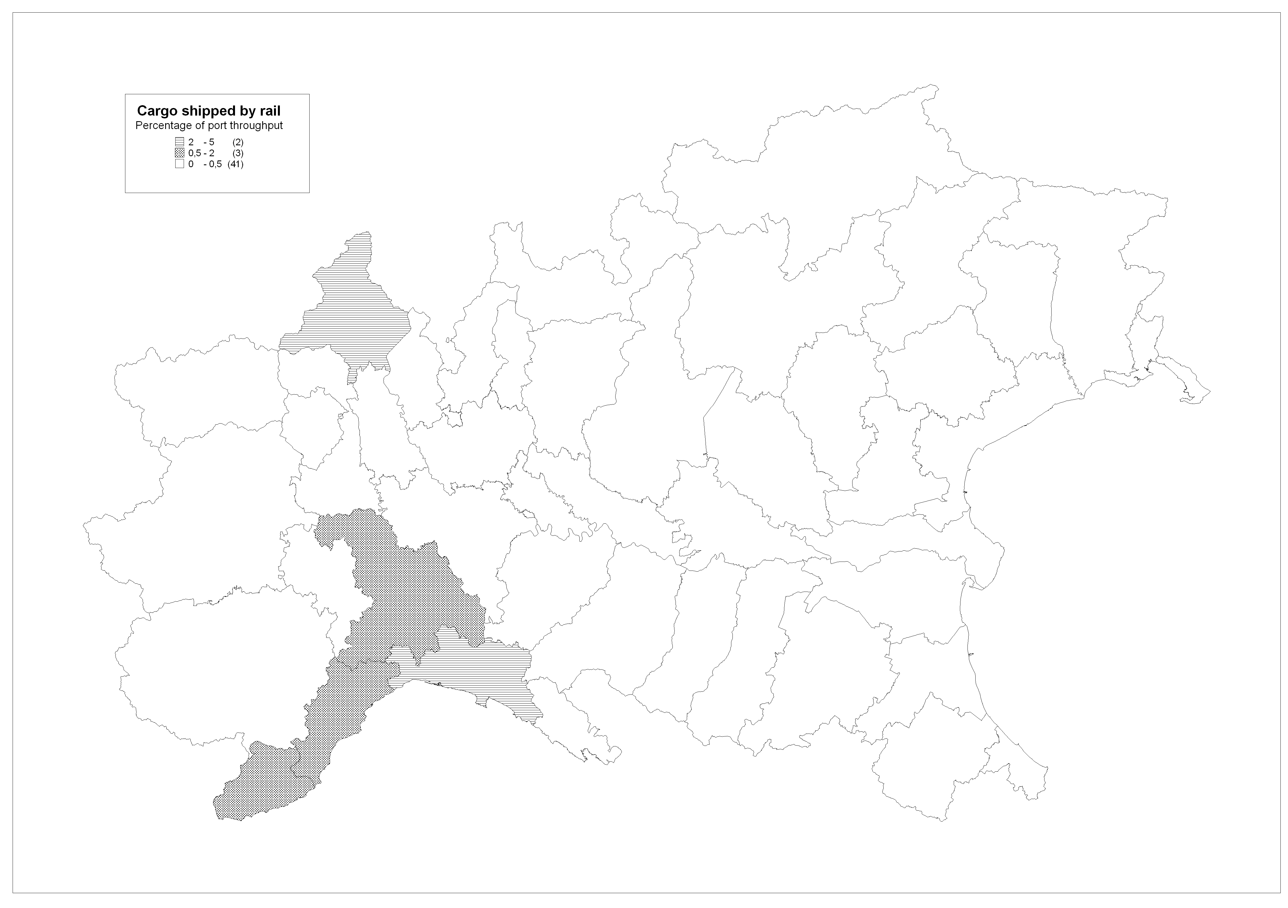
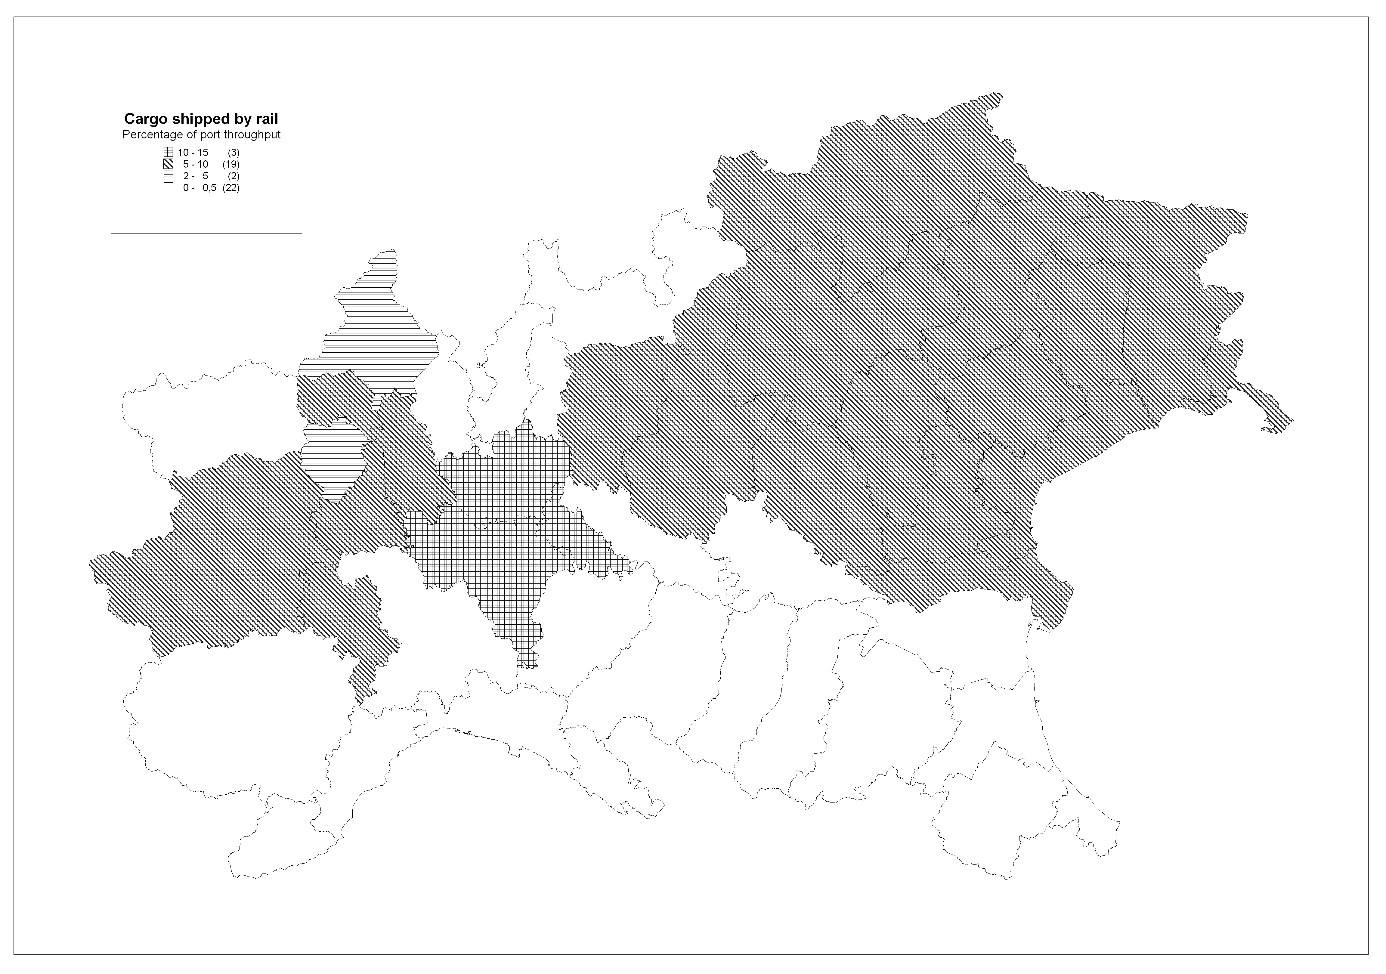

The costs related to the optimal solution are reported in Table 3.
Table 3: Optimal solution
Activation costs
Handling costs
Total inland costs
Transportation costs | Road
 | Rail
Total transportation costs
External costs | Road
 | Rail
 | Congestion at the ports
Total external costs
Total costs in the system |  |  | 100%
The main aim of this analysis is to understand if it is possible to obtain a better modal split in favour of the train modality.
Considering the results, it is worth noting that without the external costs the model depicts a situation quite similar to the real case; the inland ports can facilitate the intermodal transport even if they are not effective in balancing the distribution of goods between the rail and road modes. Moreover, since the model doesn’t consider the impact of the value added services made within the logistic parks, inland ports act merely as transit points and so they only contribute to the rationalization of the transport flows.
Moreover, the rail outbound flows from the ports reach the maximum capacity level at all three ports, creating a bottleneck in the rail branch connecting Genoa to the Po Valley (which is a rail track used also by the trains originated in La Spezia and Savona), thus limiting possible further use of the rail network. This situation also explains why most of the inbound flows to the inland ports come from the road transport, while the outbound flows mainly use the rail transport. in fact, the external costs heavily impact on the roads such that the rail connections are chosen whenever are possible.(vale per casi 3 e 4). Further, the introduction of inland ports allows to partially overpass the present infrastructural limitations and to increase the rail quota even generating new trains. This finding can be considered strategic for future transport policies; in fact, many North Italian inland ports are currently operating just as urban distribution centres. In this scenario, only few trains are organized to serve some Italian Provinces and normally cargoes just enter by train but are successively distributed by road.
Eventually, it is interesting to underline how the location of different inland ports impact in several ways on the model solutions. Just to give an idea, Turin, which is located on the West side of the port hinterland, has no impact on the distribution of the cargo flows when the external costs are neglected and a reduced effect when they are considered. On the other hand, Alessandria and, mainly, Milan have a pivotal role in the network and their impact is strategic when the external costs are considered. Despite the rail infrastructure limitations behind the port, the inland ports seem to have a strategic role in promoting intermodal transport enhancing the potential benefit of the internalization of the external costs.
In terms of modal split, the best opportunity for increasing the usage of the rail modality is represented by the scenarios in which Milan is selected as inland port.

4.2 Sensitive Analysis on the rail capacity
From the results described in the previous section, the crucial points of the network seem to be the inflow/outflow rail capacity of the inland ports and the outflow rail capacity of the ports. Thus, an analysis by varying the rail capacity has been performed by using the optimization model presented in section 3. This analysis focuses on case 6 (i.e. with external costs for congestion, pollution and noise). The rail capacity has been incremented at different values in such a way to verify the impact on both the modal split and the total costs and their partition among transportation, externalities and inland port costs.
By doubling rail capacity at sea ports the rail flow at destination increases from 26.98% to 36.37%, while when triplicating this capacity the rail flow reaches the higher value of 49.78%. Finally, by increasing (triplicating) the rail capacity at inland ports it is possible to increment these percentages until more than 60%. In this last case, the variation in the total cost of the network is about 5.29%, while by only doubling the rail capacity at sea ports this variation is about 1.77%; note that external costs are the cost component having a greater reduction among the different cost items.

4.3 Sensitive Analysis on the external costs
The last analysis here reported concernes a further investigation on external costs related to case 6. The main aim of the analysis is to understand for which levels of external costs the optimal solution, obtained by solving the model presented in section 3, changes. The optimal solution of case 6 is caractherized by one inland port atcivated in Milan and a modal split that is 73.02 road and 26.98 at destination, with an intermodal flow of 6.71%.
This solution remain the optimal one until the external costs decreases of 10%. At this level of EC a new optimal solution is found. This solution is caractherized by an inland port opened in Alessandria, while Milan is not activated; the modal split remains nearly the same. Moreover, by reducing the EC of 15% the solution changes again: the rail modality results lower and noone inland port is activated.
When considering a growth in the EC, the solution of case 6 remains the optimal one until the increase of external costs reaches the 5%. At this level a new optimal solution, caratherized by 2 operative inland ports, is found. The rail modality is used for more than 33% and intermodal flows exceed the 12% . Another variation in the solution is obtained when the increase of external costs reaches 55%. In this case the solution found is equal to the optimal solution of case 6: one opend inland port in Milan. It is interesting to underline that this switch in the optimal solution is mainly due to the fact that an increase of externl costs does not have any effect if the infrastructure and facility capacity is not upgraded consequently. In fact, the +55% scenario has a negative effect in comparison with lighter increase of paid external costs (e.g. +5%) since, without an upgrade of the rail facilities and infrastructure, flows will choose the shortest path, reducing also the attractiveness of the intermodal transport that has to be served by inland ports that could increase the overall path length.
The above described results are reported in Figure ZZZZ. In the graph of Figure ZZZZ are also reported some information about the cost deviation of the different solutions found from the cost of the optimal solution of case 6. It is importatnt to note that this deviation is computed on the transportation and inland ports costs, without including external costs, for obtaining comparable data.
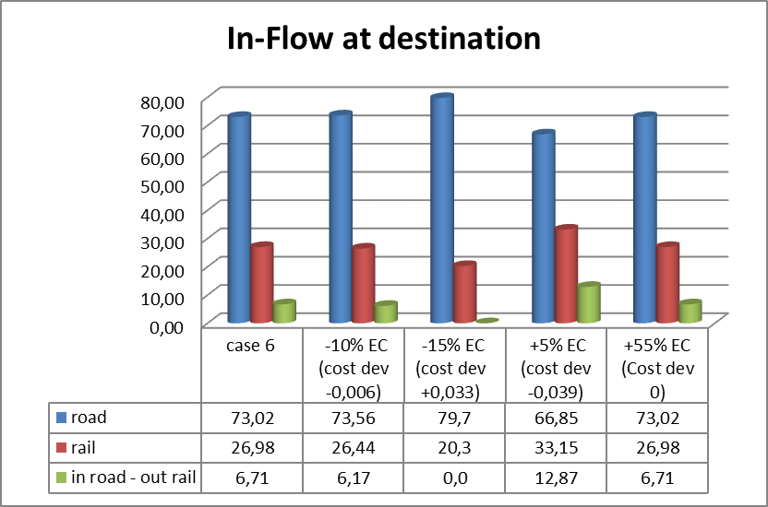
Figure ZZZZ

- Conclusion DA FARE
As introduced above, the link between optimal flow distribution among competing transport solutions and external costs may induce an optimization of the intermodal transport thanks to the location of logistic parks able to rationalize and optimize the distribution of goods per transport mode. The proposed original model might bind these two issues in order to solve several problems.
In fact, the described model shows promising provisional results able to (i) promote new intermodal connections in the North of Italy, thanks to the rationalization of logistics hubs spread in the North of Italy, and (ii) foster internalization policies thanks to possible advantages related to the increasing transport distribution efficiency.
The results shown in section 4 underline how the internalization of external costs might foster a more balanced modal split between rail and road transport: in normal conditions the containerised goods moved by road cover more than 90% of the transport share but the internalization of external costs would drastically change this situation more than doubling the TEUs shipped by train. Despite these positive effects, the proposed model highlighted how infrastructural limitations in some rail trunk might limit the positive effects of the internalization of external cost due to the rapid achievement of the current maximum capacity. The use of a system of inland ports located in the North Italian regions might – at least partially – copes this infrastructural gap, increasing the rail share up to 55%. Thus the increasing efficiency of the flow distribution given by inland ports seems to be strategic in order to foster a more balanced modal split.
Furthermore, future researches will be dedicated in order to discuss specific transport policies able to incentivize transport solution through cost internalization tools and to aggregate flows on specific inland ports, with the aim to reduce possible externality concentrations in some specific points of the network, such as the port city centres.

References
Ambrosino D., and Sciomachen A. (2012). How to reduce the impact of container flows generated by a maritime terminal on urban transport. In: C. A. Brebbia. Sustainability Today, p. 79-88, SOUTHAMPTON: WIT Press.
Ambrosino D., Sciomachen A. (2014). Location of mid-range dry ports in multimodal logistic networks, Procedia - Social and Behavioral Sciences, 1, 108, pp. 118-128.
Arnold P., Peeters D., and Thomas I. (2004). Modelling a rail/road intermodal transportation system, Transportation Research Part E, 40, 3, pp. 255–270.
Assoporti (2015). www.assoporti.it, online statistics.
Autostrade per l’Italia (2015). www.autostrade.it, online statistics.
Baumgartner J.P., (2001). Price and costs in the railway sector, Litep, Ecole Polytechnique Federal de Lausanne.
Consulta Nazionale per l’Autotrasporto e la Logistica (2011). National Logistics Plan 2011-2020. Rome.
European Environment Agency - EEA (2010). Towards a resource-efficient transport system TERM 2009: indicators tracking transport and environment in the European Union, EEA report, n.2, Bruxelles.
European Environment Agency - EEA (2010). www.eea.europa.eu, online statistics.
Ferrari C., Parola F., Gattorna E. (2011). Measuring the Quality of Port Hinterland Accessibility: The Ligurian Case, Transport Policy, 18, 2, pp. 382-391.
Ferrari C., Tei A. (2012). Emission savings through a re-scheduling of maritime services: possible implications for the Mediterranean ports. Economics and Policy of Energy and the Environment, 2, pp. 113-130.
Grosso M. (2011). The Competitiveness of Intermodal Transport: Applications on European Corridors, Phd Thesis, Genoa-Antwerp.
Italian Ministry of Transport (2015). Albo degli autotrasportatori.
Iannone F. (2012). The private and social cost efficiency of port hinterland container distribution through a regional logistics system, Transportation Research PartA, 46, 9, pp. 1424–1448.
Janic M. (2007). Modelling the full costs of an intermodal and road freight transport network, Transportation Research Part D, 12, 1, pp. 33–44.
Lakshmanan T., Nijkamp P., Rietveld P., and Verhoef E.T. (2001). Benefits and costs of transport: Classification, methodologies and policies, Papers in Regional Science ,80, 2 , pp 139-164.
Maibach M., Schreyer C., Sutter D., van Essen H.P., Boon B.H., Smokers R., Schroten A., Doll C., Pawlowska B., Bak M. (2008), Handbook on estimation of external costs in the transport sector, IMPACT Project, Delft
Meersman H., Van de Voorde E., Winkelmans W. (1998). Transport Modes and Systems. Vol. 1, Amsterdam, Pergamon.
Meersman H., Van de Voorde, E. , Vanelslander T. (2009). Future Challenges for Port and Shipping Sector, Informa, London.
Notteboom T., Rodrigue J.P. (2008). Containerization, box logistics and global supply chains: the integration of ports and liner shipping networks, Maritime Economics and Logistic, 10, pp. 152–174.
Pastori, E. (2015). Modal Share of Freight Transport to and from Eu Ports, Directorate- general for internal policies policy department b: structural and cohesion policies, EU Report, Brussels.
Pigou, A.C., (1932), The Economics of Welfare. MacMillan, 4th edition, London
Regione Liguria (2010). Regional Logistics Plan, Genoa.
Rete Ferroviaria Italiana –RFI (2015). www.rfi.it, online documentations
Rodrigue J.P., Comtois C., and Slack B. (2013). Geography of Transport System, Routledge, New York.
Tei A., Ferrari C. (2012). Italian Motorways of the Sea: When Great Expectations turn to Lost Occasions. In: Proceedings of the 2012 International Research Conference on Short Sea Shipping, pp. 1-18, 02/04/2012, Lisbon.
Tongzon J.L. (2009). Port choice and freight forwarders, Transportation Research Part E, 45, pp. 186–195.

Corresponding Author.
Destinations are represented by main Nuts-3 destinations for each port that do not share a great majority of the network. If the great majority of the network is shared by a certain destination (e.g. North East provinces) the nodes are aggregated.

