Medical equipment replacement priority:
a comparison between linear and fuzzy system models
Norbert Maggiª, Antonella Adornetto^{b}, Stefano Scillieri^{b}, Ezio Nicolàs Bruno Urbina^{b},
Carmelina Ruggiero^{b}, Mauro Giacomini^{b}
ª Department of Informatics, Bioengineering, Robotics and Systems engineering, DIBRIS, University of Genoa, Italy
ª S.C. RUP - Nuovo Galliera, EO Ospedali Galliera, Genoa, Italy;

Abstract
In hospital management, health technology assessment techniques are increasingly developing, aimed at analysing the medical-clinical, social, organizational, economic, ethical and legal implications of a technology through the assessment of multiple dimensions such as effectiveness, safety, costs, social and organizational impact. In this respect, clinical engineering departments are developing techniques that identify criteria for optimal device replacement. This paper presents a comparison of the results obtained using two different models for calculating replacement priority value, applied to the specific case of the Galliera hospital in Genoa (Italy). The Galliera model, derived from the model by Fennigkoh, which addresses four primary replacement issues, that is equipment service and support, equipment function, cost benefits and clinical efficacy by a “yes-no” scheme, and a new model using fuzzy logic are presented. The comparison between the two models shows a conservative behaviour by the Galliera model, according to which 77.4% of the analysed instrumentation is maintained whereas the classification by the fuzzy model allows a better discrimination among the devices.

Keywords:
Fuzzy Logic, Health technology assessment

Introduction
This In the health sector a rapid technological change has taken place in the last few years, but it has not been paralleled by the same extent of progress in management. In hospital facilities a great number of medical equipment requires very time-consuming and costly management. This makes it essential to introduce innovations, especially in management and maintenance activities.
So the management of technologies is becoming increasingly important, according to appropriateness, efficiency, and cost-effectiveness criteria and in compliance with the most modern principles of Health Technology Assessment (HTA). In this respect, many models have been proposed in the recent years. Specifically, the HTA procedures for the evaluation of the equipment obsolescence identify mathematical models that usually provide only apparently mathematical evaluations, as they require the inclusion of mostly subjective parameters. Since there is no reference formula for HTA techniques, many Hospitaller Corporations have implemented a phase of research into models that can express obsolescence in a more objective way. The common starting point is the model by Fennigkoh [3]{Fennigkoh, 1992 #14898}{Fennigkoh, 1992 #14898}, a linear multi-parametric model that has the peculiarity of being able to{Heinonen, 1969 #9482} be adapted (by changing the parameters as appropriate) to each single hospital reality.
This work derives from the Galliera Hospital's need to develop a protocol for the evaluation of the age of a part of the technological heritage currently present in the Hospital, in the perspective of the construction of new buildings and subsequent possible relocation of equipment expected to take place in 2021. Specifically, a model developed for the hospital organisation in Busto Arsizio (Northern Italy) [2] was adapted to meet the needs and data of the Galliera Hospital in Genoa (Galliera model). Subsequently, a new model based on fuzzy logic was developed that takes into account directly the needs of the Galliera Hospital. We present a comparison of the results obtained from the two models.

Methods
This Multiple models for the calculation of the Replacement Priority Value have been recently proposed; these take into account several parameters relating to instrument conditions, function, improvement of the cost-benefit ratio, clinical efficacy and medical staff preferences. The precursor of these models was developed by Fennigkoh and adopted at St. Luke's Medical Center in Milwaukee, USA [3].
Form the Fennigkoh model follows the one proposed by Caimmi et al. [2] which was built for the hospital structure of Busto Arsizio (BA Model). This model simplifies the previous one because the Fennigkoh model entails a number of difficulties, generally linked to the retrieval of the necessary data (e. g. information on maintenance costs attributable to individual devices, which is often difficult to find). In addition, the algorithm defining the model reflects precise choices as to which factors are regarded as relevant for the substitution decision. Some of these choices do not necessarily have general validity and may not be the most suitable in different contexts. In particular, since the most difficult phase in data collection is obtaining subjective opinions of medical users about the equipment in use and/or those to be purchased, the procedure for calculating the RPV has been split into two phases. In the first phase, only objective parameters are considered; only if they exceed a pre-established threshold, subjective data will be also examined in the second phase. This has two main advantages: the reduction of the overall workload with the improvement of easy-to-use of the model and the reduction of the dependence on subjective factors.
Taking into account the advantages provided by BA model, which simplify and optimize the evaluation process of the instrumentation, we developed a model suitable for the Galliera Hospital (GA Model). Moreover, we took into account also the ageing of the rolling stock that is generally rather dated and that the transfer of equipment does not take place at short notice (expected in 2021). As in the case of the BA model, GA model consists of two phases: the first concerns objective parameters (RPV1), the second (RPV2) concerns subjective parameters. Only if RPV1 is above a predetermined threshold, RPV2 will be calculated. The following parameters have been taken into account when using the model.
Age (x₁) – It is calculated by the following
The functional age is indicated by the manufacturer of the equipment and may also vary between devices belonging to the same group.
Downtime (x₂) - A threshold value of 6 days was set up as indicated in the specifications used by the hospital to outsource equipment management and maintenance services for fault resolution. Then x₂ takes the value of 0 if below the threshold and 1 if it is above the threshold.
Equipment function (x₄) – Same as in BA model. Scored 1 to 4.
Manufacturer support, maintenance service, and availability of parts (x5) - As in Fennigkoh’s model, x5 = 0 if parts, consumables, maintenance service, or manufacturer support are available or adequate (availability is guaranteed by law for 10 years after purchase); otherwise x5 = 1.
RVP1 has been calculated as linear combination of these parameters according to the following
Ranking of the result is the same as in BA Model and specifically RPV1 < 40 good conditions, no need to proceed, 40 ≤ RPV1 ≤ 60 critical device, enter the second step, RPV1 > 60 very critical device, replacement suggested as soon as possible. In the case where RPV1 is between 40 and 60, it enters the second assessment phase, which does not differ from that of the BA model.
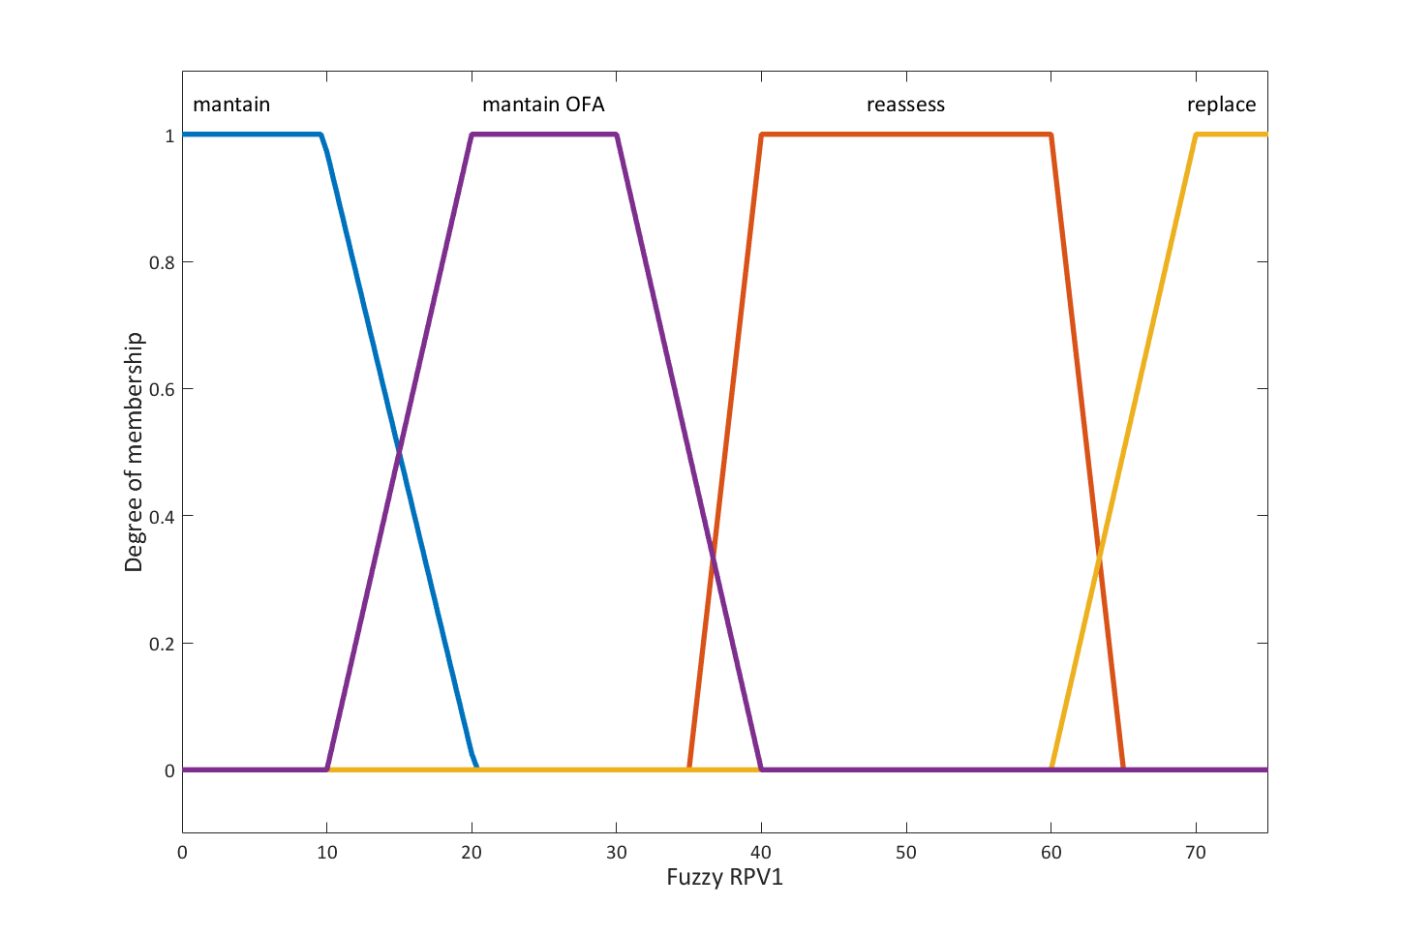
Figure 1. Membership function of RPV1

Fuzzy model
In the development of the GA model, several problems have arisen, both on data retrieval and on its interpretation. The main reason for problems have been failed companies; difficulties in identifying suppliers and technicians; infinite lifetime for some equipment; uncertainty about the possibility of finding spare parts after warranty end and availability of spare parts for an unspecified period of time. In order to enter the data within the GA model, it was therefore necessary to arrange the data in binary values, with the drawbacks that some of the RPVs obtained were over or underestimated.
Fuzzy logic-based systems have been developed in hospital management only recently even thought analogue qualitative reasoning approach was already applied many years ago in the field of bioengineering [1; 4; 5; 7; 8] where the problem of the uncertain values of variables has similar effects.. The limited availability of financial resources and qualified personnel are among the causes of improper and incorrect management of biomedical instrumentation. This principle has inspired some studies, such as the work by Taghipour, which classifies the instrumentation according to the critical points of the instrument and provides a tool for decision making [9] and the studies by Tawfik and Bassem, who have created a fuzzy model for the classification of biomedical instrumentation according to the risk level [10]. Moreover, the study carried out by Mummolo et al. has led to an inferential fuzzy model able to identify the equipment to be replaced, respecting the main objectives of spending reduction in a hospital and increase of the degree of satisfaction of patients and medical staff [6].
The Fuzzy model presented here aims to replace the first phase of the GA model. The model has been implemented using the Fuzzy Logic Toolbox in Matlab.
Biomedical equipment can be classified by type of device (life support, therapeutics, diagnostics and others). Moreover, all instruments in the same class of equipment may not have the same functional age. In this respect, different fuzzy models have been produced which differ as relates two features: rules (which allow a stricter assessment for life support or therapeutic equipment than for diagnostic or other devices) and age-related membership function (calibrated for functional age).
The variables that have been chosen are the same as used for the GA model.
The model that has been developed is a fuzzy mamdani model in which preamble and conclusion are linguistic concepts (model with set of inferential rules). The model has the four variables (corresponding to the variables used in RPV1) and provides an output that suggests whether a device should be replaced. Specifically, the variable can give four suggestions: maintain, maintain over the functional age, re-evaluate (second phase), replace.
For each input and output variable, the corresponding membership functions have been created. The membership functions are curves that define how each input (or output) value is mapped to a certain degree of membership between 0 and 1. Figure 1 shows the membership function for the output variable RPV1.

For each input, the degree of membership in fuzzy sets was calculated through the application of IF-THEN type rules which have been set up on the basis of the indications provided by the Galliera Hospital.
The fuzzified inputs have been applied to the antecedents: since the rules used have more than one antecedent, the AND intersection operator has been used to obtain the result of the antecedents. This operator provides the minimum degree of belonging among those present. The result of the antecedents has been applied to the function of membership of the consequent one according to the Clipping method, which simply cuts the consequent at the level of membership of the antecedent. The aggregation has allowed the unification of the consequent of all the activated rules. The fuzzy set for the output variable has been obtained from this process. The last step is defuzzification, whose input is the aggregates fuzzy set and output is the value is of RPV1.

Results
This work focuses on the analysis of six categories of instrumentation: electro-controlled bed for intensive care (BED) (381 units), patient monitors (MON) (170 units), biological refrigerators (BIR) (112 units), surgical lights (SUL) (42 units), ultrasound machines (USM) (36 units), armchairs for therapy and blood samples (ARC) (15 units). Both the GA model and the fuzzy model have been tested on the same equipment classes. Unfortunately, it was not possible to analyse all the equipment belonging to a certain type of instrument. Although most of the instrumentation has been analysed, for each class there are a number of biomedical equipment "not found" or for which it has not been possible to find the data necessary to calculate the RPV. The reasons for this are a number of factors, including problems in the outsourced service of management and monitoring of the technological park (updating the position of the instrument etc...), difficulties in obtaining direct feedback from suppliers and/or technicians and the equipment ageing.
Table 1 Comparison between GA and fuzzy models.

Although the two models have been defined on the basis of different logics, they do not differ greatly in identifying the instrument IPS classes. The GA model has a tendency towards a more conservative behaviour, about 78.2% of the analysed instrumentation is maintained, 22% pass to the second phase of evaluation and only for 0.6%, it gives an indication of replacement. The Fuzzy model gives an indication of maintenance of the devices analysed for 70.8%. It also further specifies that 58.3% of the instruments are certainly to be maintained and that 12.6% of the instruments at this time are not a source of concern, but that they are in an age or functional state that could cause a significant increase in IPS in the future. This model also identifies the need for re-evaluation for 25.1% of the instrumentation analysed and 4% of the total recommends replacement without further evaluation.
Table 1 shows a comparison between the two models in terms of the number of equipment that have been classified in one of the three bands: maintain, reassess and replace.
The two largest differences between models are found for USMs and monitors. The two largest differences between models are found for ultrasound machines (USMs) and patient monitors (MON). Specifically, it is suggested to maintain 83.3% of the total USMs analyzed according to the GA model and 58.3% according to the Fuzzy model, while for MON, the GA model identifies 36.7% of instruments to be maintained, 57.6% to be revalued and no instruments to be replaced immediately. The Fuzzy model identifies 15.1% of MON to be replaced.
results are presented here. Authors may choose a combination of text, tables, figures, and graphs to convey the results of their work to the reader. There are no set limitations on the number of tables, figures, and graphs that may be used in papers, posters, and proposals. Large figures and tables may span two columns. Please number tables and figures and reference them appropriately in the text.

Discussion and conclusions
A protocol has been developed with Health Technology Assessment techniques, to evaluate the biomedical equipment of the Galliera Hospital and to determine which of them is suitable for transfer to the new structure planned for 2021. The study carried out at present, provides the hospital with tools that allow planning purchases in order to distribute economic resources in the most appropriate way for the next 5 years. In this way, it will be possible to arrive at the date of the transfer to the new hospital with appropriate instrumentation.
At this preliminary stage, both models have been validated on a limited number of classes of equipment. This is the basis of a much broader analysis, which will involve all technological equipment of the structure in view of the relocation to the new hospital.
The Galliera Hospital showed interest in the Fuzzy model, considering the results obtained more satisfactory than those obtained by the GA model.
From the perspective of the New Hospital, the aim is to plan purchases in a predictive scenario of 4-5 years. Exploiting the uncertainty elements, as allowed by the fuzzy model, could be an advantage for the evaluation of the future availability of spare parts for a particular instrument.
In addition, a system of procurement of goods and services is increasingly being adopted in public administration in Italy, which involves centralising tendering procedures at a single purchasing centre. On one hand, this favours economies of scale, and on the other hand, the period between the need to purchase goods and the actual replacement of goods tends to expand well beyond 12 months. Also in this context, in the absence of a medium-long term project, it may be useful to apply the fuzzy model to the HTA analysis of renewal of a healthcare company's technology park.
In this respect, the Galliera Hospital has expressed its intention to extend the application of the fuzzy model to the entire present technology park.

References
[1] S. Badaloni, B. Di Camillo, and F. Sambo, Qualitative reasoning for biological network inference from systematic perturbation experiments, IEEE/ACM Transactions on Computational Biology and Bioinformatics (TCBB) 9 (2012), 1482-1491.
[2] C. Caimmi, A. Bocchieri, A. Buizza, and G. Genduso, A new model for the replacement priority value of medical equipment, in: 5th Mediterranean Conference on Medical and Biomedical Engineering and Computing 2001: MEDICON 2001, 12-15 June 2001, Pula, Croatia, 2001, pp. 183-186.
[3] L. Fennigkoh, A medical equipment replacement model, J Clin Eng 17 (1992), 43-47.
[4] S. Gaglio, M. Giacomini, C. Nicolini, and C. Ruggiero, A qualitative approach to cell growth modeling and simulation for cancer chemotherapy, Biomedical Engineering, IEEE Transactions on 38 (1991), 386-389.
[5] P. Linko, Uncertainties, fuzzy reasoning, and expert systems in bioengineering, Annals of the New York Academy of Sciences 542 (1988), 83-101.
[6] G. Mummolo, L. Ranieri, V. Bevilacqua, P. Galli, F. Menolascina, and G. Padovano, A fuzzy approach for medical equipment replacement planning, in: Proceedings of the 3rd International Conference on Maintenance and Facility Management, 2007, pp. 229-235.
[7] C. Ruggiero, M. Giacomini, and S. Gaglio, A qualitative model of the dynamics of blood glucose and its hormonal control, Computer methods and programs in biomedicine 40 (1993), 117-130.
[8] C. Ruggiero, M. Giacomini, O. Varnier, and S. Gaglio, A qualitative process theory based model of the HIV-1 virus-cell interaction, Computer methods and programs in biomedicine 43 (1994), 255-259.
[9] S. Taghipour, D. Banjevic, and A.K.S. Jardine, Prioritization of medical equipment for maintenance decisions, Journal of the Operational Research Society 62 (2010), 1666-1687.
[10] B. Tawfik, B.K. Ouda, and Y.M. Abd El Samad, A Fuzzy Logic Model for Medical Equipment Risk Classification, Journal of Clinical Engineering 38 (2013), 185-190.

Address for correspondence

Mauro Giacomini, via all’Opera Pia, 13 – 16145 Genova, Italy
Email: mauro.giacomini@dibris.unige.it
Tel +39 010 35 56546

