
33rd European Modeling & Simulation Symposium
18th International Multidisciplinary Modeling & Simulation Multiconference

2724-0029 © 2021 The Authors.
doi: xx.xxxx/xxxx
Autonomous Systems for Industrial Plants and Iron & Steel Facilities
Agostino G. Bruzzone1,*, Kirill Sinelshikov2, Elvezia Cepolina3, Antonio Giovannetti2, Javier Pernas2
1 Simulation Team, Genoa University, via Opera Pia 15, 16145 Genova, Italy
2 Simulation Team, via Magliotto, 17100, Savona, Italy
3 Simulation Team & DISPO Genoa University

*Corresponding author. Email address: agostino.bruzzone@simulationteam.com

Abstract
Iron & Steel facilities are characterized by presence of multiple risks caused by the nature of industrial processes. For this reason, the use of innovative solutions in order to support the work of operators and replace them during most dangerous tasks is growing more and more. In this study the authors propose the utilization of autonomous systems to cover some of the most critical and statistically dangerous routine tasks. In particular, we analyzed the utilization of modeling and simulation (M&S) and digital twin approaches in order to support the development of new autonomous vehicles as well as new procedures. Example of a virtual prototype in a 3D environment is provided.
Keywords: Autonomous Systems, Simulation, Virtual Prototyping, Digital Twin, Iron & Steel

- Introduction
Since many years, one of the main trends in industry has been to improve safety measures with the aim of preserving the health of workers and residents adjacent to plants, as well as reducing environmental impact. Although the number of industrial accidents resulting in death or serious injuries has been decreasing in recent years, processes and technologies for safety measures still need to be improved.
This task is quite difficult to achieve, especially for cases involving high temperatures, hazardous substances and bulky equipment; this situation is usually present in environments such as steel plants, glass production, seaports, etc.
In order to reduce the risk of injuries, it is essential to act simultaneously in several ways, such as organising safety training courses and drills, providing staff with adequate tools and safety equipment, enforcing new regulations and safety standards on particularly dangerous machinery, as well as employing autonomous systems in areas where safety could be compromised (Bruzzone et al., 2017; 2019a).
In fact, nowadays the use of different autonomous systems is quite common with regard to their specific purpose ranging from sampling, mapping environments or protecting critical infrastructures, among others (Bruzzone et al., 2018; Mazal, 2019). In this sense, the authors focus their attention on the last type of the aforementioned solutions along with its simulation.
In fact, autonomous solutions are currently demonstrating steady improvement in terms of autonomy, data acquisition, mobility and size, making them very promising for adoption in this field.
The latest technologies and opportunities related to Artificial Intelligence (AI), Industrial internet/Industry 4.0 and smart manufacturing highlight the need to exploit the hidden potential of industrial autonomous systems (Gamer et al., 2020). Moreover, it is convenient to use M&S either to develop a new solution, acquire a suitable solution, optimise processes or identify the best usage strategy among available systems (Bruzzone et al., 2016a; 2016b; Lamas-Rodríguez 2020). Indeed, simulation allows finding the most efficient system configuration and its working patterns without the need to put investment, time or infrastructure at risk.
In fact, modelling and simulation of autonomous systems in industry is an interesting and growing field. In the case of the present study, the authors have been working on such initiatives for a long time and continue to do so. However, the field of interest is not strictly limited to industry, but also covers aspects such as safety and processes where intelligent systems need to be used instead of human operators. An illustrative example is the simulation of autonomous systems for space and planetary exploration. Figure 1 shows a model of a Lunar rover used by the Genoa University team in the Simulation Exploration Experience 2021 project.
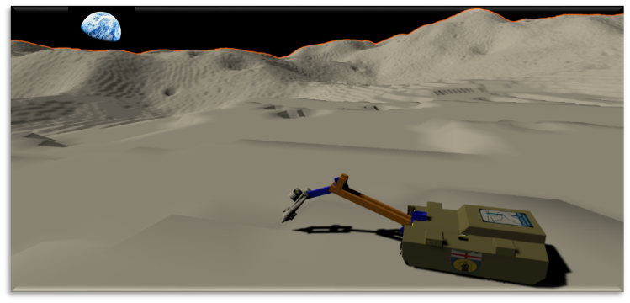
Figure 1. Example of use of an industrial autonomous system for Lunar exploration.
- State of the Art
Industry 4.0 is characterised by robotization, digitisation and automation (Botilikova & Botilik, 2020). Autonomous robotic systems (ASRs) have been used to increase productivity in many supply chains (Duong, 2020). Indeed, thanks to artificial intelligence, RAS are able to mimic the behaviours or even decisions of humans. RAS are also used in the tourism industry for the control or delivery of goods (Ivanov et al., 2019), in transport as self-driving trucks (Sanders et al., 2019), in construction for the production of skyscrapers (Cai et al., 2019) and in the food industry as farm surveillance systems (Fentanes et al., 2015).
Given their increasing importance and use, it is essential to properly test and monitor their operation. This can be addressed through the creation of models that preemptively emulate their activities in order to predict outputs. The first and most widespread aspect of autonomous systems simulation is virtual prototyping (Massei & Tremori, 2011).
Among others, M&S can be used to verify accessibility constraints, identify the most cost-effective type of solution, test different propulsion systems, etc. Even so, one of the main advantages of this approach is the possibility of carrying out staff training. Particularly in the case of hazardous areas or activities, staff training and learning is limited by several factors such as the risk of accidents, the cost of training and the difficulty of reproducing a realistic hazard. For these reasons, simulation emerges as one of the most advantageous ways to train personnel, as it makes total safety and a very realistic experience (Longo et al., 2012) (Crespo-Pereira et al., 2014).
A further extension of the functionality of a virtual prototype could be achieved through the Digital Twin approach, which involves creating a high-fidelity digital replica of a system (Bruzzone et al., 2019b). Digital twin and real system are mirror images of each other.
This aspect draws attention to how the digital twin can be used to learn about the real system and how it can be used to explore, improve and simulate new design solutions related to the real system (Batty, 2018). Once its detailed drawings and specifications are completed during the development process of an autonomous system, it may be possible to use this information to build a high-precision digital copy and integrate it with a simulated virtual environment.
Furthermore, we can exploit the current possibilities offered by control systems, sensors, Big Data and Industrial Internet of Things to model and reproduce the system's activities in real time with high fidelity and control its real twin (Bruzzone et al., 2018b). This solution allows to test the system under various initial and boundary conditions and to obtain results with good tolerances.
In particular, this type of high-fidelity model could be particularly useful to support detail engineering in order to identify possible pitfalls or choose the most suitable sensors to be employed.
In addition to this, digital twins can support very specific aspects of system development such as heat analysis (Bruzzone et al., 2019b). At the same time, the model allows for training and evaluation of personnel; therefore, these procedures could be done even before the physical system is operational.
With advances in software and hardware solutions, the Industrial internet of things (IIoT), and data acquisition, storage and processing techniques, the virtual twin could also be used in combination with virtual reality.

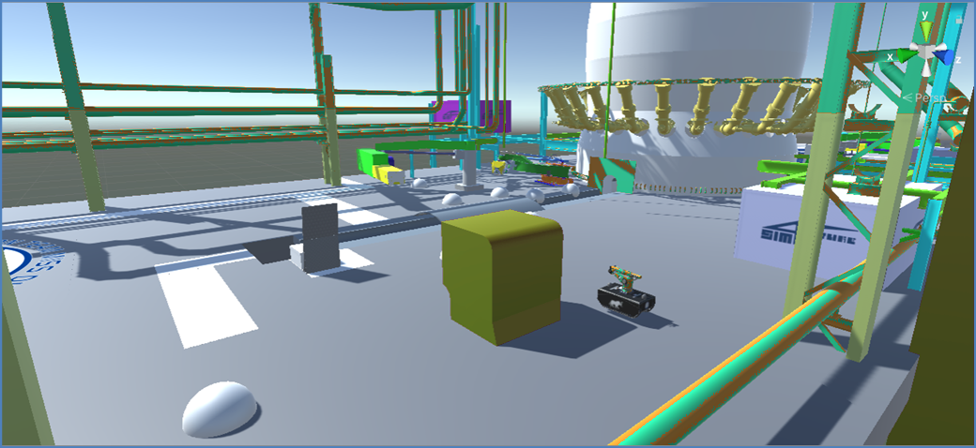
Figure 2. 3D model of plant with waypoints.
This allows the user to visualise information in an immersive and interactive environment, creating a realistic experience and increasing training efficiency (Bruzzone et al., 2019c).
- Case Study
Hereafter we propose a case study on the virtual prototyping of an autonomous system to improve safety in the context of the steel industry. In particular, it deals with the use of UGVs (Unmanned Ground Vehicles) to assist particularly dangerous sampling and cleaning operations in the tap-hole area of a blast furnace. In this project the simulation is used to support the following activities:
- Identification of macro configuration and propulsion system of the autonomous system, basic physical simulation.
- Check of accessibility constraints using virtual simulation, identification of potential interference with machinery and personnel present on site, detailed physical simulation including stability and movement analysis.
- Digital twin simulation in order to clarify specific details related to operation of the system and to support detailed engineering. Utilization of the twin to support development of remote-control system, safety analysis.
- In the next step it is expected to improve the digital twin and continue its utilization in order to support improvement of procedures.
In this phase of the study, the focus is on the development of the autonomous navigation system, including a pathfinding algorithm for the platform and one for the movement of the robot arm.
  - Path Finding on a Graph
As for the path finding algorithm, the mapping of the structure is conducted by combining its 3D model with a network of waypoints (nodes) and paths (arches) superimposed on the 3D model. An A* algorithm is then used to iteratively find the best route to the destination, even when new obstacles appear (Heineman, 2016). Although this approach requires additional work when a new static obstacle is introduced, it allows for safe and efficient on-site navigation. An example is shown in Figure 2.
This approach has been used since the beginning of the research and has proven to be fast and efficient.
  - 3D Automatic Navigation
Regarding automatic navigation, we envisage the use of solutions that can be directly connected or integrated with simulation engines, such as NavMesh and Unity 3D (Brewer, 2019). This approach is extremely flexible and allows the UGV to create new routes based on its spatial mapping and data obtained from the obstacle detection system. However, such goal-driven planning might be difficult to implement (Ayreault, 2006) since at the same time it requires the integration of the simulation engine with the control system of the real UGV. Thus, it is necessary that the control system:
- identifies target.
- finds and checking the route in the simulator.
- sends the waypoints obtained to the UGV.
Figure 3 illustrates the 3D environment with walkable areas.
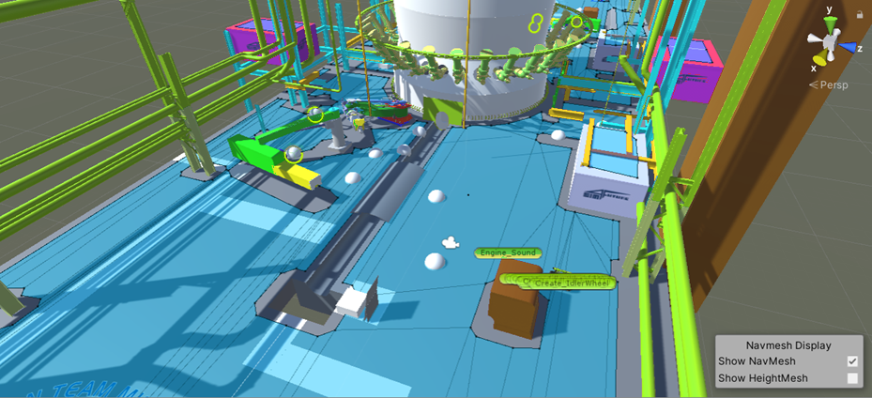
Figure 3. Walkable areas in NavMesh in Unity 3D.
Although this solution may not seem very attractive, it is important to note that most industrial plants do not have large spaces where it is possible to manoeuvre outside the intended route. The larger spaces are normally occupied by machinery, tools and materials, while other areas may be too dangerous for the autonomous system or the workers, and should therefore be avoided.
  - Predefined algorithms for optimal arm movements
In some cases, the robotic manipulator has to perform some kind of routine action. In this case, the movement calculation could be simplified by manually introducing the desired rotation sequences. By means of this approach, the arm can get close to the target point; after that, an algorithm has to take care of the fine-tuning. This approach is similar to the hand-guided training of physical manipulators (Safeea, 2017).
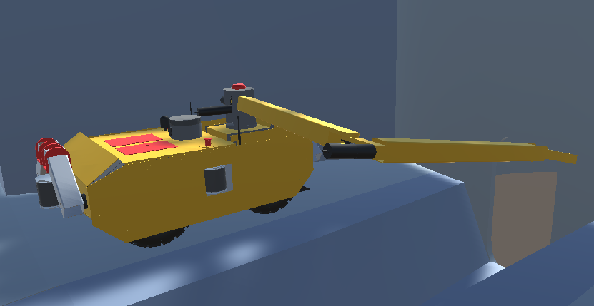
Figure 4. Robotic arm manipulator.
Figure 4 shows the arm in one of the possible configurations.
  - Inverse kinematics to reach final position
When the final position of the manipulator is known in advance, i.e. when it has to reach a specific point at certain given angles, it is convenient to use inverse kinematics.
In this case, the joint rotations are calculated from the final position (D'Souza et al., 2001). This approach could be combined with the one based on a predefined path in order to improve the accuracy of position tuning.
  - Utilization of Artificial Intelligence to find optimal movement of the arm
One of the emerging approaches in developing manipulator movements is to use machine learning algorithms. In this case, a very large population of simulated models could act in parallel to develop the best movement approach (Almusawi, 2016). However, this approach might be too complex for the presented task and would not provide any significant advantage over other
- Conclusions
In this study, the authors provide insights into the use of simulation to support the introduction of autonomous systems in hazardous environments with the aim of improving personnel safety. This approach allows experimentation on the model before and during the development of a physical prototype, while supporting the development of new procedures and staff training throughout the project.
References
Almusawi, A. R., Dülger, L. C. & Kapucu, S. (2016). A new artificial neural network approach in solving inverse kinematics of robotic arm (denso vp6242). Computational intelligence and neuroscience, 2016.
Ayreault, H., Dabe, F., Barbier, M., Nicolas, S. & Kermet, G. (2006). Goal driven planning and adaptivity for AUVs. In 1st Workshop Control Architectures Robots.
Brewer, D. (2019). Tactical pathfinding on a navmesh. In Game AI Pro 360 (pp. 25-32). CRC Press.
Batty M. 2018. Digital Twins. In Journal Environment and Planning B: Urban Analytics and City Science, vol.45 pp 817-820
Botilikova, M., Botilik, J. (2020). Local Extremes of Selected Industry 4.0 Indicators in the European Space-Structure for Autonomous Systems. In Journal of Risk and Financial Management.
Bruzzone, A.G., Agresta, M., Sinelshchikov, K. & Massei, M. (2019a). Intelligent autonomous system devoted to improve efficiency and safety in industrial plant. In proceedings of 18th International Conference on Modeling and Applied Simulation, MAS 2019, pp. 186-191.
Bruzzone, A. G., Cianci, R., Sciomachen, A., Sinelshchikov, K. & Agresta, M. (2019b). A digital twin approach to develop a new autonous system able to operate in high temperature environments within industrial plants. In Proceedings of the 2019 Summer Simulation Conference (pp. 1-11).
Bruzzone, A. G., Fancello, G., Daga, M., Leban, B. & Massei, M. (2019c). Mixed reality for industrial applications: interactions in human-machine system and modelling in immersive virtual environment. International Journal of Simulation and Process Modelling, 14(2), 165-177.
Bruzzone, A. G., Massei, M., Di Matteo, R. & Kutej, L. (2018a). Introducing intelligence and autonomy into industrial robots to address operations into dangerous area. In Int.Conference on M&S for Autonomous systems, pp. 433-444, Springer
Bruzzone, A.G., Massei, M., Sinelshchikov, K., Longo, F., Agresta, M., Di Donato, L. & Di Francesco, C. (2018b). Wearable Mixed Reality Solutions for Industrial Plants and Production Lines.
Bruzzone, A.G., Massei, M., Agresta, M., Di Matteo, R., Sinelshchikov, K., Longo, F., Nicoletti, L., Di Donato, L., Tommasini, L., Console, C., Ferraro, A., Pirozzi, M., Puri, D., Vita, L., Cassara, F., Mennuti, C., Augugliaro, G., Delle Site, C., Di Palo, F. & Bragatto, P. (2017). Autonomous systems & safety issues: the roadmap to enable new advances in Industrial Application. Prof. of EMSS.
Bruzzone, A.G., Massei, M., Maglione, G.L., Di Matteo, R. & Franzinetti, G. (2016a) Simulation of Manned & Autonomous Systems for Critical Infrastructure Protection. In Proceedings of DHSS, edited by Bruzzone A.G., Sottilare R.A., pp. 82-88. Genova, Italy, Dime University of Genoa.
Bruzzone, A. G., Longo F., Agresta M., Di Matteo R. , Maglione G. (2016b). Autonomous systems for operations in critical environments. Prof. of the M&S of Complexity in Intelligent, Adaptive and Autonomous Systems (MSCIAAS) & Space Simulation for Planetary Space Exploration (SPACE)
Cai, S., Ma, Z., Skibniewski, M., J., Bao, S. (2019). Construction automation and robotics for high-rise buildings over the past decades: A comprehensive review. In Advanced Engineering Informatics
Crespo-Pereira, D., Lamas-Rodriguez, A., Rios-Prado, R. (2014). A modified beer game for simulation and optimization teaching. 26th European Modeling and Simulation Symposium, EMSS 2014 .
Duong, L. N. K. , Al-Fadhli, M., Jagtap, S., Bader, F., Martindale W., Swainson, M. & Paoli, A. (2020). A review of robotics and autonomous systems in the food industry: From the supply chains perspective. In Journal Trends in Food Science & Technology, vol. 106, pp. 355-364
Fentanes, J.P., Badiee, A., Duckett, T., Evans, J., Pearson, S., Cielniak, G. (2020). Kriging-based robotic exploration for soil moisture mapping using a cosmic-ray sensor. In Journal of Field Robotics, 37, pp.122-136
Gamer, T., Hoernicke, M., Kloepper, B., Bauer, R. & Isaksson, A.J. (2020). The autonomous industrial plant future of process engineering, operations and maintenance. In Journal of Process Control, Vol.88, pp. 101-110
Heineman, G. T., Pollice, G., & Selkow, S. (2016). Algorithms in a nutshell: A practical guide. " O'Reilly Media, Inc.".
Ivanov, S., Gretzel, U., Berezina, K., Sigala, M., Webster, C. (2019). Progress on robotics in hospitality and tourism: A review of the literature. In Journal of Hospitality and tourism Technology, 10, pp.489-521.
Lamas-Rodríguez, A., Pernas-Álvarez, J. & Taracido-López, I. (2020). Constrained-Based Discrete-Event Simulation of an Assembly Job Shop Process in the Offshore Wind Industry. In proceedings of EMSS 2020.
Longo, F., Massei, M. & Nicoletti, L. (2012). An application of modeling and simulation to support industrial plants design. International Journal of modeling, simulation and scientific computing, 3(01), 1240001.
Longo, F., Bruzzone, A., Padovano, A. & Vetrano, M. (2016). Drones based relief on moon disaster simulation. In Proceedings of the Modeling and Simulation of Complexity in Intelligent, Adaptive and Autonomous Systems 2016 (MSCIAAS 2016) and Space Simulation for Planetary Space Exploration (SPACE 2016) (pp. 1-7).
Massei, M. & Tremori, A. (2011). Mobile training solutions based on st_vp: a HLA virtual simulation for training and virtual prototyping within ports. Proceedings SCM MEMTS, 29-30.

Mazal, J., Bruzzone, A., Turi, M., Biagini, M., Corona, F. & Jones, J. (2019). NATO Use of Modeling and Simulation to Evolve Autonomous Systems. Complexity Challenges in Cyber Physical Systems: Using Modeling and Simulation (M&S) to Support Intelligence, Adaptation and Autonomy, 353.
Safeea, M., Bearee, R. & Neto, P. (2017). End-effector precise hand-guiding for collaborative robots. In proceedings of Iberian Robotics conference (pp. 595-605). Springer, Cham.
Sanders, N.R., Boone, T., Ganeshan, R., Wood, J.D. (2019). Sustainable supply chains in the age of AI and digitisation: Research challenges and opportunities. In Journal of Business Logistic, 40, pp. 229-240
D'Souza, A., Vijayakumar, S. & Schaal, S. (2001). Learning inverse kinematics. In Proceedings of 2001 IEEE/RSJ International Conference on Intelligent Robots and Systems. Expanding the Societal Role of Robotics in the the Next Millennium (Cat. No. 01CH37180) (Vol. 1, pp. 298-303). IEEE.

