SUPPORTING INFORMATION
Drug-Free Hybrid Nanoarchitecture Modulation of the Metastatic Behavior of Pancreatic Ductal Adenocarcinoma in Alternative in Vivo Models
Agata Zamborlin,^{1,2} Patrizia Sarogni,¹ Valentina Frusca,^{1,3} Alessandra Gonnelli,^{1,4} Noemi Giannini,^{1,4} Maria Laura Ermini,¹ Andrea Marranci,⁵ Francesca Pagliari,⁶ Chiara Maria Mazzanti,⁵ Joao Carlos Seco,^{6,7} and Valerio Voliani^{1,8}
¹ Center for Nanotechnology Innovation@ NEST, Istituto Italiano di Tecnologia, Piazza San Silvestro, 12 – 56127, Pisa, Italy
² NEST-Scuola Normale Superiore, Piazza San Silvestro, 12 – 56127, Pisa, Italy
³ Scuola Superiore Sant’Anna, Piazza Martiri della Libertà, 33 – 56127, Pisa, Italy
⁴ Radiation Oncology Unit, Pisa University Hospital "Azienda Ospedaliero-Universitaria Pisana", Via Roma 67 – 56126 Pisa, Italy
⁵ Fondazione Pisana per la Scienza ONLUS, via Ferruccio Giovannini 13 – 56017, S. Giuliano Terme, Pisa, Italy
⁶ Division of BioMedical Physics in Radiation Oncology, German Cancer Research Center, 69120 Heidelberg, Germany
⁷ Department of Physics and Astronomy, Heidelberg University, Im Neuenheimer Feld 227, 69120 Heidelberg, Germany
⁸ Department of Pharmacy, School of Medical and Pharmaceutical Sciences, University of Genoa, Viale Cembrano, 4 – 16148, Genoa, Italy
Supporting Information
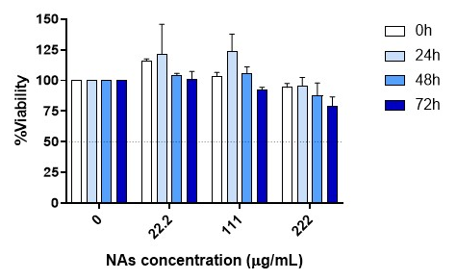
Figure 1SI. Viability of BxPC-3 cells after MFNAs treatment. Viability assays on BxPC-3 cells after 24h-incubation with MFNAs. %Viability was measured compared to the untreated cells (complete medium) for each time point. Data are reported as mean ± standard deviation from two independent experiments performed in triplicate. Statistical analysis was performed using multiple t-test with Holm-Sidak’s multiple comparison test, *p<0.05 **p<0.01 ***p<0.001 ****p<0.0001.
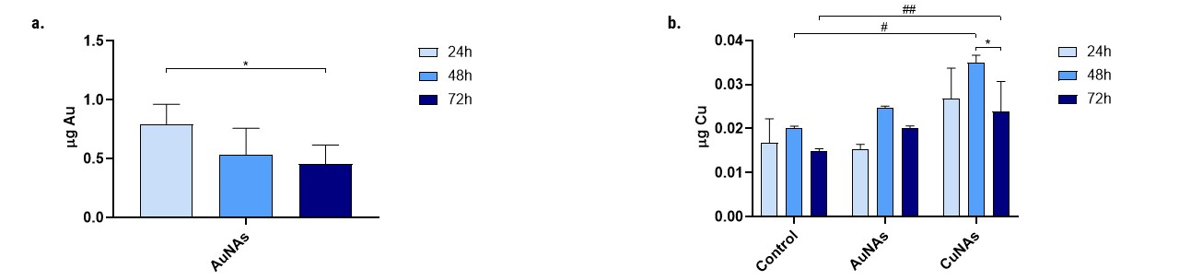
Figure 2SI. Metal uptake in 2D culture of BxPC-3 cells at different time points after 24h-incubation with AuNAs and CuNAs. (a) µg of Au detected in cells. Au content decreased significantly over time. Statistical analysis was performed through multiple t-test, Holm-Sidak’s method, *p<0.05. (b) µg of Cu detected in cells. Copper content in untreated cells and AuNAs-treated cells is due to the endogenous copper levels in cells. Statistical analysis was performed through multiple t-test, Holm-Sidak’s method, *p<0.05; and with Two-way ANOVA, Dunnett’s comparison, #p<0.05 ##p<0.01.
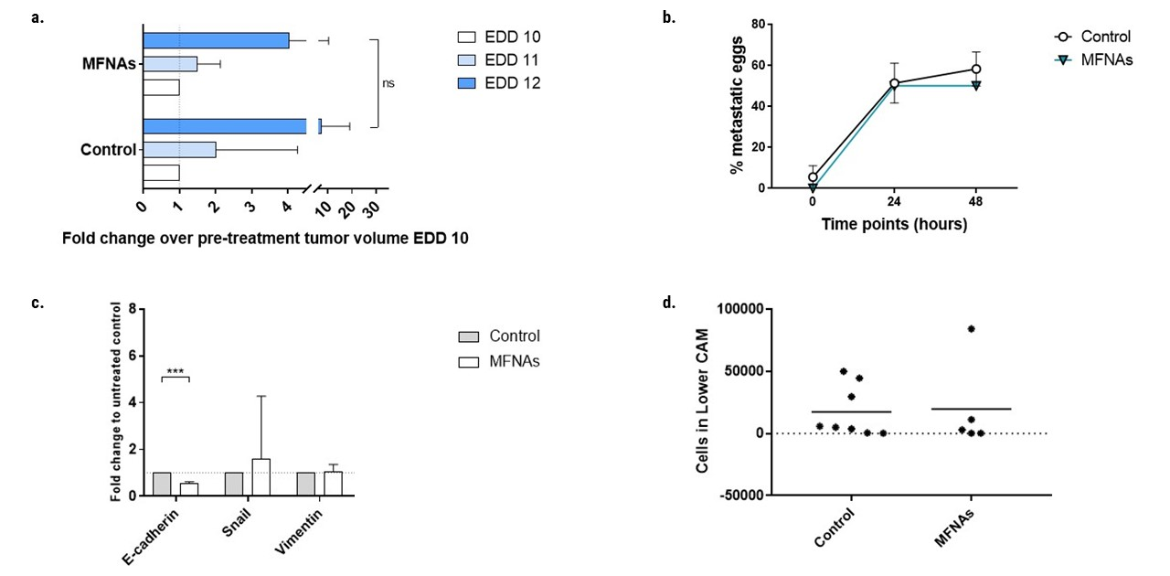
Figure 3SI. (a) Tumor volume fold change compared to EDD 10. MFNAs did not reduce the tumor growth compared to the untreated (control) eggs. Data are reported as mean ± standard deviation (control: n=10, MFNAs: n=6). Statistical analysis was performed through two-way ANOVA, with Dunnett's comparison, *p<0.05 **p<0.01 ***p<0.001 ****p<0.0001. (b) Metastasis in the upper CAM, displayed as percentage of metastatic upper CAM over the number of eggs. While AuNAs and CuNAs slowed down cancer cell migration in the upper CAM, MFNAs behaved as the control. Control: data are reported as mean ± standard deviation on two independent experiments with n₁ and n₂ number of eggs each (0h: control n₁=12 n₂=18; 24h: control n₁=12 n₂=18; 48h: control n₁=8 n₂=12; 72h: control n₁=4 n₂=7). MFNAs: data are reported as percentage of metastasis-bearing upper CAMs with n=6. Statistical analysis was performed through two-way ANOVA, with Sidak's comparison, *p<0.05 **p<0.01 ***p<0.001 ****p<0.0001. (c) MFNAs effects on the regulation of EMT-related genes on CAM tumors. rt-PCR analysis on tumors harvested 48h from CAM treated with MFNAs showed no tendency of MFNAs in modulating EMT. Data are reported as mean ± standard deviation (N=3). Statistical analysis was performed through multiple t-test, Holm-Sidak’s method, *p<0.05 **p<0.01 ***p<0.001 ****p<0.0001. (d) Quantification of the cancer cells in the lower CAM by rt-PCR analysis of Alu expression at 48h. Data are reported as mean ± standard deviation (control n=8, MFNAs n=5). Statistical analysis was performed through multiple t-test, Welch's test, *p<0.05 **p<0.01 ***p<0.001 ****p<0.0001.
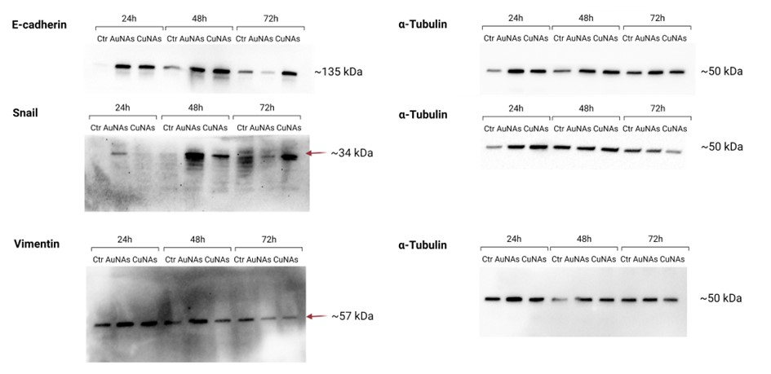
Figure 4SI. Uncropped blot of the investigated proteins in CAM tumors.

